The Woodlands Community Primary School | Year 1/2 | Art
Key Vocabulary | Key Skills
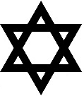  Judaism Star of David  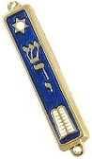  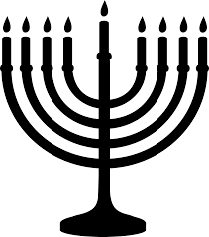  Mezuzah Menorah  Torah Kippah  Shabbat Hanukah  Synagogue Rabbi | I can name religious objects and symbols.  I can compare religious objects.  I can group religious objects.  I can use religious words and phrases relating to Judaism.  I can recall the main parts from the story of Hanukkah.  I know that Judaism is a religion.  I know that Shabbat is a Jewish celebration.  I know the reason why Hanukah is celebrated.  I know that a Synagogue is a Jewish place of worship.

