Home Learning Booklet
Summer 1
Year 1
This booklet belongs to

Woodlands Primary School
Homework Grid Summer 1 (Muck, mess and mixtures)
Please return your homework to school on Monday for marking.

 | Expected |  | Exceeding Expected |  |  |  | Greater Depth
 | These need to be carried out every week |  | Maths |  | English |  | Select 2 projects from the list below to do over the half term  - Cook something with a grown up and create a picture record of what you have done. Perhaps you could try one of Roald Dahl’s revolting recipes?  - Use measuring jugs to measure different amounts of water. Create your own capacity problems and bring them into school for other children to solve.  - Make your own slush drink by freezing a cup of juice. How long does it take to freeze? How about making different coloured drinks by mixing different juices? Record your investigation in a scientific report.  - Create a clay tile imprinted with different patterns and shapes or decorated with clay slip.  - Write a poem with the title ‘muck, mess and mixtures’. Include some exciting adjectives.  - Create an original piece of artwork inspired by an artist you admire.  - Go shopping, buy and try foods that you’ve never eaten before. Record your findings as you wish!
Week 1 | Reading at LEAST 3 times  Complete the Number Bonds to 20 sheet  Spellings grid practise for weekly spelling test |  | Can I identify ordinal numbers?
Week 2 | Reading at LEAST 3 times  Complete the counting in twos sheet  Spellings grid practise for weekly spelling test |  | Can I add lengths together?
Week 3 | Reading at LEAST 3 times  Complete the subtraction within 30 sheet  Spellings grid practise for weekly spelling test |  |  |  | Can I write using the correct verbs?
Week 4 | Reading at LEAST 3 times  Complete the counting in fives sheet  Spellings grid practise for weekly spelling test |  |  |  | Education city- See page for activity online
Week 5 | Reading at LEAST 3 times  Complete the number bonds to 20.  Spellings grid practise for weekly spelling test |  |  |  | Education city- See page for activity online

Expected
Week 1: Spelling practise: Look, say, cover, write, check.
Look | Say | Cover | Write | Check | Write | Check | Write | Check
now
how
brown
down
town
out
about
mouth
sound
you

Now choose two of the words to write in a sentence.
1. _______________________________________________________________________________________
2. _______________________________________________________________________________________
Expected
Week 1 Complete the number bonds to 20.
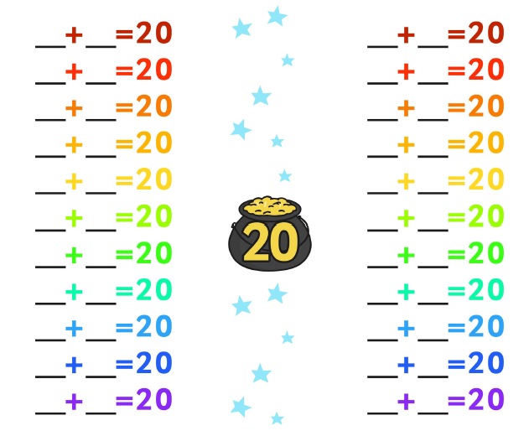

Exceeding expected
THTH
Remember…

Ordinal numbers are the order in which they appear.
Week 1- Ordinal Numbers
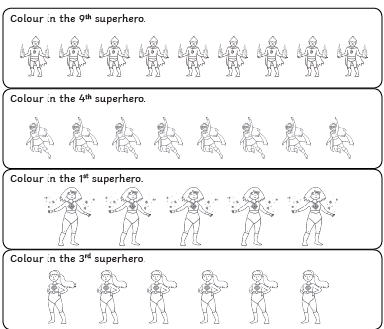

Expected
Week 2: Spelling practise: Look, say, cover, write, check.
Look | Say | Cover | Write | Check | Write | Check | Write | Check
very
happy
funny
party
family
dizzy
smelly
silly
jolly
sunny

Now choose two of the words to write in a sentence.
1. _______________________________________________________________________________________
2. _______________________________________________________________________________________
Expected
Week 2 – Complete the sequence (counting in twos)
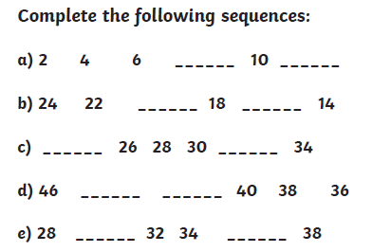
.

Exceeding expected
Week 2- Complete these length addition problems.
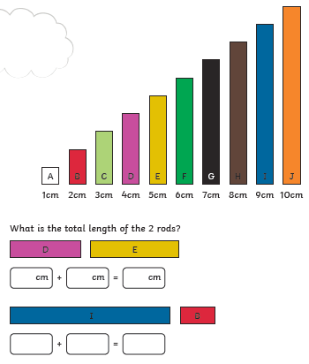

don’t

Expected
Week 3: Spelling practise: Look, say, cover, write, check.
Look | Say | Cover | Write | Check | Write | Check | Write | Check
for
short
born
horse
morning
more
score
before
wore
shore

Now choose two of the words to write in a sentence.
1. _______________________________________________________________________________________
2. _______________________________________________________________________________________
Expected
Week 3-. Complete the subtractions within 20.
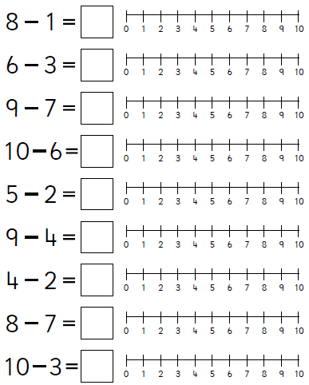
Remember to use the number Line to help you.

Exceeding expected
Week 3- Complete the sentences with the correct verbs.
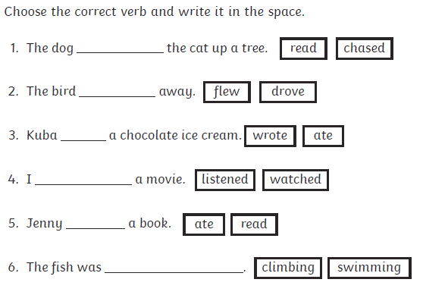

Expected
Week 4: Spelling practise: Look, say, cover, write, check.
Look | Say | Cover | Write | Check | Write | Check | Write | Check
saw
draw
yawn
crawl
claw
author
August
dinosaur
astronaut
your

Now choose two of the words to write in a sentence.
1. _______________________________________________________________________________________
2. _______________________________________________________________________________________
Expected
Week 4- Complete the sequence (counting in fives)

Complete the following sequences
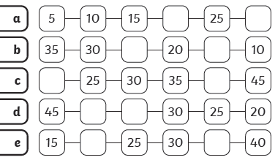

Exceeding expected
Week 4- Education city
Use your Education City log in in the front of your diary to complete the activity ‘Amazing Punctuation’ ending sentences.
What did you score?
THTH
Will you get the highest score?
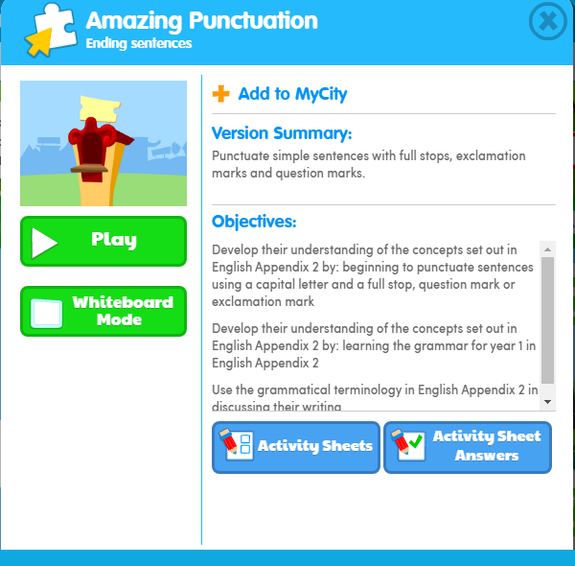

Expected
Week 5: Spelling practise: Look, say, cover, write, check.
Look | Say | Cover | Write | Check | Write | Check | Write | Check
air
fair
pair
hair
chair
bare
dare
care
share
scared

Now choose two of the words to write in a sentence.
1. _______________________________________________________________________________________
2. _______________________________________________________________________________________
Expected Week 5- complete the number bonds to 20.
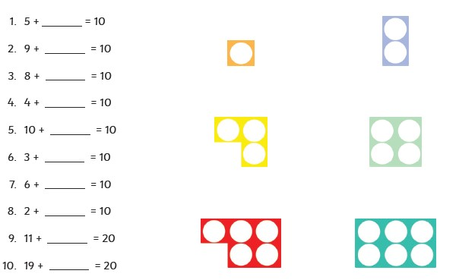
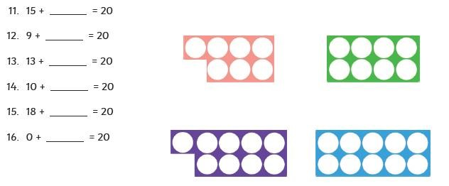

Exceeding Expected
Week 5- Education city
Use your Education City log in in the front of your diary to complete the activity ‘Roots to Fortune’ adding ‘s’ and ‘es’.

What did you score?
THTH
Will you get the highest score?

