A Guide for Parents…
Early Years Foundation Stage framework
What is the EYFS Framework?
The EYFS Framework is there to support all professionals working in the Early Years age group. It has a large emphasis on the adult’s role in helping the children develop.
It sets out:
- The legal welfare requirements that everyone registered to look after children must follow to keep your child safe and promote their welfare;
- The 7 areas of learning and development which guide professionals’ engagement with your child’s play and activities as they learn new skills and knowledge;
- Assessments that will tell you about your child’s progress through the EYFS;
- The expected levels (Early Learning Goals) that your child should reach at the age of 5, which is usually at the end of their reception year.
What is the Early Years Foundation Stage?
This is the stage in your child’s life that gets them ready and prepares them for school, as well as for their future learning and successes. The EYFS was created to ensure your child’s first 5 years are happy, active, exciting, fun and secure, as well as to support their development, care and learning needs.
All nurseries, pre-schools, reception classes and childminders who are registered to deliver the EYFS must follow a legal document called the Early Years Foundation Stage Framework.
What does this mean for parents?
Within the EYFS there are a set of welfare standards that everyone must follow which will ensure your child is as safe as possible. These include the maximum numbers a childminder can have in their care at any given time and the need to carry out risk assessments.
You can find out about the quality of your child’s childminder in relation to the EYFS Framework by checking what the Government’s official inspection body for early years, Ofsted, has to say about it. You can find this information at
www.ofsted.gov.uk/inspection-reports/find-inspection-report.

How your child will be learning:
Your child will be learning skills, acquiring knowledge and demonstrating their understanding through 7 areas of learning and development.
Children should mostly develop the 3 prime areas first:
- Communication and language
- Physical development
- Personal, social and emotional development
These prime areas are those most essential for your child’s healthy development and future learning.
As children grow, the prime areas will help them to develop skills in 4 specific areas:
- Literacy
- Mathematics
- Understanding the world
- Expressive arts and design

Childminders will use these to plan your child’s learning and activities. Activities will be suited to your child’s unique ways. They will learn by playing and exploring, being active and through creative and critical thinking, which will take place indoors and outside.

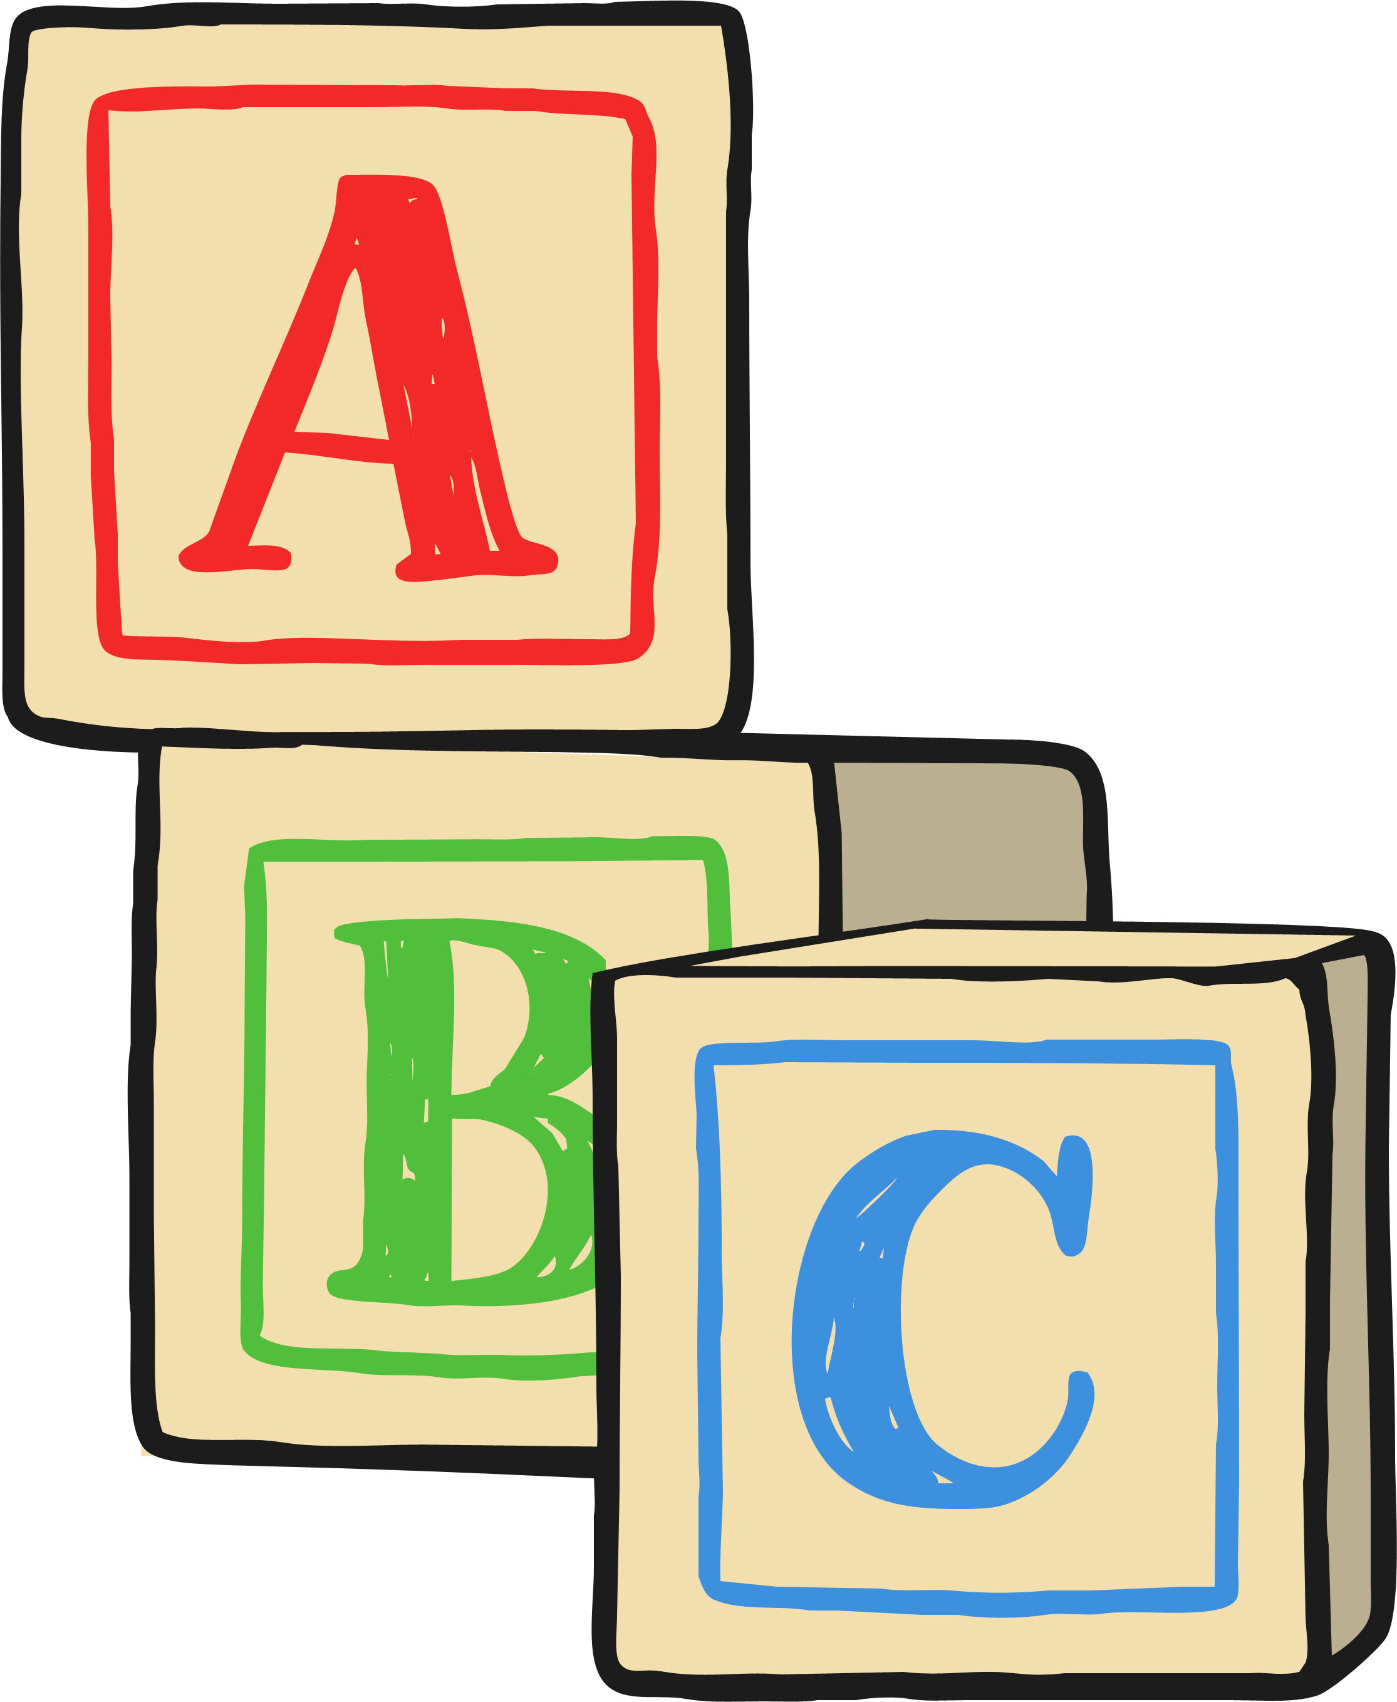
How can I help as a parent?
All the fun activities that you do with your child at home are important in supporting your child’s learning and development. Even when your child is very young and not yet able to talk, talking to them helps them to learn and understand new words and ideas.
If you are looking for new ideas for things to do then find out what is on offer at your local children’s centre. There are also a wealth of activity ideas on the Internet.
You will be asked to share information with the childminder via a questionnaire.
It might look something like these examples:
Parent and Child Review of Learning and Next Steps
Parent and Child Review of Interests and Achievements at Home Tracking Sheet Template

How do I know how my child is getting on?
It is important that both professional childcarers and parents work together, sharing information about the child, what they have done at home and in the childcare setting. There are various assessment steps throughout the EYFS but practitioners will continually be assessing and building on your child’s skills.
When your child starts in a new setting, observations will be made to ascertain where the child is at their stage of development and recorded on observation sheets like these:
EYFS On Entry Observation Record
My First Day Observations Sheet
Some examples of assessment record sheets:
EYFS Characteristics of Effective Learning Termly Tracking Sheet
Early Years Outcomes Tracking Document September 2014 Divided into Ages and Stages
When your child is 2 years old, the professionals working with them will write a summary of how your child is progressing against the 3 prime areas of learning:
- Communication and language
- Physical development
- Personal, social and emotional development
This is called the progress check at age two which can be documented with an EYFS Progress Check at Age Two Report Form.
When your child is 5 years old, at the end of the EYFS (the summer term of reception year in school) teachers will complete an assessment known as the EYFS Profile - such as this Early Years Progress Summary Form - which is based on what the teacher has observed over time.

More information
The most important place to find out more is your child’s childminder. Ask as many questions as you need to.
You can also find the Early Years Foundation Stage at www.foundationyears.org.uk

