The Woodlands Community Primary School | Year 1/2 | Topic – History |  | Bright lights, big city
Key Vocabulary | Key Knowledge and Skills
The plague was spread by rats and fleas.  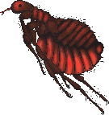  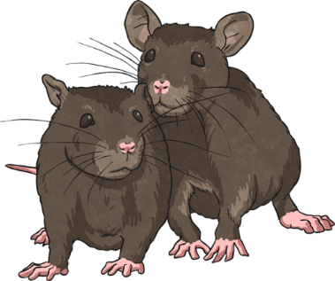 | London is the capital city  Of the United Kingdom. |  | Knowledge  I know that history is the study of past events.  I know at least one event that happened before I was born.  I know events happen in time order.  I know and recount episodes from stories about the past.  Skills  I can sequence events  I can use a source – why, what, who, how, where to ask questions and find answers
 | Key knowledge
The Plague Doctor

Glass Eye
Glass eyes were built into the mask to make sure that the eyes were fully protected.

Mask
The mask covered the head completely and was gathered in at the neck for extra protection.

Gown
The full-length gown was made out of thick material which was then covered with wax.

Leather Gloves
The doctor wore leather gloves to protect his hands from any form of contact with the disease.

Wooden Stick
The Plague Doctor carried a wooden stick so that he could drive people who came too close to him away.

