Year 3/4
Home Learning
Summer Term
Summer 2 Week 1: 01.06.20

*Guided Reading and Maths are in separate booklets for each group.*

Summer 2 2020
English – Week 1
Can I describe character?
Aim:
I can familiarise myself with the legend of King Arthur
I can select language to describe character: adjectives and nouns
I can describe appearance.
I can use verbs (actions) and feelings and describe them.
I can describe character

Day 1: I can familiarise myself with the legend of King Arthur
Read the story about King Arther

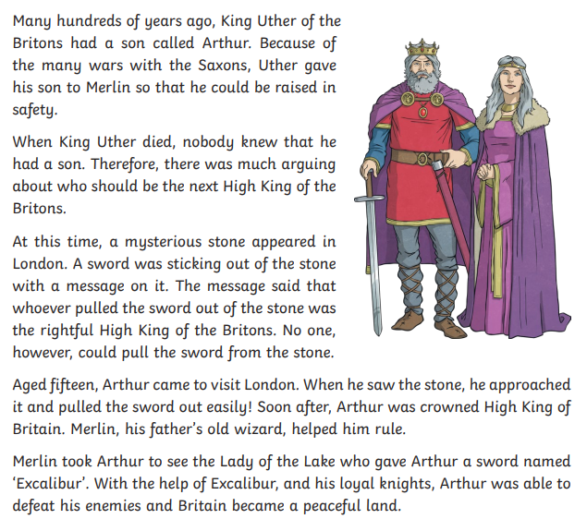

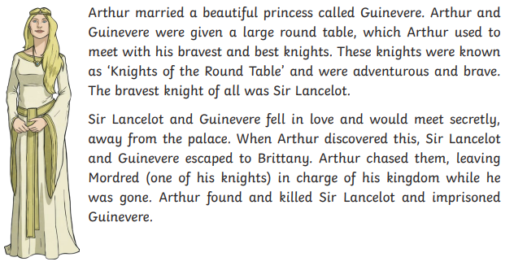
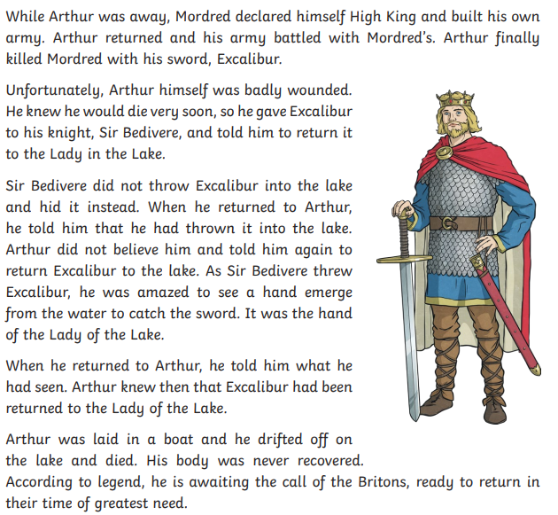

Click on the links below for more about King Arthur:
https://www.ks2history.com/king-arthur-info-guide
https://www.historyforkids.net/king-arthur.html
https://kids.kiddle.co/King_Arthur

Also on the Woodlands website, there is a power point called The Legend of king Arthur. Read this as well.

Activity 1
From your reading, try to recognise what King Arthur looked like, what he accomplished and what his personality was like.

Day 2: I can select language to describe character: adjectives and nouns

This week select language ready to describe the character of Arthur. Label the image. See example so you know how to carry out the activity.

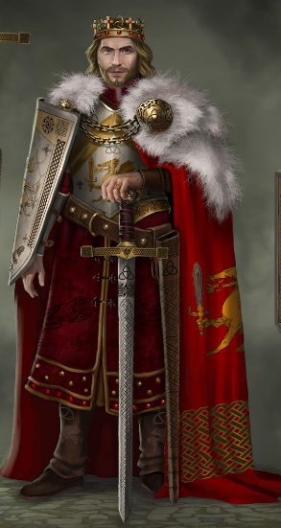
A golden crown rested
on his head
Long, sunburnt hair

Day 3: I can describe appearance.

Take your ideas from yesterday and write a short paragraph that describes Arthur’s appearance in the same image.

Example using ideas yesterday. Use as a starter if you want to. Look at what is included: fronted adverbials and noun phrases. Can you include them?
A golden crown, embedded with ruby red, sparkling jewels, rested on top of his head. Beneath the crown, thick, sun tanned locks of hair ran down to his strong, broad shoulders …

Day 4: I can use verbs (actions) and feelings and describe them.
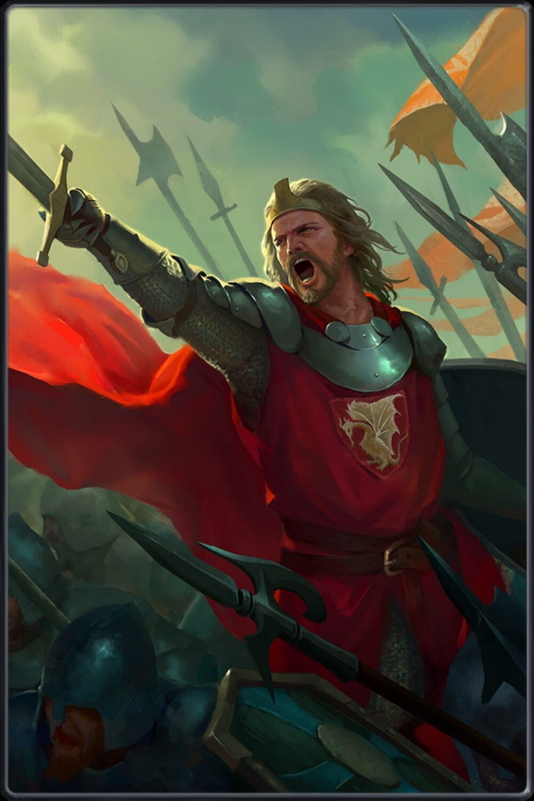
Feelings
Bravery
Angry
Pride
Anxious
Calm
Heartbroken
Tired

Actions
Shouted
Pointed
Grabbed
Ran
Charged
Standing

When describing Arthur, start by introducing the feeling or action in the first sentence, then follow it up with sentences that show this action or feeling. Think what you would do.
Example: Arthur stood heartbroken. Many men lay lifeless on the floor. Falling to his knees, he closed his water-filled eyes and looked up towards the sky. A piercing scream left his mouth.

Example: The army charged towards him. He felt fear run all over his body. A cold shiver shot up his spine. His heart beat loud and fast, so loud he could hear it in his eyes. Wide eyed, he stared at the stampeding horses. He couldn’t move: his legs felt like lead weights.

Activity: Describe the feelings and actions of Arthur. You can write individual sentences or write it as a whole paragraph.

Day 5: I can describe character

Use your ideas from the previous four days and write a character description for King Arthur.

Science – Plants
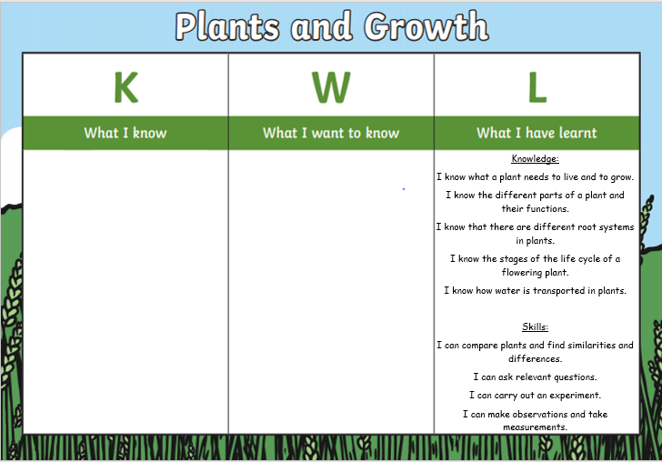
What can you remember from your previous learning about plants? (K) What would you like to find out? (W)

Science – Plants (Vocabulary)
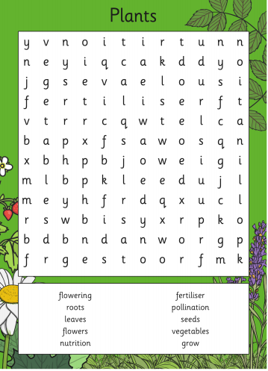
Find these key topic words in the word search below:

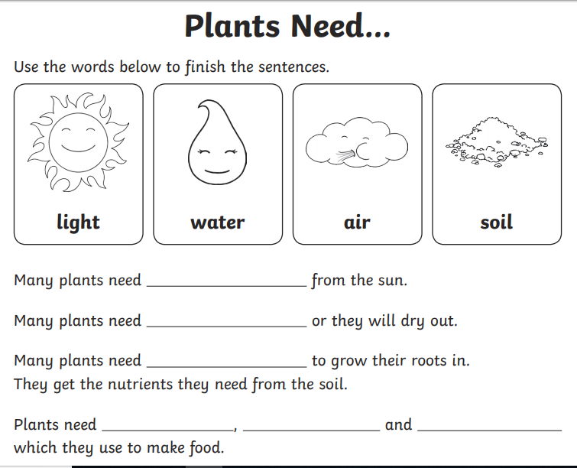
Revisit: What does a plant need to grow?

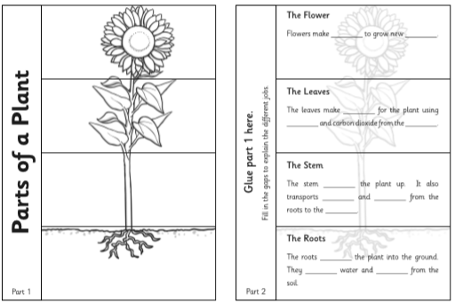
Research what each part of the plant is needed for, then fill in the gaps in the sentences with the correct word.

Traders and Raiders

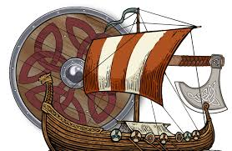

Goodbye Romans
Despite the increase in attacks on Britain from the Picts, Scots and Saxons, by around 410AD the last of the Romans had left Britain to go and defend their home territory as they were under increasing threat from external invaders. This meant Britain was left to its own devices for the first time in about 400 years of protection under Roman rule, the British were quite unprepared for fighting!

The Scots
The Gaelic speaking Scotti who came from Ireland were descendants of the Picts who had earlier invaded Ireland, around 200AD. Historians believe that these Irish Scots invaded and claimed land in Scotland in the 4th and 5th centuries.
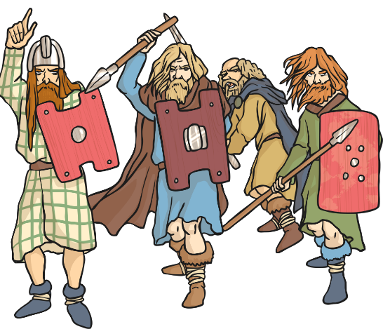

The Scots divided the land in Scotland into 4 separate kingdoms which were named Dal Riata, Pictland, Strathclyde and Bernicia.
The Picts and the Scots were a constant threat to the Britons and it was even harder to fight them off without support from the Romans. They were described as ‘foul’ and with ‘a lust for blood’ by a historian from the time, named Gildas.
They are said to have streamed over Hadrian’s Wall killing everyone in their way.
Vortigern
The British King Vortigern was left in charge after the Roman armies left but he faced great difficulty organising troops to hold back the Picts and Scots who were very powerful and superb fighters. He worried they would take over in Britain.
In a bid to retain control and keep the Picts at bay, it is believed that Vortigern asked two brothers called Hengest and Horsa from Jutland (in modern day Denmark) to come and fight for him and keep the Picts and Scots out.
The Anglo-Saxons
The brothers and their warriors weren’t the only ones who had their sights set on colonising Britain. Other Germanic tribes had also been invading Britain for some time, and without Roman protection they proved to be a formidable force against the Brits.

These invaders are known to us as The Anglo-Saxons because the two biggest invading tribes were the Angles and the Saxons.
Other invaders were the Jutes, Franks and Frisians. They came from the modern places of Germany, Holland and Denmark.

Use the information you have learnt to complete the sentences.

In around 410AD the ____________________ left Britain.
The ______________________ from Northern and Eastern Ireland invaded Scotland in the 4th and 5th centuries. The Scots divided into four ___________________ called Dal Riata, Pictland, Strathclyde and Bernica.
The British King who was called ___________________ asked Saxon Brothers Hengest and Horsa to help him fight against the Scots and the ________________________.
Hengest and Horsa liked it in Britain and decided to stay so they sent for people from home.
We call these people who invaded and settled in Britain the Anglo-Saxons because the two biggest groups were called ____________ and __________________.

Saxons | Picts | Kingdoms | Angles
Scots | Romans | Vortigern

French
Summer 2 Week 1

Match the speech with the correct item of clothing and tick the correct picture.

