The Woodlands Community Primary School |  | Year 5/6 | Topic – History and Geography  Autumn 1 2021 |  | The Vikings are Coming!
Key Vocabulary | Timeline of Key Events |  |  | Key Knowledge and Skills
Archaeologist – An expert who studies objects from the past to learn about the people  Conquer – To take something by forces  Era – a defended period of time, usually linked to a people or ruler  Fertile – capable of producing fruit or offspring  Kingdom – A country whose ruler is a king or queen  Massacre – The killing of many people  Monastery – A building where people worship and devote their time to God  Ritual – a ceremony or series of acts that is always performed in the same way  Scandinavia – The area that is made up of the countries of: Denmark, Norway and Sweden  Settlement – A place where people have come to live  and build homes  Treaty – A written agreement between two states. | AD 700: The Viking age begins. AD 793: First invasion by the Vikings. They raided monasteries on the coast of Northumbria AD 794: First raids on Scotland and Ireland. AD 865: Great Viking army from Denmark invades England  AD 866: Danes capture York (which the Viking called Jorvik) and make it their kingdom (land ruled by a king) AD 876: Vikings from Denmark, Norway and Sweden settle permanently in England. AD 886: King Alfred the Great defeats the Vikings but allows them to settle in Eastern England. AD 954: Eric Bloodaxe, the last king of Jorvik, is thrown out of York  AD 1001: Vikings land in America and establish a settlement. AD 1014: King Canute (Cnut) of Denmark becomes King of England. AD 1066: Battle of Hastings occurred; William I (the Conqueror) crowned King of England. AD 1100: End of the Viking age. |  |  | Knowledge  - I know when and why the Vikings came  - I know the importance of Mercia during the Viking era  - I know key facts about some Gods and Goddesses  - I know some significant figures from the era  Skills  - order key events on a timeline.  - locate and plot significant places and journeys on a map.  - I research and present information on significant figures  - make judgements about the validity of information
Seven Kingdoms of Britain | Significant Gods and Goddesses |  |  | What makes Vikings so significant to British history?
 | 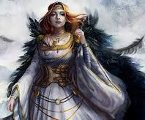  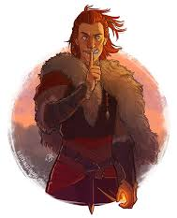  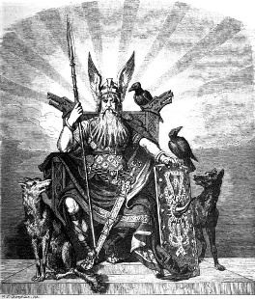  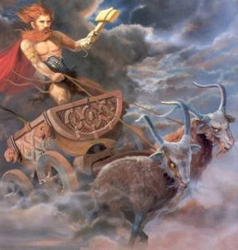  Loki: Son of Laufey, frost giant, lives in Valhalla, trickster god of mischief  Thor: Son of Odin, God of Thunder, protected humans, wielded Mjǫllnir  Freya: Goddess of love, magic, women, beauty and Queen of the Valkyries  Odin, All Father: King of the Gods, can see all time and knows all things |  |  | -They made advances in shipbuilding and navigation.  They used longboats, which moved faster and were more manoeuvrable than other boats.  -Language: a mixture of old Norse and Old English gave us many words that we still use today, e.g. give, window, village and dream.  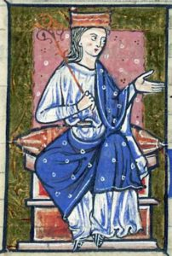  -They settled in villages and were farmers who kept  animals and grew crops.  -They were skilful craft workers who made beautiful  metalwork and wooden carvings.  -Their lasting legacy was the formation of the independent kingdoms of England and Scotland.  -Æthelflæd was married to Æthelred as part of deal to keep the Vikings out of London.

