 | The Woodlands Community Primary School |  |  |  | Year 1/2 | History |  |  | Muck, Mess and Mixtures
 | Key Vocabulary |  |  | Knowledge |  |  |  | Skills
Capital City – Where government is located.  Diary – A book that people write about their lives in.  Past – An earlier time.  Present – Happening now.  Significant Event – An event that caused great change.  Samuel Pepys |  |  | - I know how to identify fact and fiction.  - I know the difference between past and present within my own life and the lives of others.  - I know that pictures, photographs and artefacts can be used as sources of information. |  |  |  | - I can sequence events in chronological order.  - I can use a range of sources to find out about people and events from the past.  - I can compare pictures or photographs of people or events from the past.  - I can describe memories of key events in my life.
 | The Spread | Time Line of events
 | 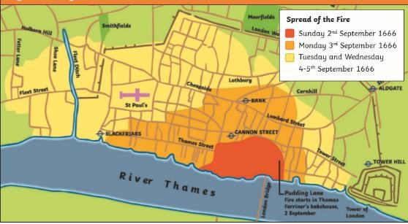 | 