Reading

[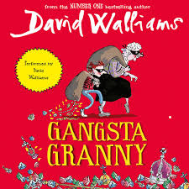](https://www.google.co.uk/imgres?imgurl=https%3A%2F%2Fkbimages1-a.akamaihd.net%2Fc61f91d5-1229-416b-ba9d-41a29ade2d92%2F1200%2F1200%2FFalse%2Fgangsta-granny-1.jpg&imgrefurl=https%3A%2F%2Fwww.kobo.com%2Fgb%2Fen%2Faudiobook%2Fgangsta-granny-1&tbnid=bj8E_n_HQEFURM&vet=12ahUKEwiTo4L82szoAhVN0IUKHdR9AYIQMygBegUIARCkAg..i&docid=93nGf8_S-csGHM&w=1200&h=1200&q=gangsta%20granny&safe=active&ved=2ahUKEwiTo4L82szoAhVN0IUKHdR9AYIQMygBegUIARCkAg) [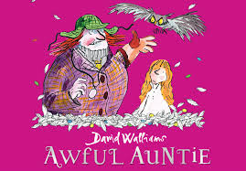](https://www.google.co.uk/imgres?imgurl=https%3A%2F%2Fmedia.timeout.com%2Fimages%2F105314023%2Fimage.jpg&imgrefurl=https%3A%2F%2Fwww.timeout.com%2Flondon%2Ftheatre%2Fawful-auntie&tbnid=ow2uaZkY-fJsjM&vet=12ahUKEwjGybKV28zoAhWP5RoKHbSHClIQMygCegUIARDTAg..i&docid=mSPMBTbfgKHiWM&w=955&h=665&q=awful%20auntie&safe=active&ved=2ahUKEwjGybKV28zoAhWP5RoKHbSHClIQMygCegUIARDTAg) [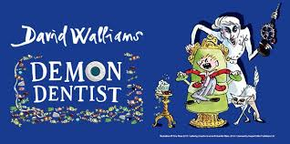](https://www.google.co.uk/imgres?imgurl=https%3A%2F%2Factdrop.uk%2Fshows%2Fimages%2F2020%2Fdemon-dentist-10064-680x339-20200117.jpg&imgrefurl=https%3A%2F%2Factdrop.uk%2Fshows%2Fshow_listing%3Fshow%3DDemon%2520Dentist%26id%3D10064%26theatre%3DChickenshed%2520Theatre&tbnid=M0iltJTjXHhfZM&vet=12ahUKEwi8tNWm28zoAhVjgM4BHci7DYsQMygMegUIARDAAg..i&docid=F5hpCLbH3LQV4M&w=680&h=339&q=demon%20dentist&safe=active&ved=2ahUKEwi8tNWm28zoAhVjgM4BHci7DYsQMygMegUIARDAAg)

Summer 2 Week 1

Anglo Saxon Kings

The kings of Anglo Saxon Britain each ruled their own kingdom and the people in it. They also controlled their own army. Kings constantly fought to control other kingdoms and defend their land. They were known as warrior-kings.

When the Anglo-Saxons first settled in Britain there were seven kingdoms. However, by AD 878 there was only one kingdom left; Wessex, ruled by Alfred the Great. The other kingdoms had been overrun by Vikings who established their own kingdoms. Some of the Anglo-Saxons are well known for the resistance they put up against the Vikings. They fought hard to keep control of their land and tried to push the Vikings out.

[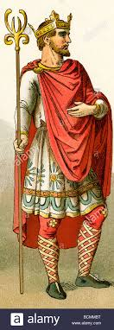](https://www.google.co.uk/imgres?imgurl=https%3A%2F%2Fc8.alamy.com%2Fcomp%2FBCMMBT%2Fanglo-saxon-king-in-ad-996-BCMMBT.jpg&imgrefurl=https%3A%2F%2Fwww.alamy.com%2Fstock-photo%2Fanglo-saxon-king.html&tbnid=QtxkuCtng7KPsM&vet=12ahUKEwiYqvqu-67pAhXTIRoKHZb0D98QMygEegUIARCCAg..i&docid=dgzdA6D7zaPHVM&w=482&h=1390&q=anglo%20saxon%20kings&safe=active&ved=2ahUKEwiYqvqu-67pAhXTIRoKHZb0D98QMygEegUIARCCAg)

**King Alfred the Great**

One of the best known Anglo-Saxon kings is King Alfred the Great. He is the only British monarch to have the title of ‘great’ in his name. So, what made King Alfred so great?

Alfred became king in AD 871 and he is credited with being the first Anglo Saxon king to defeat the Vikings in battle and buy the people of Britain some peace. In AD 878, when the Vikings invaded Wessex and forces King Alfred into hiding, he was not prepared to give up. In the same year, King Alfred and his small band of followers defeated the Vikings at the Battle of Edington. The Battle of Edington was reported as a fierce and bloody event and King Alfred was reported to charge into battle like a wild boar. Alfred and his men drove back at the attacking Vikings, who surrendered. It is said that the Viking leader of this battle, King Guthrum, immediately converted to Christianity and was baptised by King Alfred himself.



King Alfred knew that although he had been able to stop the Vikings from taking over in Wessex, he would never be able to control them in the rest of England. So, in AD886 he made a deal with the Viking King Guthrum and established a treaty which gave the Vikings control over Northern and Eastern England, an area which later became known as Danelaw. The treaty allowed King Alfred to keep control over Wessex and he also got to rule over West Mercia and Kent. This arrangement also helped to establish more peaceful relationships between the English and the Vikings. Alfred the Great remained king until his death in AD 899.

Day 1

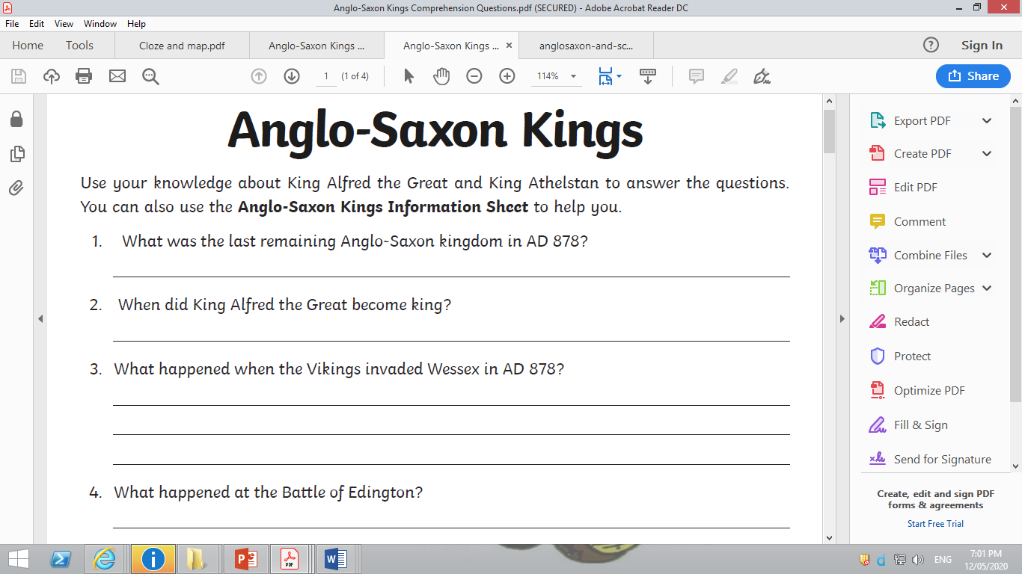

Day 2

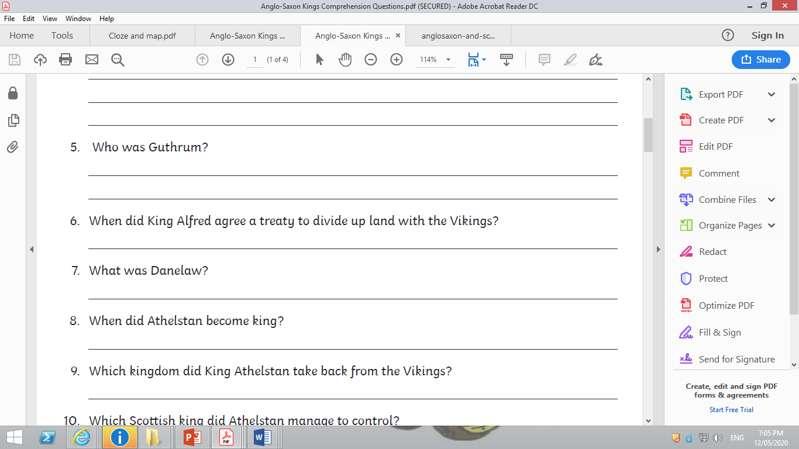

**King Athelstan**

After the death of King Alfred the Great, his son, Edward the Elder, took the throne. When Edward died, his son Athelston (King Alfred’s grandson), became the king.

Athelstan was king from AD 924-939. During his reign, he drove the Vikings back more and more and was able to claim control over a greater area of land. In AD 927, Athelstan won back the kingdom of York from the Vikings. He also established control over King Constantine from Scotland and the other Northern kings. The five kings of Wales also agreed to pay tribute (money) each year to King Athelstan. At the battle of Brunanburh in AD 937, Athelstan fought with his Viking and Welsh allies to stop an invasion by the Scottish king. Athelstan is known for forming good relationships with leaders from other countries. He married his four sisters to important rulers abroad which helped strengthen Britain’s position overseas. He also had strong links with religious leaders and he founded many churches.



Day 3

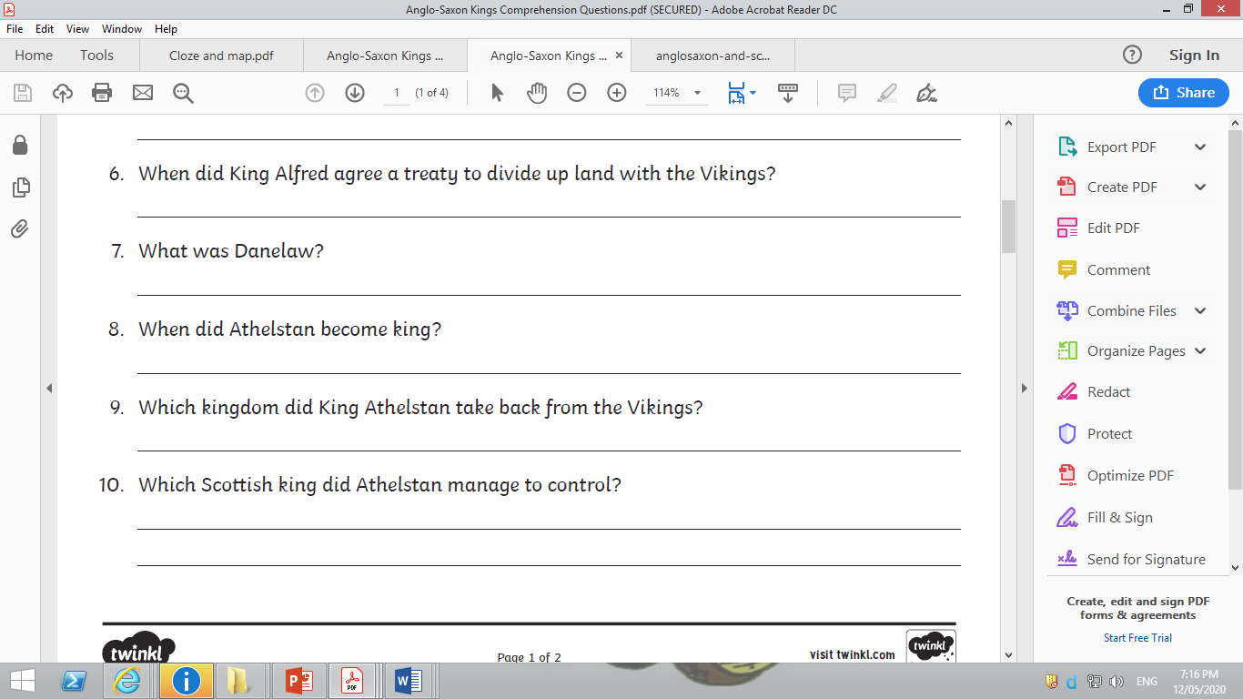

Day 4

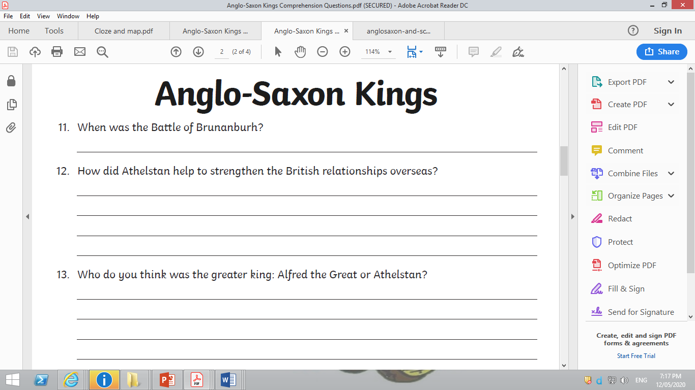

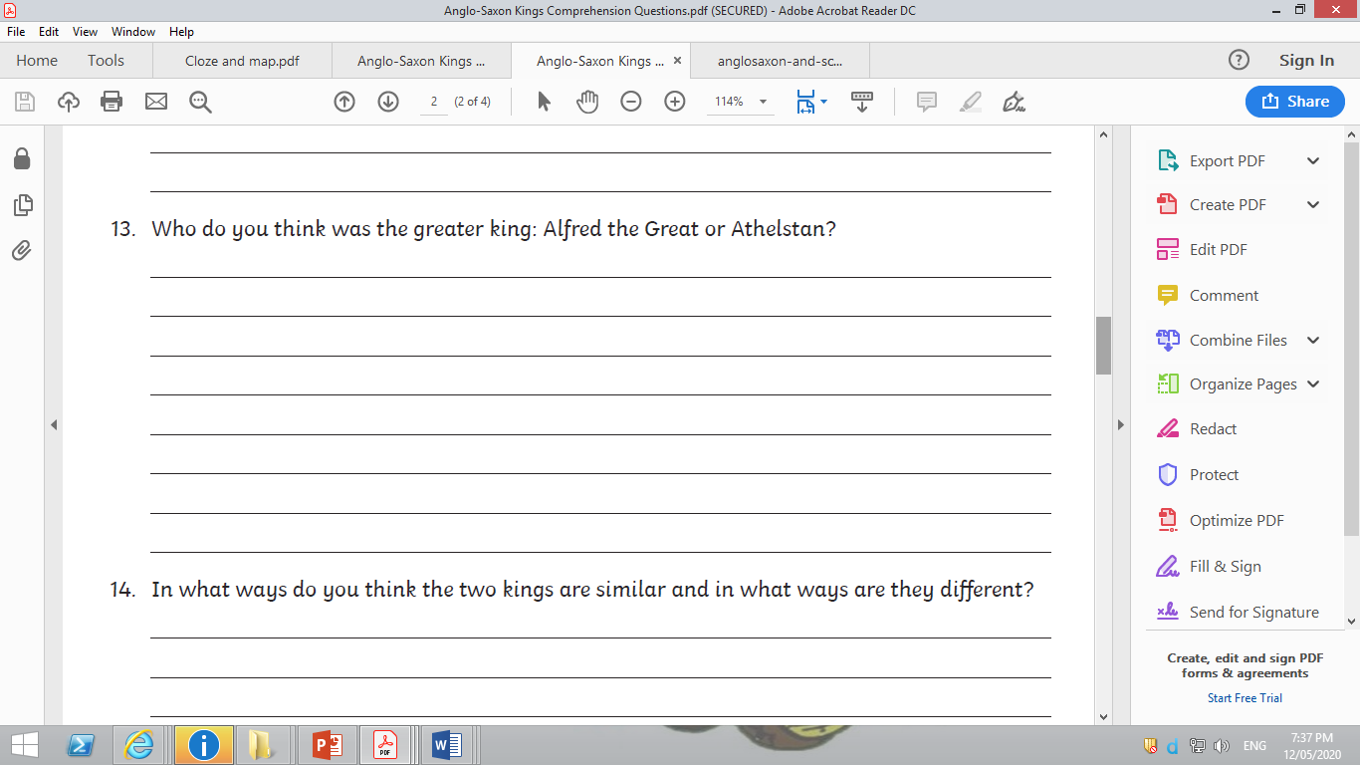

Day 5

In what ways do you think the two kings are similar and in what ways are they different?

|  |  |
| --- | --- |
| Similarities | Differences |
|  |  |
|  |  |
|  |  |
|  |  |
|  |  |
|  |  |
|  |  |