Summer 2 2020
Maths – Week 1
Number (Year 4)
Success Criteria | S-A (tick if achieved)
I can count in multiples of 6, 7
I can count in multiples of 25 and 1000
I can recognise the place value of each digit in a four-digit number (thousands, hundreds, tens, and ones)
I can count backwards through zero to include negative numbers
I can round any number to the nearest 10, 100

Note: Before beginning any learning or activity below, look over your ‘knowledge organiser’ for addition and subtraction for your year group.
It has all the knowledge, methods and learning you have done in class to help you carry out the activities below.
Use your ‘knowledge organisers’ as you carry out the activities. They are there for you to use and help you in the activities.
Your ‘knowledge organiser’ is at the end of this document.

Day 1: I can count in multiples of 6 and 7s
Practise counting up and down in both 6s and 7s. Practise this by reading the 6s and 7s below but also without looking at them.
Practise counting backwards.
Get someone to ask you questions like, ‘What number comes after 12?’ ‘What number comes before 42?’
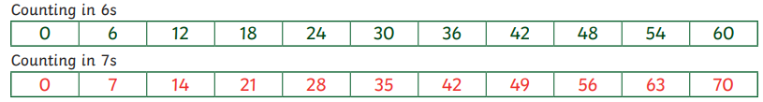

Activity 1: If you have access to ‘Hit the button’, click the link below and practise recall of your multiplication facts for your 6s and 7s
https://www.topmarks.co.uk/maths-games/hit-the-button

Activity 2: Complete the sequences below. They are counting on or counting back in 6s or 7s.
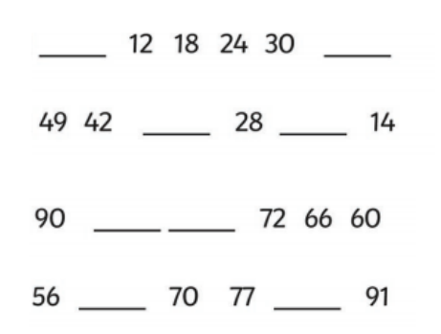

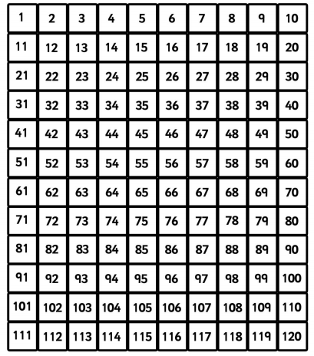
Activity 3: circle all the 7s on the grid below. Begin at 7

Day 2: I can count in multiples of 25 and 1000.

Practise, with the resource below, counting up in 25s and 1000s.
Can you spot a pattern to help you count up in 25s and 1000s? Do any particular digits change or remain the same?
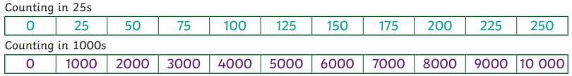

Extra to practise.
- Practise counting backwards.
- Get someone to ask you questions like, ‘What number comes after 150 when counting in 25s?’ ‘What number comes before 6000 if counting in 1000s?’

Activity 1: Follow the instructions and complete the activities below.
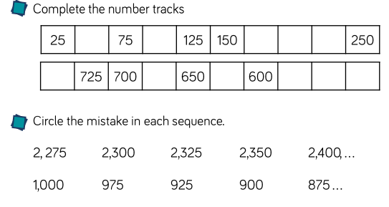

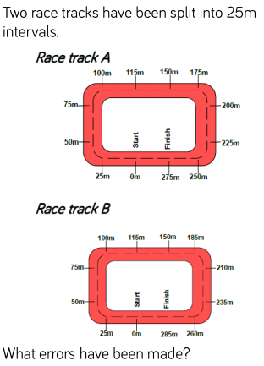
Activity 2:

Day 3: I can recognise the place value of each digit in a four-digit number (thousands, hundreds, tens, and ones)
Here’s a place value chart we have used in class which helps you recognise the value of a digit.
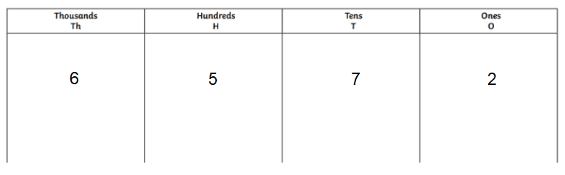
This would help us to recognise the value of a digit and it can also help you read the number.
So above the number is (in words) six thousand, five hundred and seventy-two (6572)

Activity 1:
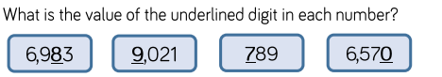

Activity 2:
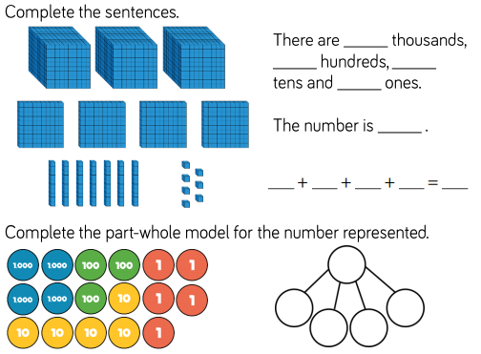

Activity 3: The picture of the number doesn’t match the digits. Find out and explain what’s wrong with each comparison

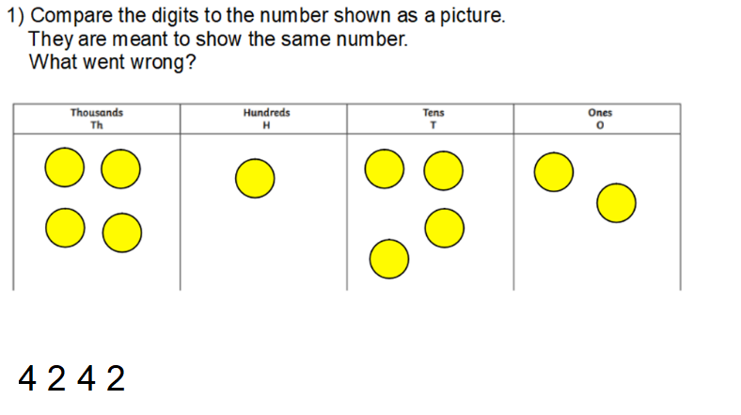

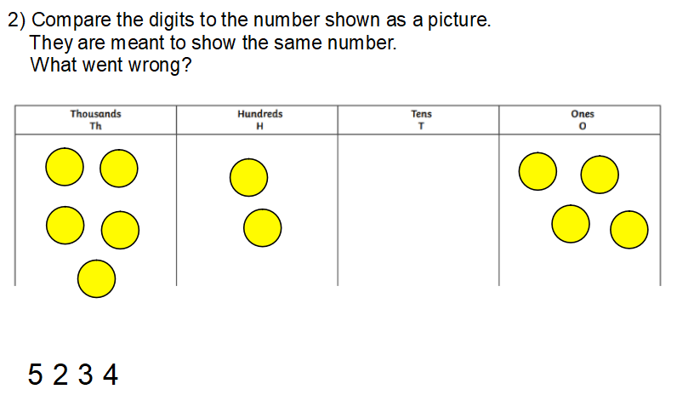
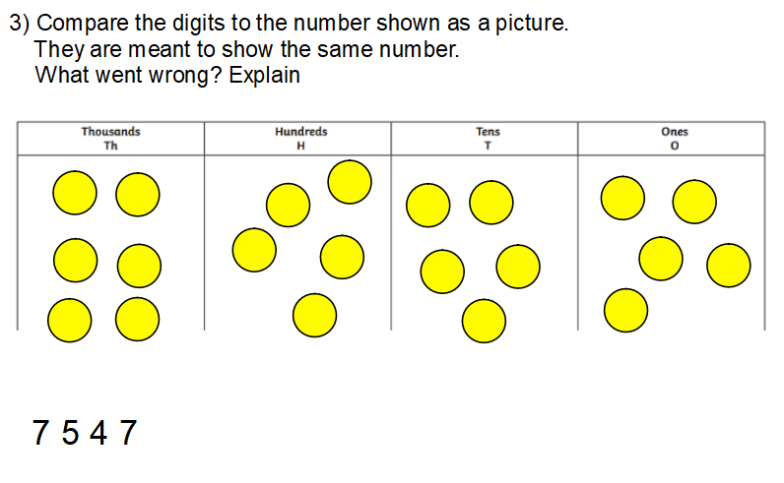

Activity 4:
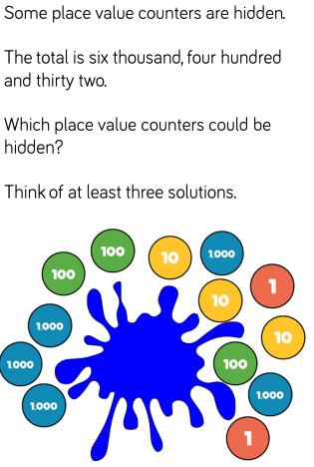
Record your answers in this area.

Day 4: I can count backwards through zero to include negative numbers
What are negative numbers? Negative numbers are whole numbers below zero. We can view them as smaller than 1, like 3 is smaller than 5. Don’t confuse them with decimals. Remember decimals are the same as fractions. They are both PARTs of whole numbers.
Negative numbers can be recognised because they have the minus sign in front of the number -3
We have seen negative numbers in the real world. For example, temperature. We know that the temperature falls below zero we then have reached minus numbers. This is where freezing occurs.

Adding and taking away with positive and negative numbers.
Use the number line to help adding and subtracting positive and negative numbers.
Subtracting moves left on the number line.
Adding moves right on the number, like when you use a number without negative numbers.

Example:
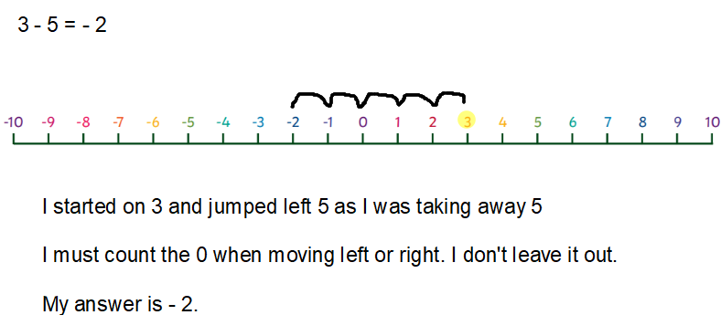

Two more examples below

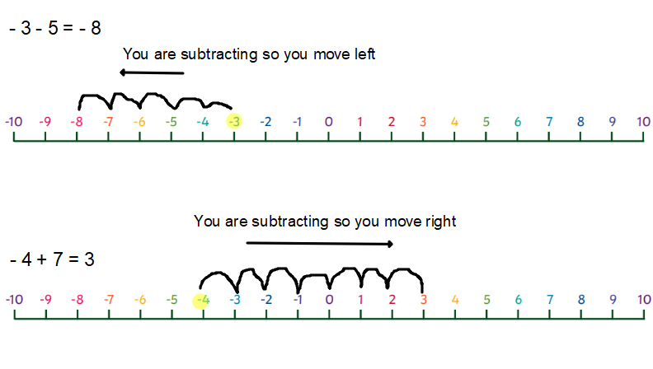

Activity 1
Use the Number line to help you solve the calculations.
Calculate:
- -2 + 4 =
- -7 – 1 =
- 5 – 8 =
- 4 – 4 =
- -1 + 4 =

Activity 2:
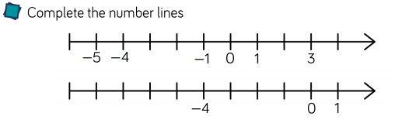

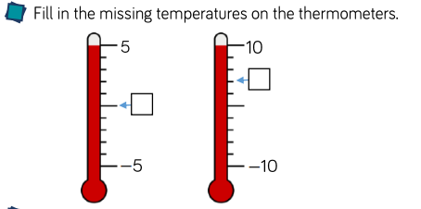

Activity 3:
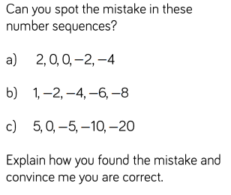

Day 5: I can round any number to the nearest 10, 100
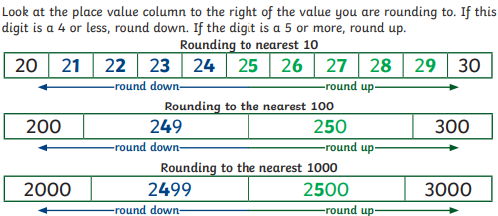

To round to the nearest 10 or 100 you need to first know your multiples of 10s and 100s: counting up in 10s and counting up in 100s
Multiples of 10s:
10, 20, 30, 40, 50, 60, 70, 80, 90, 100, 110, 120, 130 …
Multiples of 100s
100, 200, 300, 400, 500, 600, 700, 800, 900, 1000, 1100, 1200, 1300 …

Next step: Rounding to nearest 10
Example: round 34 to the nearest 10. Think of multiples of ten, 34 is in between.
34 is in between 30 and 40. Let’s see this on a number line.

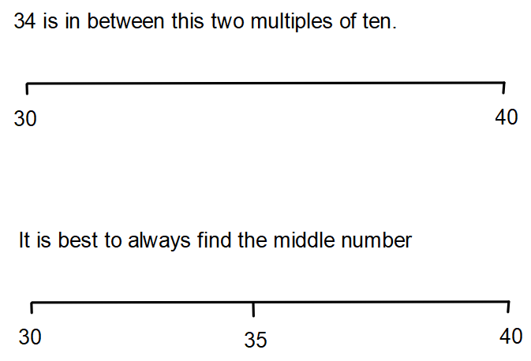

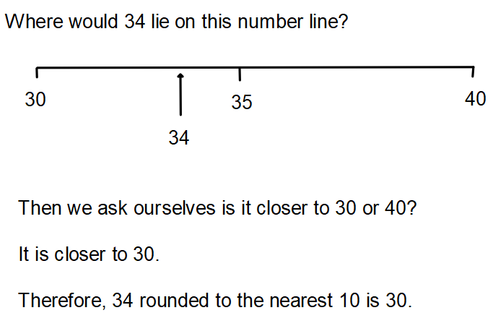

Activity 1: Round the following numbers to nearest 10, using a number line.
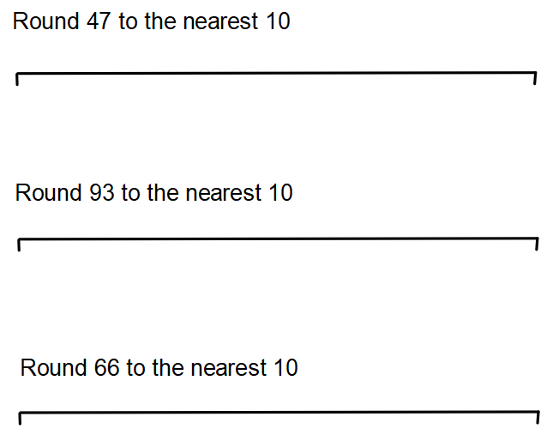

This is the same when rounding to the nearest 100.
Example: round 470 to the nearest 100. Think of the two multiples of 100, 470 is in between.
470 is in between 400 and 500. Let’s see this on a number line on the next page.

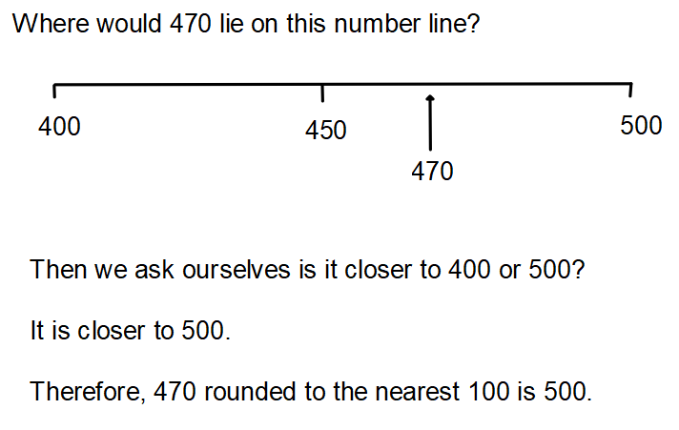

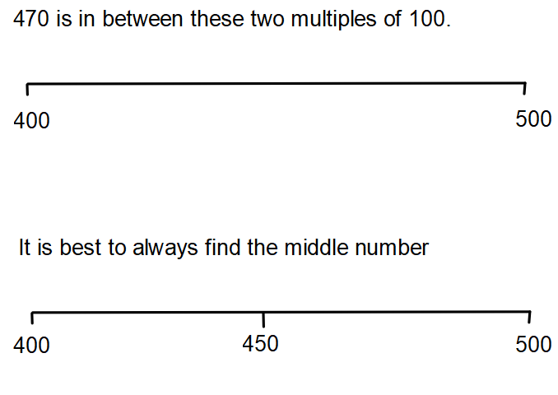

Activity 2: Round the following numbers to nearest 100, using a number line.
(Next Page)

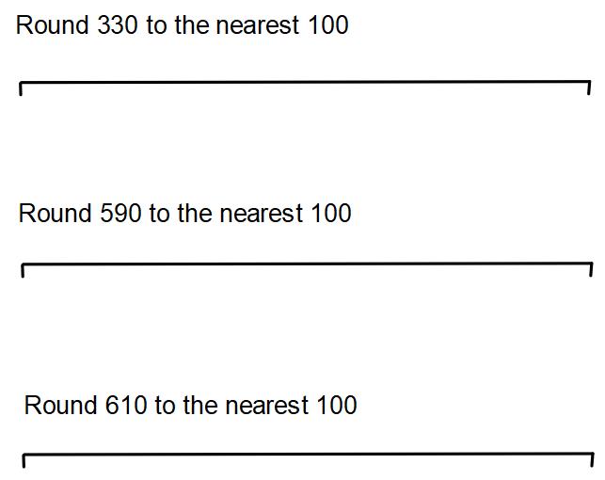

Activity 2:

Activity 3:
