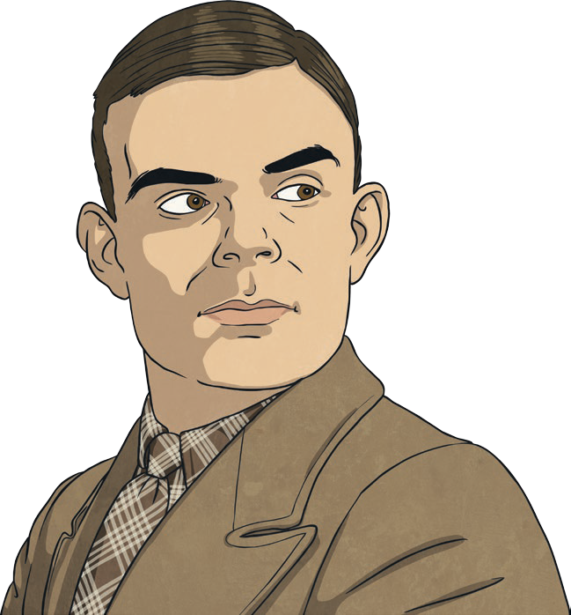
Alan Turing
Alan Turing was an English scientist, mathematician and codebreaker. He is best known for his important role in cracking German codes during the Second World War.

Early Life
Alan was born on 23rd June, 1912 in London. His father, Julius, worked for the Indian Civil Service and his mother, Ethel, was the daughter of the chief engineer of the Madras Railway in southern India. Julius and Ethel spent a lot of time travelling between their homes in Hastings, in England, and India. Because they wanted their children to be raised in Britain, Julius and Ethel decided that Alan and his older brother John would not travel to India with them. Instead, while their parents were in India, the boys would stay with friends of the family in England.

Childhood Genius
From a very early age, it was clear that Alan was very clever. Stories about Alan’s childhood show a boy who enjoyed puzzles and challenges. One story tells that Alan tracked the path of flying bees so that he could find their hive and get honey for his family.
At the age of 13, Alan joined Sherborne School – a boarding school in the county of Dorset. It was while at Sherborne School that Alan’s excellence in mathematics and science became clear. He was able to solve problems and understand ideas far harder than a child of his age usually could. At only 16 years of age, Alan was able to understand the work of Albert Einstein.

Bletchley Park
Alan was 27 years old at the start of the Second World War, and had been working part time at Bletchley Park. He worked there with the Government Code and Cypher School. Bletchley Park was a stately home at which all codebreakers worked during the war.
The German army believed that changing their messages into code would stop their enemies from reading them. The Germans used a clever system which involved replacing one letter
with another lots of times. By writing

Alan Turing

down what changes had been made, German soldiers could still read the original message, even though what they had received did not appear to make any sense.
However, a machine called the Enigma had been invented by Polish codebreakers during the First World War. In 1939, the Polish codebreakers shared their machine with British and French codebreakers so that they could learn the Germans’ secrets and outsmart them in the war. The Enigma machine tried to change the Germans’ codes back into the original message that was sent.
Alan and a team of codebreakers tried to use the Enigma machine to break the German code. Within weeks of starting work at Bletchley Park, Alan had created a new machine called ‘the bombe’. Alan’s machine was far better at cracking codes than the Enigma machine had been. His new machine became one of the most important tools used to read German messages and it played a huge part in ending the Second World War.
For his services during the war, Alan was awarded an OBE (Officer of the Order
of the British Empire) by King George VI in 1946.
Glossary
Albert Einstein: A scientist and philosopher who is credited with making some of the greatest scientific discoveries in recent history.
boarding school: A school at which the students also live, as well as learn.
stately home: A large and impressive house that is or was lived in by a rich family.

Questions
- Which of these is not a member of Alan Turing’s family? Tick one. Ethel
Albert
Julius John
- Number the events below to show the order in which they happened during Alan’s life.
The first one has been done for you.
Alan joined Sherborne School.

1
Alan began to work at Bletchley Park.
Alan was awarded an OBE for his wartime services. Alan could understand the works of Einstein.
Alan was born in London.
- Where did Alan and his brother stay while his parents were in India?

- …had been working part time at Bletchley Park. Explain what you think ‘part time’ means.

- Find and copy a phrase from the text which shows what Alan enjoyed doing as a child.

- Explain why Alan’s teachers thought that he was special.

- How did the Germans turn their messages into code?

- Why do you think Alan created ‘the bombe’ machine so quickly?

Answers
- Which of these is not a member of Alan Turing’s family? Tick one. Ethel
Albert Julius John
- Number the events below to show the order in which they happened during Alan’s life. The
first one has been done for you.
Alan joined Sherborne School.
2
4
5
3
1
Alan began to work at Bletchley Park.
Alan was awarded an OBE for his wartime services. Alan could understand the works of Einstein.
Alan was born in London.
- Where did Alan and his brother stay while his parents were in India?

Alan and his brother stayed with friends of the family.

- …had been working part time at Bletchley Park. Explain what you think ‘part time’ means. Pupils’ own responses, such as: I think that part-time means that you work there but only on a few days of the week.

- Find and copy a phrase from the text which shows what Alan enjoyed doing as a child.

‘a boy who enjoyed puzzles and challenges’

- Explain why Alan’s teachers thought that he was special.

Pupils’ own responses, such as: Alan’s teachers thought that he was special because he was very clever for his age and he could understand ideas far harder than a child of his age usually could.
- How did the Germans turn their messages into code?

Pupils’ own responses, such as: The Germans turned their messages into code by
replacing one letter with another lots of times.

- Why do you think Alan created ‘the bombe’ machine so quickly?

Pupils’ own responses, such as: I think Alan created ‘the bombe’ machine so quickly because he was incredibly clever and it didn’t take him long to figure out how to improve the Enigma machine.

Alan Turing
Alan Turing was an English computer scientist, mathematician and cryptanalyst. He is thought to be one of the inventors of modern computing and he is best known for his important role in cracking German codes during the Second World War.
Early Life
Alan Mathison Turing was born on 23rd June, 1912 in Maida Vale, London. His father, Julius, worked for the Indian Civil Service. His mother, Ethel, was the daughter of the chief engineer of the Madras Railway in southern India. Due to Julius’s job, Julius and Ethel spent a vast amount of time travelling between their homes in Hastings (in England) and India. Wishing for their children to be brought up in Britain, Julius and Ethel made the decision that Alan and his older brother, John, would not travel to India with them. Instead, while they were in India, the boys would stay with friends of the family.

Childhood Genius
From a very early age, Alan began to show signs of his intelligence, and stories about his childhood clearly show a boy who enjoyed puzzles and challenges. One story tells that Alan traced the path of flying bees, in order to work out where their hive was and find honey for his family.
Alan’s intelligence was also recognised by his teachers. At the age of 13, Alan joined Sherborne School: a boarding school in the county of Dorset. Alan was so determined to attend school on his first day at Sherborne that he rode his bicycle for over 60 miles and slept overnight at an inn, all without any help from an adult.
It was while at Sherborne School that Alan’s ability in mathematics and science became clear. Alan was able to solve problems and understand theories far beyond those expected for a child of his age. At only 16 years of age, Alan was able to understand the work of Albert Einstein.

Bletchley Park
Alan was 27 years of age at the start of the Second World War, and had been working part time at Bletchley Park with the

Alan Turing

Government Code and Cypher School, known as the GC&CS. Bletchley Park was a stately home at which all codebreakers worked during the war.
During the war, the Germans believed that encrypting their messages would stop their enemies from reading them. The Germans used a clever system which involved replacing one letter with another several times. By keeping a log of what changes had been made (called a key), German soldiers could still read the original message, even though the final outcome did not appear to make any sense.
However, a machine called the Enigma had been invented by Polish codebreakers during the First World War. In 1939, the Polish codebreakers shared their machine with British and French codebreakers. The Enigma machine tried to change the final outcome back into the original message that was sent. This would help Britain and France to learn the Germans’ secrets and outsmart them in the war.
Working alongside senior codebreaker Dilly Knox, Alan and a team of cryptanalysts tried to use the Enigma machine to break the German code. Within weeks of starting work at Bletchley Park, Alan had created a new machine – ‘the bombe’ – which was far better at cracking codes than the Enigma machine had been. Alan’s new machine became one of the most important tools used to read German messages and it played a huge part in ending the Second World War.
For his services during the war, Alan was awarded an OBE (Officer of the Order
of the British Empire) by King George VI in 1946.
Glossary
Albert Einstein: A scientist and philosopher who is credited with making some of the greatest scientific discoveries in recent history.
boarding school: A school at which the students also live, as well as learn.
cryptanalyst: Somebody who is able to break coded messages without being told the key.
encrypting: Turning something into code.
stately home: A large and impressive house that is or was lived in by a rich family.

Questions
- What was the name of the senior codebreaker that Alan worked alongside at Bletchley Park? Tick one.
Albert Einstein John Sherborne Dilly Knox
Julius Hastings

During the war, the Germans believed that encrypting their messages…
What does encrypting mean? Tick one. destroying something
turning something into code
transmitting a message
outsourcing work to someone
- List three members of Alan Turing’s family.
1.
2.
3.

Alan and a team of cryptanalysts tried to use the Enigma machine…
Give another word which the author could have used instead of cryptanalysts.

- At what age did Alan enrol at Sherborne School?

- According to stories, why did Alan trace the path of flying bees?

- What was unusual about Alan’s first journey to Sherborne School?

- Why do you think Polish codebreakers shared their invention with the British and French?

- Summarise what you have read in the section entitled ‘Childhood Genius’ in 20 words or fewer.

Answers
- What was the name of the senior codebreaker that Alan worked alongside at Bletchley Park? Tick one.
Albert Einstein John Sherborne Dilly Knox
Julius Hastings

During the war, the Germans believed that encrypting their messages…
What does encrypting mean? Tick one. destroying something

turning something into code
transmitting a message
outsourcing work to someone
- List three members of Alan Turing’s family.

Julius, Ethel, John
- Alan and a team of cryptanalysts tried to use the Enigma machine…
Give another word which the author could have used instead of cryptanalysts. codebreakers
- At what age did Alan enrol at Sherborne School?

Alan enrolled at the age of 13.

- According to stories, why did Alan trace the path of flying bees?

Alan traced the path of flying bees so that he could work out where their hive was and find honey for his family.
- What was unusual about Alan’s first journey to Sherborne School?

Alan’s first journey to Sherborne School was unusual because he rode his bicycle for over 60 miles without an adult and slept overnight at an inn to make sure that he got there.

- Why do you think Polish codebreakers shared their invention with the British and French? Pupils’ own responses, such as: I think that Polish codebreakers shared their invention because they wanted to war to end as much as the British and French did and knew that working together would make this happen more quickly.

- Summarise what you have read in the section entitled ‘Childhood Genius’ in 20 words or fewer.

Pupils’ own responses, such as: Alan showed signs of great intelligence from an early age and was quickly able to understand complicated theories.

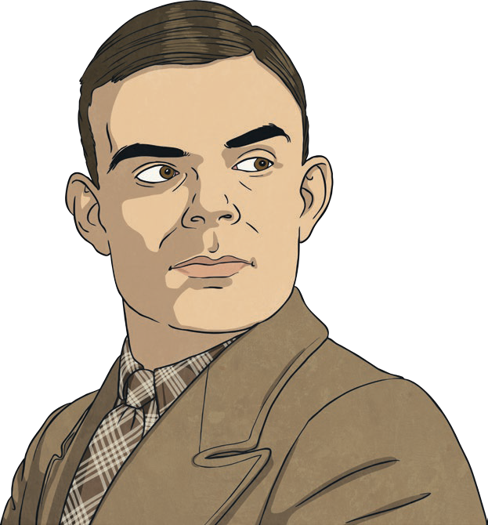
Alan Turing
Alan Turing, an English computer scientist, mathematician and cryptanalyst (codebreaker), is considered to be one of the fathers of modern computing. He is best known for his instrumental role in cracking German codes during the Second World War.
Early Life
Alan Mathison Turing was born on 23rd June, 1912 in Maida Vale, London. At the time of Alan’s birth, his father, Julius, worked as a member of the Indian Civil Service. His mother, Ethel, was the daughter of the chief engineer of the Madras Railway, which operated in southern India.
Due to the location of their work, Julius and Ethel spent a significant amount of time travelling between their homes in Hastings and India. Wishing for their children to be brought up in Britain, Julius and Ethel made the decision that Alan and his older brother, John, would not travel to India with them. Instead, during their absence, the boys would stay with friends of the family – a retired Army couple – with whom they spent a significant amount of their childhood years.

Childhood Genius
From a very early age, Alan began to show signs of his incredible intelligence and, although unverifiable, stories about his childhood clearly show a boy who enjoyed puzzles and challenges. One particular story tells that Alan traced the path of flying bees, worked out where their hive was and retrieved honey for his family.
Alan’s genius was immediately recognised by his teachers. At the age of 13, Alan enrolled at Sherborne School – a boarding school in the county of Dorset. In an unusual turn of events, Alan’s first day at Sherborne School coincided with the 1926 General Strike – a nine-day-
long strike staged by workers across Britain to protest a reduction in their wages. This meant that there was no transport available, but Alan was so determined to attend school that day that he rode his bicycle, unaccompanied by an adult, for over
60 miles and slept overnight at an inn.

Alan Turing

It was while at Sherborne School that Alan’s aptitude and ability for mathematics and science became instantly apparent. Alan was able to solve problems and understand theories far beyond those expected for a child of his age. At the mere age of 16, Alan was able to understand the work of Albert Einstein.

Bletchley Park
Alan was 27 years of age at the outbreak of the Second World War and had been working part time at Bletchley Park with the Government Code and Cypher School, known as the GC&CS. Bletchley Park was a stately home which had been used as a central point for all codebreakers to work at during the Second World War. Due to the increased need for codebreaking, additional huts had been built in the grounds surrounding the mansion and it was in these that Alan predominantly worked.
During the war, the Germans believed that encrypting their messages – turning them into codes – would prevent their enemies from reading them. The Germans used an ingenious system which involved replacing one letter with another several times. By keeping a log of the changes made each time and comparing this to what had come out of the machine, German soldiers could still read the original message, despite the final outcome not appearing to make any sense.
However, a cypher machine called the Enigma had been invented by Polish codebreakers during the First World War and, in 1939, this machine was shared with British and French codebreakers. By running the process in reverse, the Enigma machine tried to change the final outcome back to the original message that was sent. This would help the British and French to learn the Germans’ secrets and outsmart them in the war.
Working alongside senior codebreaker Dilly Knox, Alan and a team of cryptanalysts tried to use the Enigma machine to break the German code. However, within weeks of arriving at Bletchley Park, Alan had created a new machine – ‘the bombe’ – which was far more effective in cracking codes. This machine became one of the primary tools used to intercept coded German messages and played a significant part in ending the Second World War.
For his services during the war, Alan was appointed as an Officer of the Order
of the British Empire (OBE) by King George VI in 1946.

Questions
- Where was Sherborne School situated? Tick one. Maida Vale
Dorset
London
India
- In which two subjects did Alan excel while at school? Tick two. philosophy
science
cryptanalysis mathematics
- Find and copy a phrase from the text which shows that the things that happened on Alan’s
first day at Sherborne School were abnormal.

- Which government department was based at Bletchley Park during the Second World War?

- What do the letters OBE stand for?

- Discuss two things that were unusual about Alan’s childhood.

…is considered to be one of the fathers of modern computing…
Explain what is meant by this phrase and give an alternative phrase that the author could have used.

- Write an alternative subheading for the third section of the text and explain your choice.

- Why do you think the stories of Alan’s childhood are described as ‘unverifiable’?

- Summarise Alan Turing’s contribution to the Second World War in 30 words or fewer.

Answers
  - Where was Sherborne School situated? Tick one. Maida Vale
Dorset
London
India
  - In which two subjects did Alan excel while at school? Tick two. philosophy
science
cryptanalysis
mathematics
  - Find and copy a phrase from the text which shows that the things that happened on Alan’s
first day at Sherborne School were abnormal.

‘In an unusual turn of events’

  - Which government department was based at Bletchley Park during the Second World War?

The Government Code and Cypher School, or GC&CS, was based at Bletchley Park.

  - What do the letters OBE stand for?

OBE stands for Order of the British Empire.

  - Discuss two things that were unusual about Alan’s childhood.

Pupils’ own responses, such as: Two things that were unusual about Alan’s childhood are: that he spent a significant amount of time with friends of the family while his parents worked abroad; extraordinary intelligence allowed him to do things that most children would not be able to do.

  - …is considered to be one of the fathers of modern computing… Explain what is meant by this phrase and give an alternative phrase that the author could have used.

Pupils’ own responses, such as: This phrase means that Alan played a vital role in the development of systems which led the way for modern computing. An alternative phrase the author could have used is ‘is seen as a key figure in the development of modern computing’.

  - Write an alternative subheading for the third section of the text and explain your choice. Pupils’ own responses, such as: An alternative subheading for the third section could be Wartime Codebreakers. I chose this because the third section of the text is about Alan’s contributions to deciphering German code during the Second World War.

  - Why do you think the stories of Alan’s childhood are described as ‘unverifiable’?

The stories about Alan’s childhood are unverifiable because there is no one alive today
who witnessed the events and there is no surviving evidence of them occurring.

  - Summarise Alan Turing’s contribution to the Second World War in 30 words or fewer. Pupils’ own responses, such as: Alan created a cypher machine better than the Enigma which quickly broke the German’s codes and enabled the military to outsmart them in the war.

