

Year 6 Homework

Autumn Term 1 2021

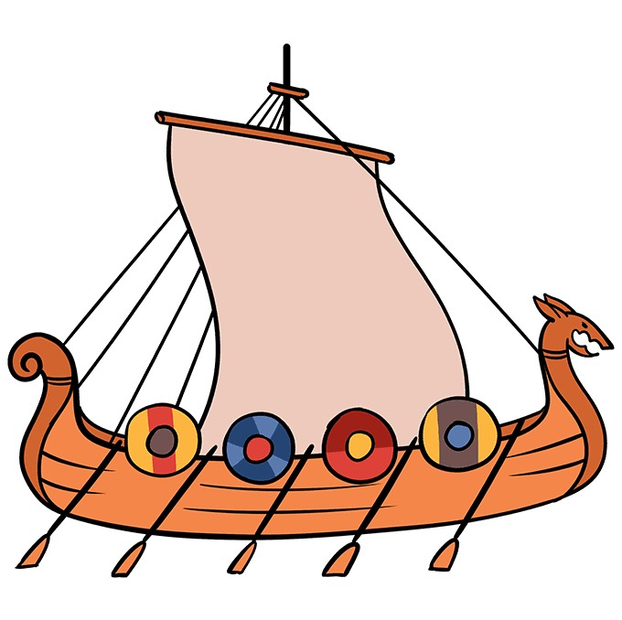***The Vikings are Coming!***

Name ______________________________________________________

**Woodlands Primary School**

**Homework Grid Autumn 1 2021 Yr6**

|  |  |  |  |  |  |
| --- | --- | --- | --- | --- | --- |
|  | **Expected**  **2TP** | | **Exceeding Expected**  **2TP** | | **Greater Depth**  **5TP** |
|  | These need to be carried out every week | | English and maths | | Select 2 projects from the list below to do over the half term |
| Week 1 | Read and record at LEAST 3 times.  Complete the spelling sheet: suffixes  Complete the times tables practice (3x 3÷) |  | English: Spelling rules for common verb endings |  | 1. Draw your family tree (History). 2. Find the meaning of place names with Viking heritage 3. Write an interview with a Viking settler – why did they come here? What do they hope will happen? 4. Research Yggdrasil and its significance and importance to Viking belief 5. Create a travel brochure advertising England to other Viking invaders – why should they come here? |
| Week 2 | Read and record at LEAST 3 times.  Complete the spelling sheet: suffixes  Adjectives  Complete the times tables practice. (4x 4÷) |  | English: irregular past tense verbs  Maths: Statistics – interpret the data for the given word problems. |  |
| Week 3 | Read and record at LEAST 3 times.  Complete the spelling sheet.  Pronouncing nouns and verbs  Complete the times tables practice. (8x 8÷) |  | English: plural rules |  |
| Week 4 | Read and record at LEAST 3 times.  Complete the spelling sheet: homophones.  Complete the times tables practice. (Square numbers) |  | English: homophone word class |  |
| Week 5 | Read and record at LEAST 3 times.  Complete the spelling sheet  Complete the times tables practice. (Cube numbers) |  | Maths: Fractions/percentages – use the bar model to solve problems. |  |
| Week 6 | Read and record at LEAST 3 times.  Complete the spelling sheet  Complete the times tables practice.  (Prime numbers) |  | English: Exception words |  |
| Week 7 | Read and record at LEAST 3 times.  Complete the spelling sheet  Complete the times tables practice. (Common factors) |  | Maths: Measures – using conversions to solve problems. Ordering measures |  |
| Week 8  WB:  21/10/19 | Read and record at LEAST 3 times.  3TP bonus homework- send in a picture of you reading in an unusual place. |  | Maths: Geometry – using knowledge of 3-D shapes and their properties. Solve the given problems. |  |  |

08/09/21

Write this week’s spellings in the context of a sentence.

________________________________________________________________________________________________________________________________________________________________________________________________________________________________________________________________________________________________________________________________________________________________________________________________________________________________________________________________________________________________________________________________________________________________________________________________________________

Remove the suffix to find the root word.

Use each word in the context of a sentence.

**Look, cover, write and check**

|  |  |  |
| --- | --- | --- |
|  | Try 1 | Try 2 |
| |  | | --- | | aggressive  hostile  awkward  obstinate  desperate  frantic  disastrous  calamitous  marvellous  spectacular | |  |  |

Week 1: English revision of spelling rules: Common verb endings

See Education city for verb spelling.

Look at the spellings, what is the common rule?

stop stopped stopping

hop hopped hopping

clap clapped clapping

jog jogged jogging

cry cried crying

try tried trying

smile smiled smiling

open opened opening

talk talked talking

walk walked walking

ask asked asking

climb climbed climbing

Complete the common rules.

For words ending with a vowel then consonant (op/ap) double the _______________________

Write an example of your own.

For words ending with consonant + y (ry) change y to __________________

Write an example of your own.

Week 1: Times Tables (3x 3÷)



Due: 15/09/21 Week 2

Write this week’s spellings in the context of a sentence.

________________________________________________________________________________________________________________________________________________________________________________________________________________________________________________________________________________________________________________________________________________________________________________________________________________________________________________________________________________________________________________________________________________________________________________________________________________

**Look, cover, write and check**

|  |  |  |
| --- | --- | --- |
|  | Try 1 | Try 2 |
| |  | | --- | | advice  advise  device  devise  licence  license  practice  practise  prophecy  prophesy | |  |  |

Week 2: irregular past tense verbs

Find the past tense of these verbs:

|  |  |  |
| --- | --- | --- |
| Present tense | Past tense | Past tense verb in a sentence |
| bring |  |  |
| buy |  |  |
| catch |  |  |
| drink |  |  |
| eat |  |  |
| forgive |  |  |
| lay |  |  |
| leave |  |  |
| say |  |  |
| sleep |  |  |
| speak |  |  |
| think |  |  |

Week 2: Times Tables (4x 4÷)



Week 2: Statistics – Solve the given problems.



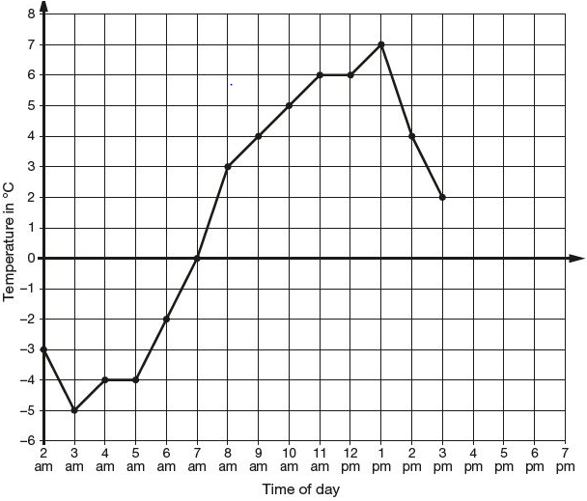

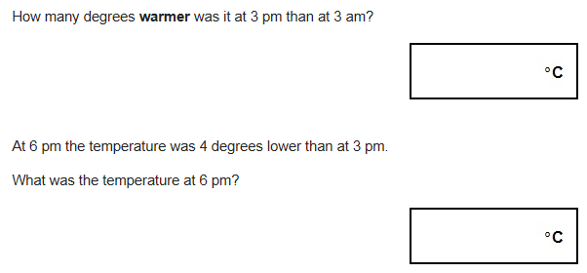

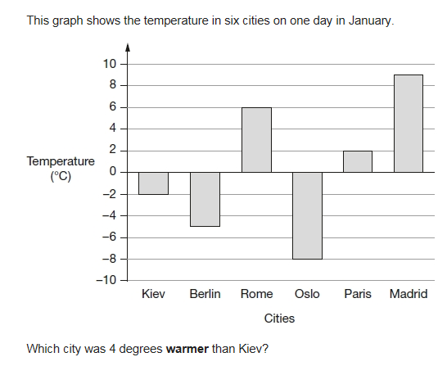

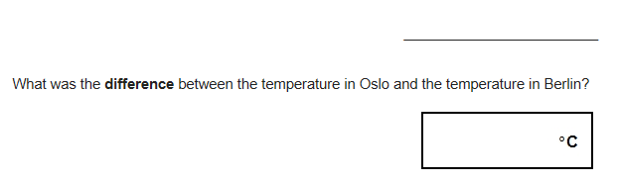

Due: 22.09.21 Week 3

Write this week’s spellings in the context of a sentence.

________________________________________________________________________________________________________________________________________________________________________________________________________________________________________________________________________________________________________________________________________________________________________________________________________________________________________________________________________________________________________________________________________________________________________________________________________________

Use each word in the context of a sentence.

**Look, cover, write and check**

|  |  |  |
| --- | --- | --- |
|  | Try 1 | Try 2 |
| |  | | --- | | observant  observance  expectant  expectancy  hesitant  hesitancy  tolerant  tolerance  relevant  relevance | |  |  |

Week 3: Plural rules

For common plurals, we normally just add the suffix ‘s’.

These are irregular plurals. Use Education city to find further examples.

|  |  |
| --- | --- |
| Single | Plural |
|  | men |
| goose |  |
| louce |  |
|  | children |
| antenna |  |
|  | formulae |
|  | women |

Week 3: Times Tables (8x 8÷)



Due 29/09/21 Week 4

Write this week’s spellings in the context of a sentence.

________________________________________________________________________________________________________________________________________________________________________________________________________________________________________________________________________________________________________________________________________________________________________________________________________________________________________________________________________________________________________________________________________________________________________________________________________________

Use each word in the context of a sentence.

**Look, cover, write and check**

|  |  |  |
| --- | --- | --- |
|  | Try 1 | Try 2 |
| |  | | --- | | innocent  innocence  decent  decency  excellent  excellence  confident  confidence  existent  existence | |  |  |

Week 4: Homophone word class

Homophones are words which have the same sound but different spelling and meaning; they may also change word class.

For each homophone write an example of each word class.

|  |  |  |
| --- | --- | --- |
| Homophone | Noun | Verb |
| duck | We had a picnic at the park and saw a duck. | I had to duck quickly when the Frisbee was thrown at my head. |
| play |  |  |
| drink |  |  |
| key |  |  |
| watch |  |  |
| fish |  |  |
| wish |  |  |
| phone |  |  |

Week 4: Times Tables (Square 2 )

|  |  |  |  |  |  |  |
| --- | --- | --- | --- | --- | --- | --- |
| 1x1 | 2x2 | 3x3 |  | 92 | 82 | 12 |
| 4x4 | 5x5 | 6x6 | 122 | 102 | 32 |
| 7x7 | 8x8 | 9x9 | 42 | 72 | 52 |
| 10x10 | 11x11 | 12x12 | 62 | 72 | 12 |
| 4x4 | 8x8 | 7x7 | 122 | 112 | 82 |
| 6x6 | 5x5 | 9x9 | 92 | 22 | 32 |

Due 06/10/21 Week 5

Write this week’s spellings in the context of a sentence.

________________________________________________________________________________________________________________________________________________________________________________________________________________________________________________________________________________________________________________________________________________________________________________________________________________________________________________________________________________________________________________________________________________________________________________________________________________

Use each word in the context of a sentence.

**Look, cover, write and check**

|  |  |  |
| --- | --- | --- |
|  | Try 1 | Try 2 |
| |  | | --- | | co-operate  co-ordinate  co-own  co-author  re-enter  re-educate  re-examine  re-evaluate  re-energise  re-elect | |  |  |

Week 5: Times Tables (Cube numbers)

|  |  |  |  |  |  |  |
| --- | --- | --- | --- | --- | --- | --- |
| 1x1x1 | 2x2x2 | 3x3x3 |  | 93 | 83 | 13 |
| 4x4x4 | 5x5x5 | 6x6x6 | 123 | 103 | 33 |
| 7x7x7 | 8x8x8 | 9x9x9 | 43 | 73 | 53 |
| 10x10x10 | 11x11x11 | 12x12x12 | 63 | 73 | 13 |
| 4x4x4 | 8x8x8 | 7x7x7 | 123 | 113 | 83 |
| 6x6x6 | 5x5x5 | 9x9x9 | 93 | 23 | 33 |

Week 5: Fractions – Solve the given problems using the bar method.

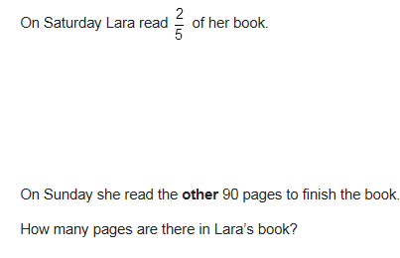

Lara had some money.

She spent £1.25 on a drink.

She spent £1.60 on a sandwich.

She has **three-quarters** of her money left.

How much money did Lara have to **start with**?

Three-quarters of a number is **48**

What is the number?

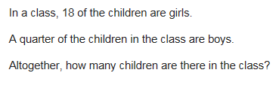

Due 13/10/21 Week 6

Write this week’s spellings in the context of a sentence.

________________________________________________________________________________________________________________________________________________________________________________________________________________________________________________________________________________________________________________________________________________________________________________________________________________________________________________________________________________________________________________________________________________________________________________________________________________

Use each word in the context of a sentence.

**Look, cover, write and check**

|  |  |  |
| --- | --- | --- |
|  | Try 1 | Try 2 |
| |  | | --- | | man-eating  little-used  rock-bottom  wide-eyed  pig-headed  tight-fisted  cold-hearted  stone-faced  green-eyed  short-tempered | |  |  |

Week 6: Exception words

These words are commonly miss-spelt. Practice them in the context of a sentence.

|  |  |
| --- | --- |
| want |  |
| which |  |
| what |  |
| friend |  |
| climb |  |
| sugar |  |
| parents |  |
| again |  |
| where |  |
| were |  |
| we’re |  |
| they’re |  |
| their |  |

Week 6: Times Tables (Prime numbers and prime factors)

|  |  |  |  |  |  |
| --- | --- | --- | --- | --- | --- |
| Circle the prime numbers. | |  | Find the prime factors of: | | |
| 1, 2, 3, 4 | 25, 26, 27, 28 | 36 | 12 | 56 |
| 5, 6, 7, 8 | 29, 30, 31, 32 |
| 9, 10, 11, 12 | 33, 34, 35, 36 |
| 13, 14, 15, 16 | 37, 38, 39, 40 | 42 | 84 | 99 |
| 17, 18, 19, 20 | 41, 42, 43, 44 |
| 21, 22, 23, 24 | 45, 46, 47, 48, 49 |

Due 20/10/21 Week 7

Write this week’s spellings in the context of a sentence.

________________________________________________________________________________________________________________________________________________________________________________________________________________________________________________________________________________________________________________________________________________________________________________________________________________________________________________________________________________________________________________________________________________________________________________________________________________

Write 10 of your own spelling from words you did not get correct on previous weeks

**Look, cover, write and check**

|  |  |  |
| --- | --- | --- |
|  | Try 1 | Try 2 |
|  |  |  |
|  |  |  |
|  |  |  |
|  |  |  |
|  |  |  |
|  |  |  |
|  |  |  |
|  |  |  |
|  |  |  |
|  |  |  |

Week 7: Measures: Solve the problems involving conversions

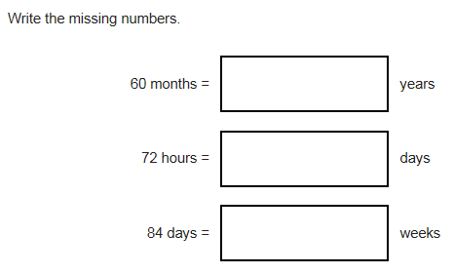

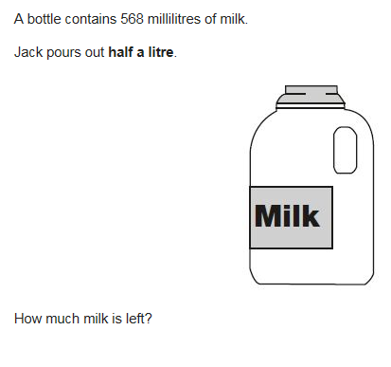

Megan wants to fill a bucket with water.

A bucket holds 6 litres.

A jug holds 500 millilitres.

How many jugs of water does Megan need to fill an empty bucket?

Freddie is half as tall as his mother.

Freddie is one metre shorter than his father.

Freddie’s father is 180 centimetres tall.

How many centimetres tall is Freddie’s mother?

Week 7: Times Tables (Factors and common factors)

|  |  |  |
| --- | --- | --- |
| Find the factors of: |  | Find common factors of |
| 36 | 12 & 36 |
| 12 | 36 & 99 |
| 56 | 36 & 84 |
| 84 | 12 & 56 |
| 99 | 42 & 84 |
| 42 | 42 & 56 |