The Woodlands Community Primary School |  | Year 1/2 | Topic – Science |  | Animals including humans
Key Vocabulary | Key Knowledge and Skills
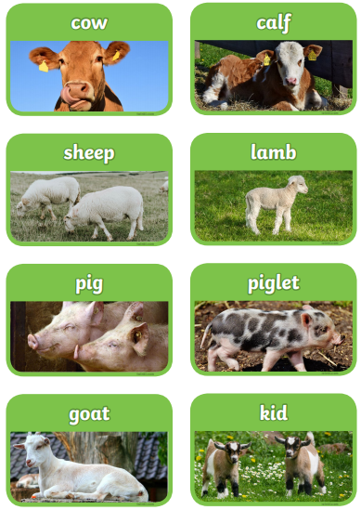 | 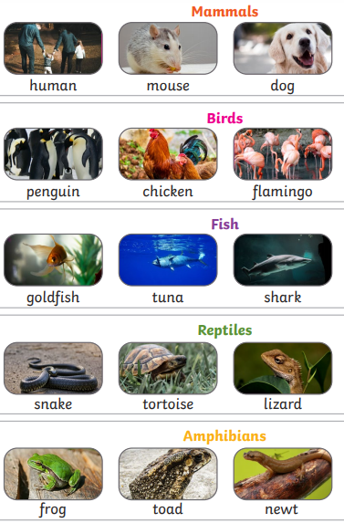 |  |  | Knowledge  - I can identify and name a variety of common animals.  - I can name a variety of common animals that are carnivores, herbivores and omnivores.  - I can describe and compare the structure of a variety of common animals.  - I can notice that animals, including humans, have offspring which grow into adults.  - I can describe the basic needs of animals, including humans, for survival.  - I can identify that most living things live in habitats to which they are suited.  Skills  - I can ask simple questions and recognise that they can be answered in different ways.  - I can identify and classify.  - I can use my observations and ideas to suggest answers to questions.
 | Key knowledge
 | 