Woodlands Remote Learning – Aspen – Week 5
Absence Stage 1- First 3 days of absence
This remote learning is to be undertaken from DAY 1 of absence. The class teacher will check your progress each day.
If you cannot access this learning please contact your class teacher by contacting school – 01827 429020
Fun online learning activities and games linked to your learning can also be found on the school website
Class: Aspen | Week: 5 | Date: 30/11/20
Reading | Please read 15 minutes each day
Spelling | Year 6  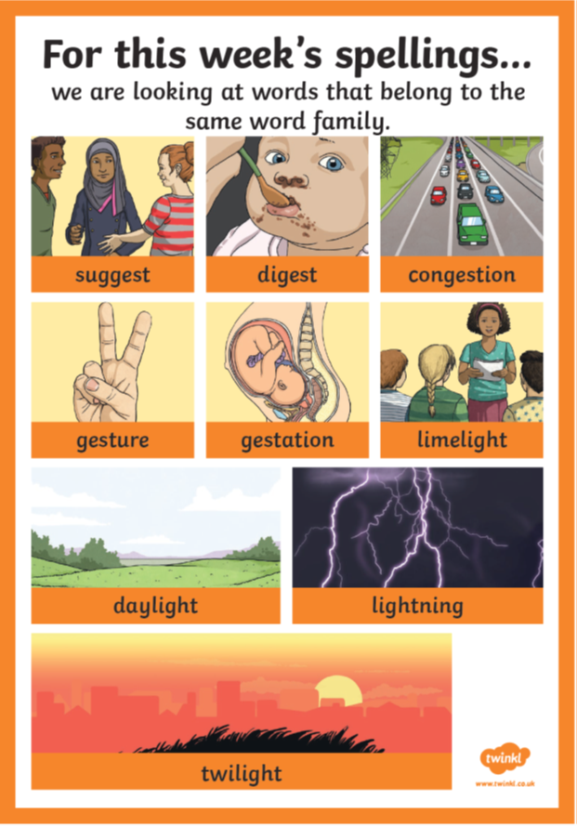
Tables | Please practice your tables and the related division facts  x6, x7, x9, x12 squares and cubes  Don’t forget to log into your TTRockstars account!
English | We are learning about: Narrative  Please complete the following activity on Education City  Reading for purpose – On the Home Front  Reading assessment – Stig’s visit to the dentist  Subject and verb agreement – Stig on Tour
Maths | We are learning about: Place Value  Please complete the following activity on Education City  Place Value of numbers up to 1, 000, 000 – Arcade Champion  Place Value of numbers up to 10, 000, 000 – High Score Hero  Assessment – Number System in Context
Science | We are learning about: Forces  Please watch the following video on the Oak Academy Website.  On Google type in Oak National Academy, click onto the first website. Select lessons, then subjects, select key stage 2 and select Science. Scroll down and select forces and complete lesson 1.  https://classroom.thenational.academy/lessons/what-are-forces-6dh3ec  Have a look at this extra information  https://www.bbc.co.uk/bitesize/topics/zvpp34j/articles/zywcrdm

If, after 3 days, you are still absent from school then we will contact you to determine if any further work is needed or if you are returning to school. If further work is needed the class teacher will send home more learning activities linked to the learning in class. School will continue to contact you.

