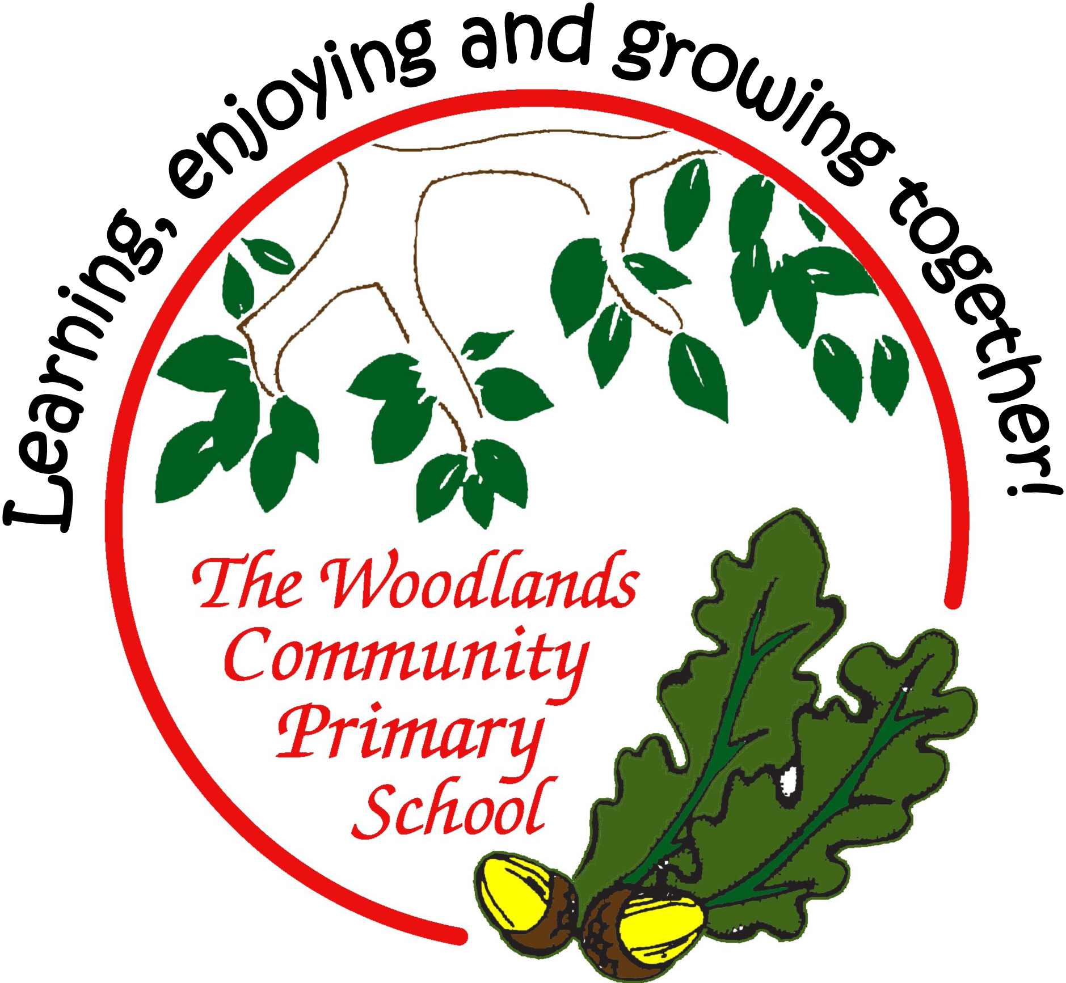

Age-related expectations

Year Three

In the tables below, you’ll find a list of end of year expectations for reading, writing and maths.

The expectations are based very closely on The national curriculum in England

Key stages 1 and 2 framework document (Department for Education, 2013). This sets out what teachers need to teach and what children are expected to learn, both for the core subjects (English, Maths and Science) and the foundation subjects. Here, we look at just English and Maths.

Sometimes, the DfE sets out expectations for each year group; sometimes for a phase (such as Years 3 and 4 or Years 5 and 6). At Woodlands Primary, we have set out all expectations for year groups – this has meant sometimes simplifying an expectation for the younger class, or sometimes referring to greater detail or amount expected for the older class in the phase. Where we think it helps, we have used our own headings to group the expectations.

Before the introduction of this curriculum, schools assessed pupils according to levels, where a typical Year 2 pupil would be expected to attain Level 2 and a Year 6 pupil to reach Level 4. Higher levels would indicate greater success. Now, there is greater importance placed on deeper learning rather than this rapid progression. This means that a pupil should not necessarily be ‘pushed’ to acquire knowledge and skills in a higher year group; instead, learning how to use and apply the learning in lots of contexts and challenges is more important.

Based on this principle, please use the expectations set out here to support your child’s learning by broadening his / her experiences and providing lots of opportunities to apply their skills and knowledge in different situations.

For example:
in reading, find and understand clues and consider the writer’s choice of language in a wider range of texts (such as magazines and comics, non-fiction books, or try out a new genre of fiction which your child doesn’t normally opt for);
in writing, try to use new vocabulary as much as possible (eg have a word of the week) and develop more formal ways to talk during your child’s Talk Time homework;
in maths, practise measuring in contexts such as cooking, shopping, DIY…

(We have, nevertheless, included examples of how you might support your child if (s)he has securely reached age-related expectations – these ideas are listed in small grey text.)

Most importantly, always remember to keep learning fun as much as possible. Some things – learning spellings and times tables, mainly – might require some effort and hard work, but the rest of your child’s learning at home can be fun, engaging and practical.

Age-related expectations: Year Three

READING

Reading words

- Can fluently read a set text appropriate for their age.

- Apply phonic knowledge and skills to read unfamiliar words.

- Apply knowledge of root words, prefixes and suffixes to read aloud and to understand meaning of unfamiliar words.

- Read further exception words, noting the unusual correspondences between spelling and sound, and where these occur in the word.
- Attempt pronunciation of unfamiliar words drawing on prior knowledge of similar looking words.

Use the features of non-fiction texts to locate information. Use text marking to identify key information.

Read longer texts, using independent strategies to ensure full understanding.

Finding facts

- Understand what they read in books (and other texts) independently, checking that the text is meaningful.
- Retrieve and record information from non-fiction.

- Explain the meaning of words in context.

- Use dictionaries to check the meaning of unfamiliar words.

- Know which words are essential to retain meaning in order to begin to summarise.

Use clues from action, dialogue and description to establish meaning.

Finding and understanding clues

- Draw inferences such as inferring characters' feelings, thoughts and motives from their actions, beginning to justify these inferences with evidence eg how characters relate to each other.

- Predict what might happen from details stated and implied.

- Explain and discuss understanding of books, poems and other material, both those read aloud and independently.

- Ask questions to improve understanding of a text.

Infer reasons for actions and events based on evidence from the text. Make plausible predictions and justify them by referring to the text. Deduce from the evidence in the text what characters are like.

Use the features of non-fiction texts to locate information.

Organisation

- Begin to recognise some of the literary conventions in text types covered.
- Know that non-fiction books / other texts are structured in different ways and be able to use them effectively.

- Identify how structure and presentation contribute to the meaning of texts.

- Begin to understand that narrative books are structured in different ways eg quest stories and stories with

dilemmas.

Understand how paragraphs are used to organise and build up ideas.

Writer’s choice of language

- Discuss and record words and phrases that writers use to engage and impact on the reader eg what choice of verb has been used?

- Begin to realise that literary conventions in text types can influence a writer’s choice / style.

- Make links between spellings, punctuation and grammar that has been taught.

Evaluate how effectively specific text types have been written.
Show awareness of writers’ use of figurative language and how it is used to create effects. For example – simile and metaphor.

Readers’ opinions

- Discuss books, poems and other works that are read aloud and independently, taking turns and listening to others’ opinions.

- Begin to express opinions about how narrative books can be structured eg quest stories and stories with dilemmas.
- Develop pleasure in reading, motivation to read, vocabulary and understanding.
- Choose books (and other texts) for specific purposes.

- Discuss responses to text.

Context

- Begin to recognise themes / ideas in text types covered.

- Experience and discuss a range of fiction, poetry, plays, non-fiction and reference books or textbooks.
- Know a wider range of stories, including fairy stories and legends.

- Begin to recognise some different forms of poetry – list poems, shape poems, free verse etc.

Relate events and characters’ feelings to their own reading and personal experiences. Investigate what is known about an historical setting and events and how they affect a text.

Oral retelling and performance

- Orally re-tell some known stories.
- Prepare poems and scripts to read aloud and to perform, showing understanding through intonation, tone, volume and action.
- Read aloud with intonation, tone, volume to show awareness of characters’ speech and punctuation.

Pause appropriately in response to punctuation and / or meanin
Age-related expectations: Year Three
MATHS

Number and place value

- count from 0 in multiples of 4, 8, 50 and 100
- find 10 or 100 more or less than a given number
- recognise the place value of each digit in a three-digit number (hundreds, tens, ones)

- compare and order numbers up to 1000
- identify, represent and estimate numbers using different representations
- read and write numbers up to 1000 in numerals
- read and write numbers up to 1000 in words

- solve number problems and practical problems involving these ideas
Recognise the value of each digit in a 4-digit number and the value of a tenth Being to have an understanding about negative numbers recognising they are smaller than zero

Addition and subtraction

- add and subtract numbers mentally, including a three-digit number and ones; a three-digit number and tens; a three-digit number and hundreds
- add numbers with up to three digits, using formal written methods of columnar addition
- subtract numbers with up to three digits, using formal written methods of columnar subtraction
- estimate the answer to a calculation

- use inverse operations to check answers
- solve problems, inc missing number problems, using number facts, place value, and more complex addition and subtraction
Add and subtract numbers with any number of digits using formal written methods

Multiplication and division

- recall and use multiplication and division facts for the 3, 4 and 8 multiplication tables
- write and calculate mathematical statements for multiplication and division using the multiplication tables that they know
- multiply two-digit numbers by one-digit numbers, using mental and progressing to formal written methods

- divide two-digit numbers by one-digit numbers, using mental and progressing to formal written methods
- solve problems, including missing number problems, involving multiplication and division, including positive integer scaling
problems and correspondence problems in which n objects are connected to m objects
Know all multiplication facts up to 10 x 10 Be able to instantaneously answer questions eg how many 7s in 42? x and ÷ any 2-digit by 1-digit number, with underst anding of remainder

Fractions

- as a vulgar and decimal fraction: count up and down in tenths; recognise that a tenth arises from dividing an object into 10 equal parts and in dividing one-digit numbers or quantities by 10

- begin to recognise and understand decimals in relation to measures (money, length…) and simple uni t fractions

- recognise, find and write fractions of a discrete set of objects: unit fractions and non-unit fractions with small denominators
- recognise, find and write fractions as numbers: unit fractions and non-unit fractions with small denominators
- recognise and show, using diagrams, equivalent fractions with small denominators
- add and subtract fractions with the same denominator within one whole eg ⁵₇ + ¹₇ = ₇⁶

- know pairs of fractions that total 1
- compare and order unit fractions
- compare and order fractions with the same denominators

- solve problems that involve all of the above
Can find fractional values (from ½ to 1/10) of amou nts up to 1000

Measurement

- measure, compare, add and subtract: lengths (m/cm/mm); mass (kg/g); volume/capacity (l/ml)

- measure the perimeter of simple 2-D shapes
- add and subtract amounts of money to give change, using both £ and p in practical contexts
- tell and write the time from an analogue clock with increasing accuracy to the nearest minute
- tell and write the time from a clock using Roman numerals from I to XII

- tell and write the time from a clock with 12-hour and 24-hour clocks
- estimate, record and compare time with increasing accuracy to the nearest minute; record and compare time in terms of seconds, minutes and hours
- use vocabulary such as o’clock, am/pm, morning, afternoon, noon and midnight

- know the number of days in each month
- know the number of seconds in a minute and the number of days in each year and leap year
- compare durations of events [eg to calculate the time taken by particular events or tasks]
Use knowledge of number to solve problems related to money, time and measures Measure, compare, + and - more complex problems using common metric measures (different units) Can relate knowledge of time to problems related to timetables

Geometry: properties of shapes

- draw 2-D shapes and make 3-D shapes using modelling materials; recognise 3-D shapes in different orientations and describe them

- recognise angles as a property of shape or a description of a turn
- identify right angles, recognise that two right angles make a half-turn, three make three quarters of a turn and four a complete turn

- identify whether angles are greater than or less than a right angle
- identify horizontal and vertical lines and pairs of perpendicular and parallel lines
Know that the total internal angles of a triangle measure 180°

Statistics

- present data using bar charts, pictograms and tables
- interpret and present data using bar charts, pictograms and tables
- solve 1-step and 2-step questions (eg How many more/fewer?) using data presented in scaled bar charts, pictograms, tables

