The Woodlands Community Primary School |  | Year 1/2 | Topic – Outdoor PE |  |  | Ball Skills
Key Vocabulary | Key Knowledge and Skills
Ball  Racket – Equipment used to hit a ball  Bats – Equipment used to hit a ball  Strike – Hit  Stationary – Not moving  Retrieving – To locate and bring back | Knowledge  I know how to explore and use skills, actions and ideas individually and in combination  I know how to watch, copy and describe what others are doing  I Know how to hold a racket  I know how to recognise and describe what my body feels like during different types of activity  I know how to use information to improve my work |  |  |  | Skills  I can master basic movements including running, jumping, throwing and catching, as well as developing balance, agility and co-ordination, and begin to apply these in a range of activities.  I can throw an object underarm.  I can hold a racket.  I can strike a stationary ball.
Hand –Eye Coordination | Strike |  |  | Racket
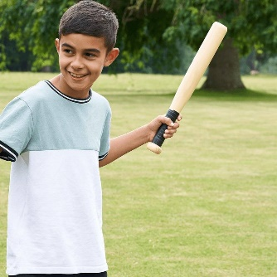  Striking using a rounder’s bat |  |  |  | 