The Woodlands Community Primary School |  | Year 5/6 | Science  Autumn 1 2021 |  | Classifying Living things
Key Vocabulary | Classification chart |  |  | Key Knowledge and Skills
 | 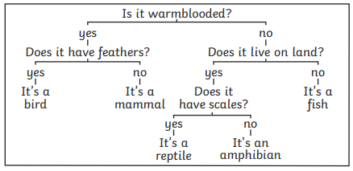 |  |  | Knowledge  - I know what a classification system is.  - I know the vocabulary used to classify animals and group vertebrates.  - I know what a micro-organism is.  Skills  - I can explain how and why I have classified certain objects in certain ways.  - I can group plants in different ways.  - I can use observable characteristics to group and classify vertebrates.  - I can create a classification system for some of the living things
 | Micro-organisms |  |  | Grouping Living Things
 | 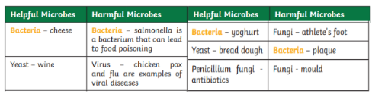  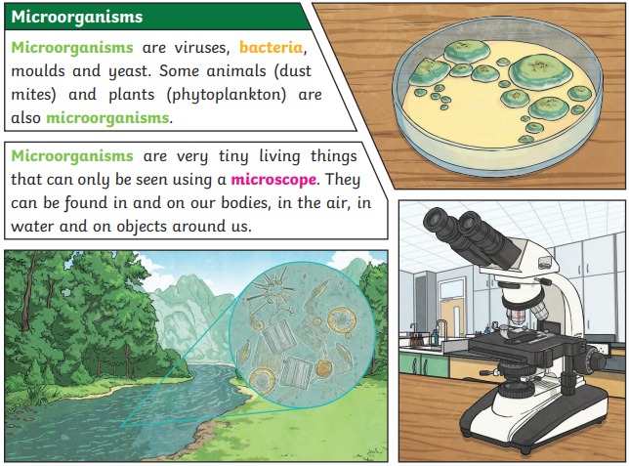 |  |  | 