Home Learning Booklet
Autumn 1
Year 6
This booklet belongs to

Woodlands Primary School
Homework Grid Autumn 1
 | Expected | Exceeding Expected |  |  |  | Greater Depth
 | These need to be carried out every week | Maths |  | English |  | Select 2 projects from the list below to do over the half term
Wk 1 | Reading at LEAST 3 times  Complete Spelling Sheet  Rule: Endings which sound like /shus/ spelt –cious or –tious –  Complete times table sheets | Place Value |  | 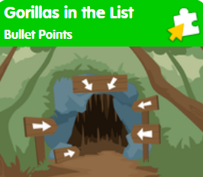
Wk 2 | Reading at LEAST 3 times  Complete Spelling Sheet  Rule: Words ending in –ant-  Complete times table sheets | 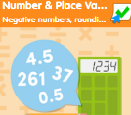 |  | Inverted Commas |  | - Map out the locations, with information of the iguana, chameleon, stick insect and any other small insects/reptiles.  - Write an interview with a David Attenborough – why did they come here? What do they hope will happen?  - Research Darwin’s theory of evolution  - Create a mini beast information leaflet , poster, or display on insects and flowers  - Create a board game, computer game, or card game involving mini beasts, life cycles, the places they live and explore
Wk 3 | Reading at LEAST 3 times  Complete Spelling Sheet  Rule: ance/–ancy if there is a related word with a clear /a/ or /ai/ sound in the right position – ation endings are often a clue.  Complete times table sheets | 2D Shapes |  | 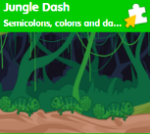
Wk 4 | Reading at LEAST 3 times  Complete Spelling Sheet  Rule: words ending in –ent.  Complete times table sheets |  |  | Alternative words for said
Wk 5 | Reading at LEAST 3 times  Complete Spelling Sheet  Rule: ency after soft c (/s/ sound), soft g (/j/ sound) and qu, or if there is a related word with a clear /e/ sound in the right position.  Complete times table sheets | Statistics
Wk 6 | Reading at LEAST 3 times  Complete Spelling Sheet  Rule: Words ending in –ence.  Complete times table sheets | 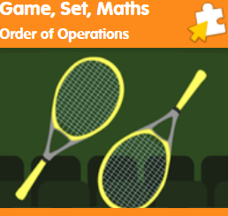 |  | Fronted adverbials
Wk 7 | Reading at LEAST 3 times  Complete Spelling Sheet  Rule: Words with the /ee/ sound spelt ei after c, (i before e, except after c).  Complete times table sheets | Mental addition and subtraction |  | 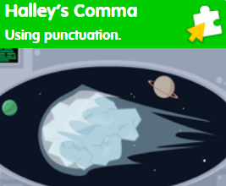
 | Homework will be given out every Friday. Homework will be collected every Wednesday.

Expected: Due 14/09/22 Week 1 Spelling practise: Look, say, cover, write, check
Look | Say | Cover | Write | Check | Write | Check | Write | Check
example |  |  | exampel |  | example |  | example
aggressive
hostile
awkward
obstinate
desperate
frantic
disastrous
calamitous
marvellous
spectacular
Now apply six of those words in a sentence.
1. ____________________________________________________________________________________________________________________________________________________
2. ___________________________________________________________________________________________________________________________________________________
3. ___________________________________________________________________________________________________________________________________________________
4. ___________________________________________________________________________________________________________________________________________________
5. ___________________________________________________________________________________________________________________________________________________
6. ___________________________________________________________________________________________________________________________________________________

Expected - Week 1
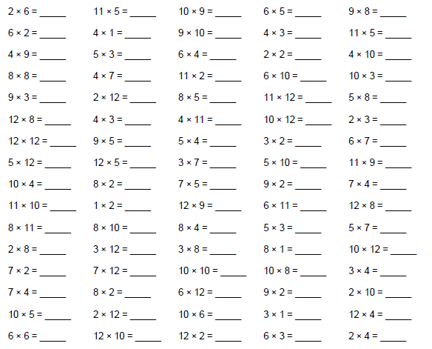
Exceeding expected- Week 1
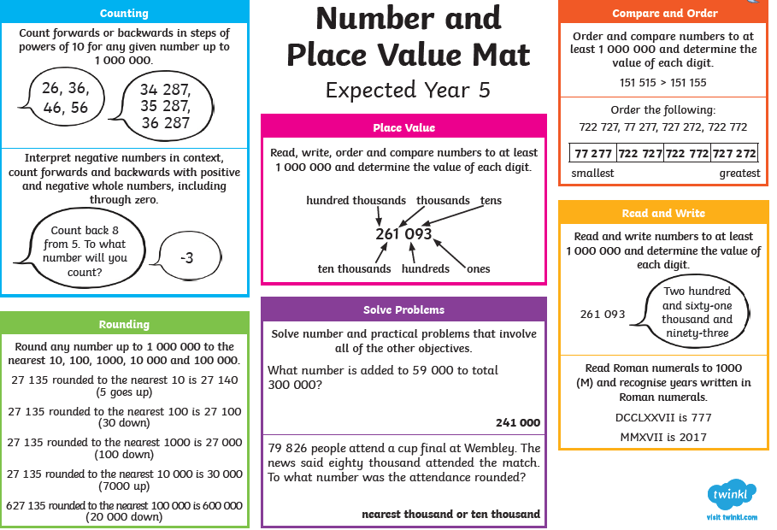
Expected – Due 21/09/22 Week 2 Spelling practise: Look, say, cover, write, check
Look | Say | Cover | Write | Check | Write | Check | Write | Check
example |  |  | exampel |  | example |  | example
advice
advise
device
devise
licence
license
practice
practise
prophecy
prophesy
Now write the words in a sentence.
1. ____________________________________________________________________________________________________________________________________________________
2. ___________________________________________________________________________________________________________________________________________________
3. ___________________________________________________________________________________________________________________________________________________
4. ___________________________________________________________________________________________________________________________________________________
5. ___________________________________________________________________________________________________________________________________________________
6. ___________________________________________________________________________________________________________________________________________________
7. ___________________________________________________________________________________________________________________________________________________
8. ___________________________________________________________________________________________________________________________________________________
Expected - Week 2
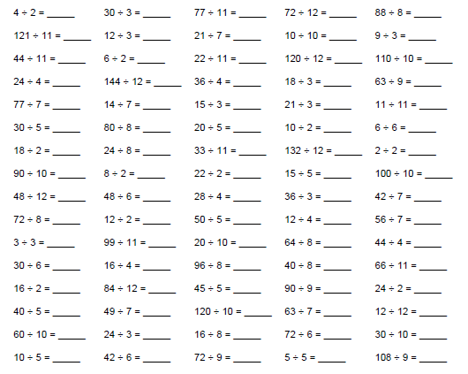
Exceeding expected- Week 2

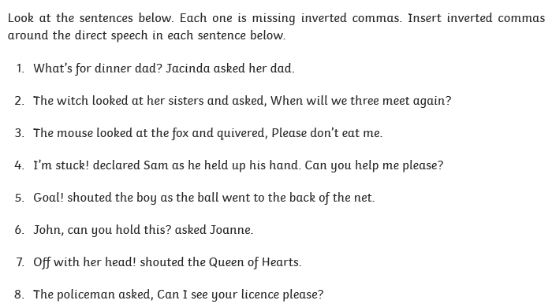

Expected – Due 28/09/22 Week 3 Spelling practise: Look, say, cover, write, check
Look | Say | Cover | Write | Check | Write | Check | Write | Check
example |  |  | exampel |  | example |  | example
observant
observance
expectant
expectancy
hesitant
hesitancy
tolerant
tolerance
relevant
relevance
Now write the words in a sentence.
1. ____________________________________________________________________________________________________________________________________________________
2. ___________________________________________________________________________________________________________________________________________________
3. ___________________________________________________________________________________________________________________________________________________
4. ___________________________________________________________________________________________________________________________________________________
5. ___________________________________________________________________________________________________________________________________________________
6. ___________________________________________________________________________________________________________________________________________________
Expected - Week 3

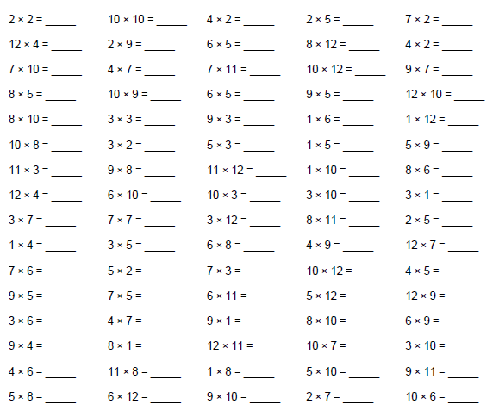
Exceeding expected – week 3
Name the 2D shapes for an extra challenge write as many properties as possible.

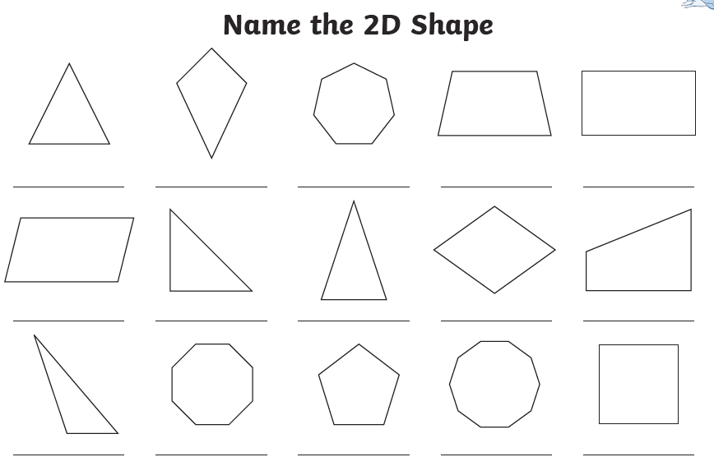

Expected – Due 5/10/22 Week 4 Spelling practise: Look, say, cover, write, check

Look | Say | Cover | Write | Check | Write | Check | Write | Check
example |  |  | exampel |  | example |  | example
innocent
innocence
decent
decency
excellent
excellence
confident
confidence
existent
existence
Now write the words in a sentence.
1. ____________________________________________________________________________________________________________________________________________________
2. ___________________________________________________________________________________________________________________________________________________
3. ___________________________________________________________________________________________________________________________________________________
4. ___________________________________________________________________________________________________________________________________________________
5. ___________________________________________________________________________________________________________________________________________________
6. ___________________________________________________________________________________________________________________________________________________
Expected - Week 4
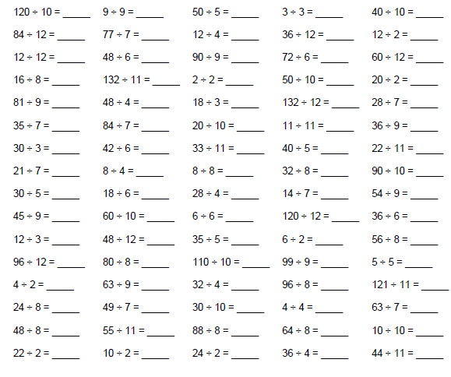
Exceeding expected – week 4

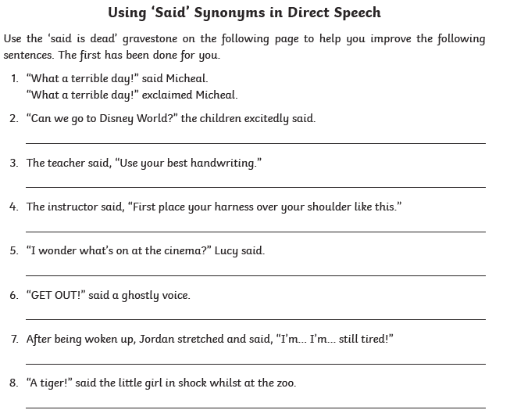
Expected – Due 12/10/22 Week 5 Spelling practise: Look, say, cover, write, check
Look | Say | Cover | Write | Check | Write | Check | Write | Check
example |  |  | exampel |  | example |  | example
co-operate
co-ordinate
co-own
co-author
re-enter
re-educate
re-examine
re-evaluate
re-energise
re-elect
Now write the words in a sentence.
1. ____________________________________________________________________________________________________________________________________________________
2. ___________________________________________________________________________________________________________________________________________________
3. ___________________________________________________________________________________________________________________________________________________
4. ___________________________________________________________________________________________________________________________________________________
5. ___________________________________________________________________________________________________________________________________________________

Expected - Week 5
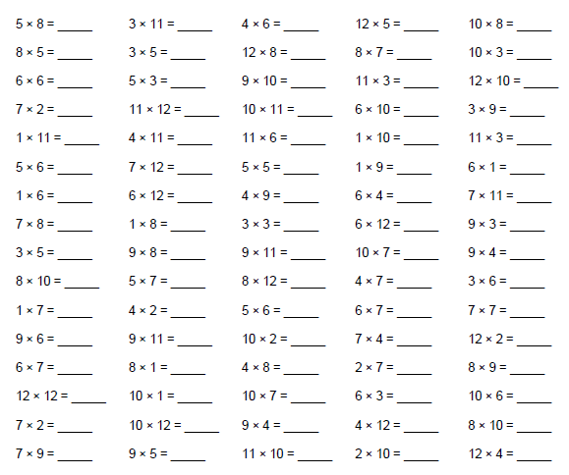

Exceeding expected – week 5
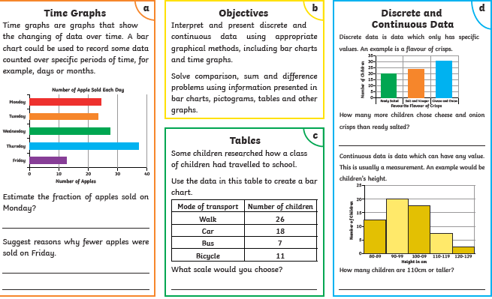

Expected – Due 19/10/22 Week 6 Spelling practise: Look, say, cover, write, check
Look | Say | Cover | Write | Check | Write | Check | Write | Check
example |  |  | exampel |  | example |  | example
man-eating
little-used
rock-bottom
wide-eyed
pig-headed
tight-fisted
cold-hearted
stone-faced
green-eyed
short-tempered
Now write the words in a sentence.
1. ____________________________________________________________________________________________________________________________________________________
2. ___________________________________________________________________________________________________________________________________________________
3. ___________________________________________________________________________________________________________________________________________________
Expected - Week 6
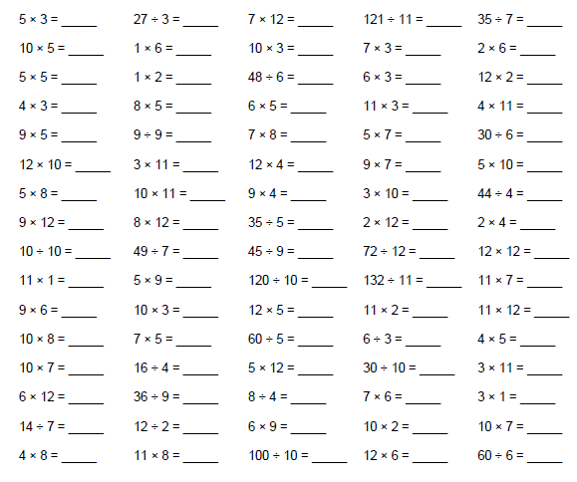

Exceeding expected – week 6

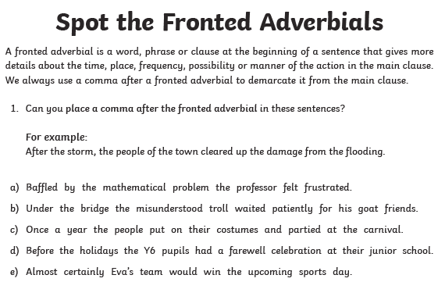

Expected – Due 23/10/22 Week 7 GAP Week: Look, say, cover, write, check
Look | Say | Cover | Write | Check | Write | Check | Write | Check
example |  |  | exampel |  | example |  | example
Now write the words in a sentence.
1. ____________________________________________________________________________________________________________________________________________________
2. ___________________________________________________________________________________________________________________________________________________
3. ___________________________________________________________________________________________________________________________________________________
4. ___________________________________________________________________________________________________________________________________________________
5. ___________________________________________________________________________________________________________________________________________________
6. ___________________________________________________________________________________________________________________________________________________
Expected - Week 7
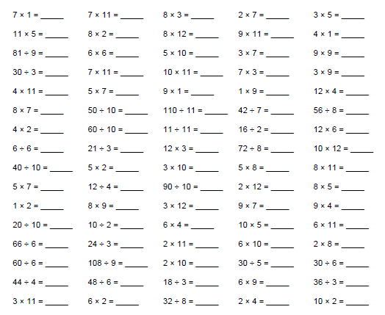
Exceeding expected – week 7

