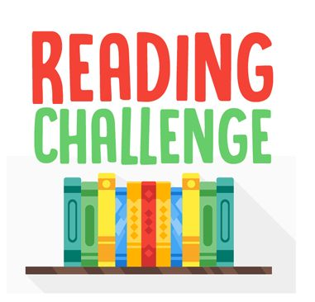
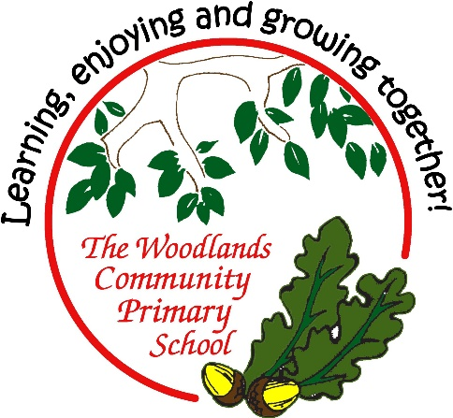
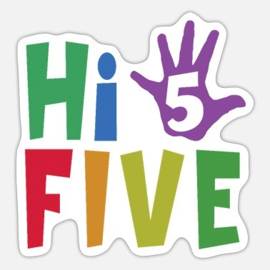
Our reading challenge competition for the next two weeks is to choose a book and complete any 5 tasks from the grid below. You can pick any 5 activities but try and get BINGO with all 5. If you are ready for a real challenge why not complete all 9?
There are exciting prizes up for grabs so... Happy reading!
Send your challenges back into school when complete. Ready, Set, Read!
Draw your favourite character from the book. | Re-write the story in your own way. | Design a new front cover for your book.
Video yourself reading the book out loud for your class | Write a book  review. | Write a different ending
Video an advert to sell the book | Video acting a scene from the book | Design a poster to advertise the book
Remember – any 5- any pattern.
Cross them off as you complete them
 | 5 |  |  | 5 |  |  | 5 |  |  | 5

