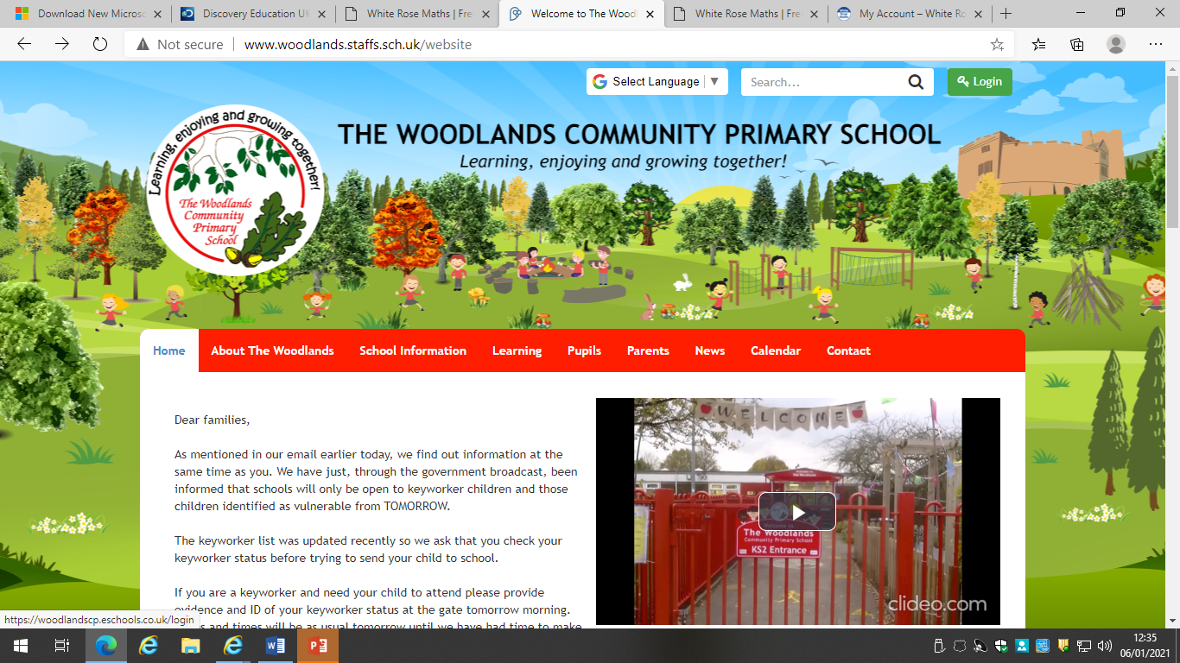

**QUICK GUIDE FOR PUPILS AND PARENTS USING E-SCHOOLS FOR REMOTE LEARNING.**

Please access E-Schools by visiting the school website and logging in in the top right hand corner.

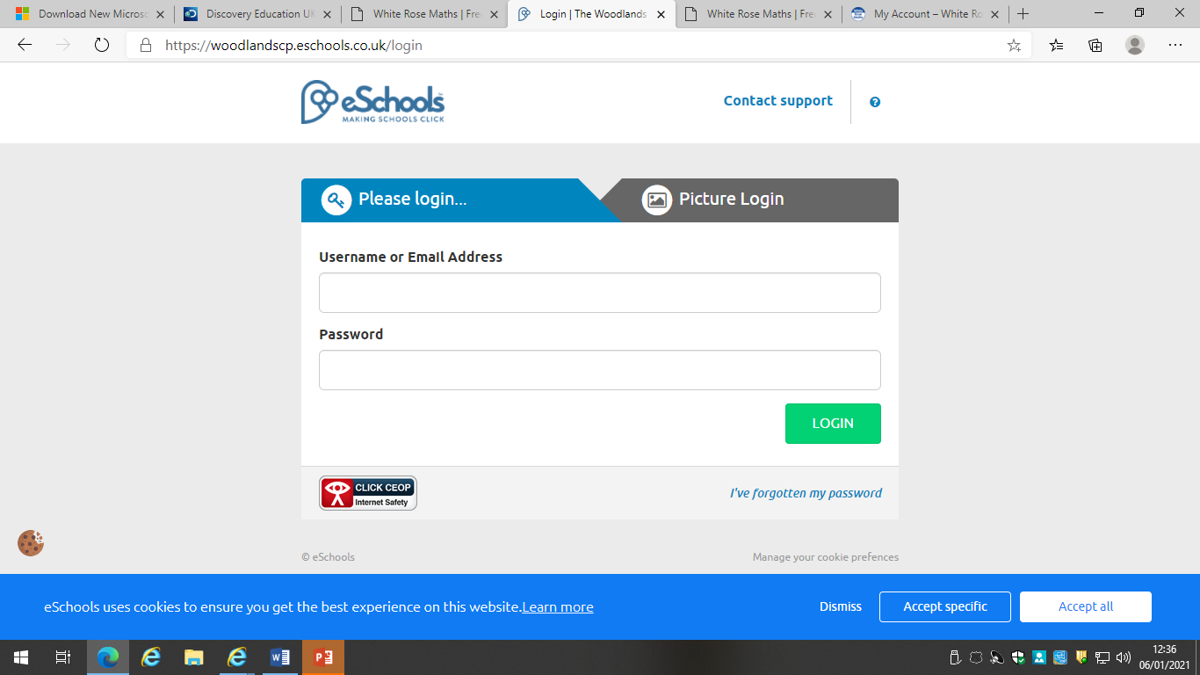

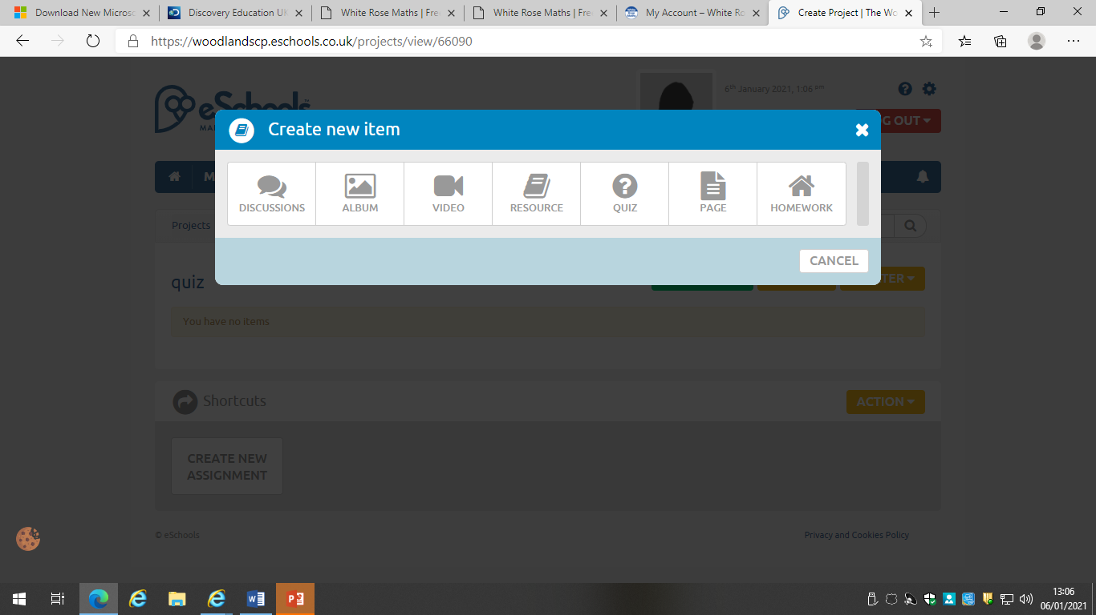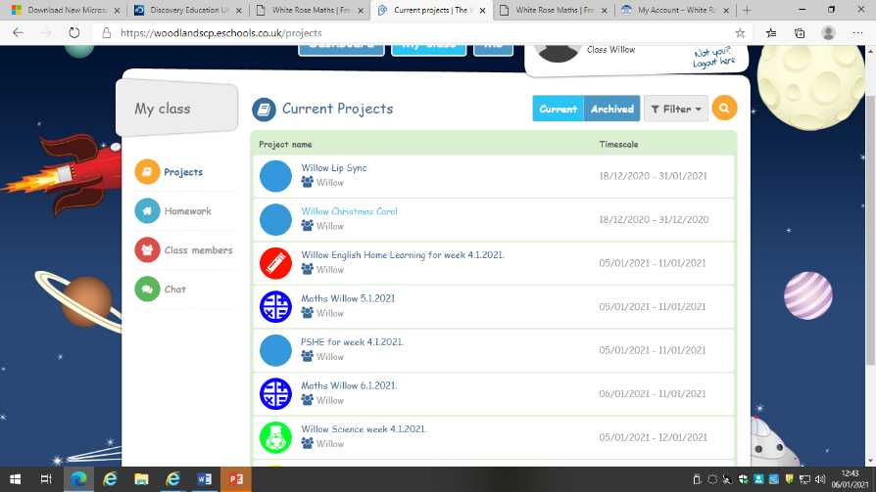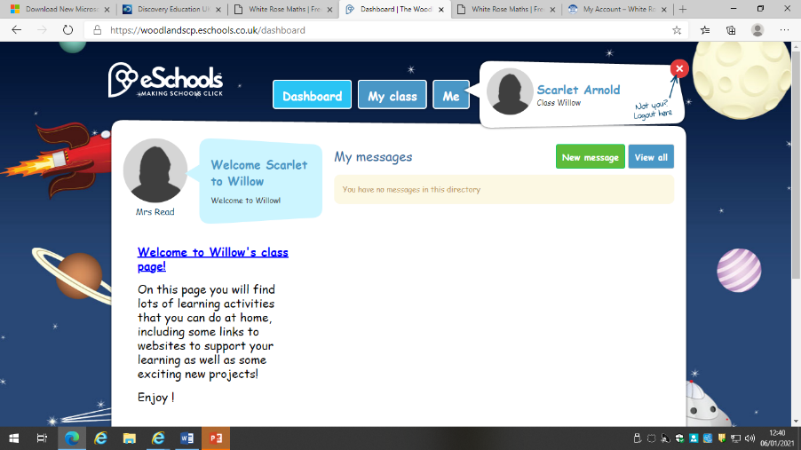

**Remember** to complete

your learning quiz each day

and return your answers to

your teacher as instructed.

Each class will be given a daily time slot where pupils can go onto the ‘Chat’ function for an hour to ask a teacher from their phase any questions about learning for that day.

Any questions regarding admin or not specifically for the learning that day need to be directed through the school office via phone call or email and we will get responses to you as soon as possible.

You will then see under ‘Projects’ any home learning that your teacher has allocated to you. You can click on each item and complete them as instructed.

As a pupil, you will automatically go to your class dashboard. From there, click on My Class.

Please enter the **student** username and password and log in.

All pupils have been advised of their log in details and should have them stuck into their homework book. If you have forgotten / can’t find your log in details, please contact school and we can arrange to get it to you.