The Woodlands Community Primary School | Year 1/2 | Topic – Art | Colour Chaos
Key Vocabulary | Key Knowledge and Skills
Primary colours  Primary colours can’t be made by mixing any other colour  Secondary colours  You can mix the primary colours together to make new colours. These are called secondary colours. | Knowledge  I know about the work of a range of artists, craft makers and designers.  I know you can develop a wide range of art and design techniques in using colour, pattern, texture, line, shape, form and space.  Skills  I can say how other artists have used colour, pattern and shape.  I can create a piece of work in response to another artist’s work.  I can reflect on my own work and the work of others and say what I might change.  I can mix and match colours, predict outcomes.  I can make tints by adding white.  I can make tones by adding black.
 | Key knowledge
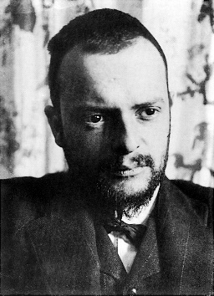
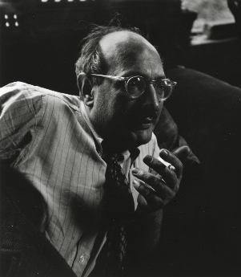
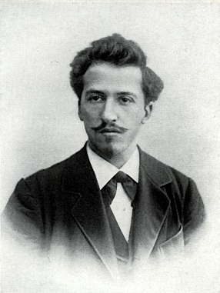

Piet Mondrian
Paul Klee
Mark Rothko

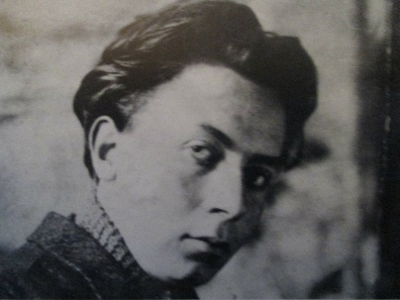
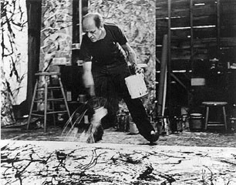
This half term we will be exploring the work of these artists.

Robert Delaunay
Jackson Pollock

