The Woodlands Community Primary School |  | Year 1/2 | Topic – Computing |  |  | Bright Lights, Big City
Key Vocabulary | Key Knowledge and Skills
log on  icon  search engine  website | Knowledge  I know how to stay safe online.  I know what an icon looks like. |  |  |  | Skills  I can log onto a laptop.  I can open the internet.  I can use a search engine.
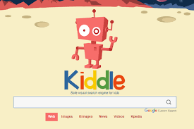
Google search icon
type here

