The Woodlands Community Primary School |  | Year 1/2 | Topic – DT |  | Designing a moving toy
Key Vocabulary | What a good one looks like? Key Knowledge and Skills
Design – a plan or drawing of the end product.  Stronger – Able to withstand force, pressure or wear.  Stiffer – Not easily bent or changed in shape.  Stable – Not likely to overturn.  Pivot – to rotate or swing.  Lever – long, sturdy part that rests on a  support.  Wheel -  Slider - | 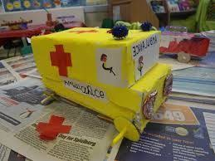  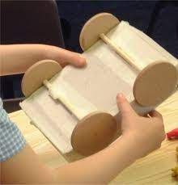 |  |  | Knowledge  - I know the ideas for my design and can explain what I am going to do.  - I know how to evaluate my work against the design criteria  - I can talk about my ideas, explaining what I like or dislike.  Skills  - I can build structures exploring how it can be made stronger.  - I can use tools safely.  - I can measure, mark out and cut a range of materials.  - I can assemble, join and combine materials and components together.  - I can think about simple finishing techniques to improve the appearance of the product.  - I can develop ideas through talk and drawings – creating templates and designs.
 | Key knowledge
