The Woodlands Community Primary School |  | Year 5/6 | Computing |  | Publisher
Getting to know … | Vocabulary |  |  | Key Knowledge and Skills
Microsoft Publisher is a wonderful tool for creating flyers, brochures, newsletters, cards, banners, certificates and much more. You can create a document from scratch if you wish, but it’s much easier to use the catalogue of templates that comes with the software. | Template – Publisher provides models for certain text types for you to use e.g. newspapers, greeting cards etc.  Tabs – Tabs are specific sections on a Microsoft program which has a multitude of functions you can choose from.  File Tab – options such as opening, saving and closing documents exist here.  Home Tab – options for adapting text and pictures.  Insert Tab – allows you to add pictures, hyperlinks, tables etc.  Page Design Tab – adapt what the page looks like e.g. background.  Text Box – to add writing to.  Font – change the style of writing.  Clip art – images available to those working on their documents.  Pictures – to help enhance the text written.  Save as … - to choose a location to save a document.  Filename – The name of the document for when it is saved. |  |  | Knowledge  - I know the purpose of publisher.  - I know how to locate text boxes and resize them.  - I know how to locate images.  - I know why we use a thesaurus.  - I know the purpose of bullet points.  Skills  - I can choose a font.  - I can choose an appropriate letter size.  - I can select, position and resize a text box.  - I can locate images.  - I can resize and position an image.
Inserting images |  |  |  | Writing Text
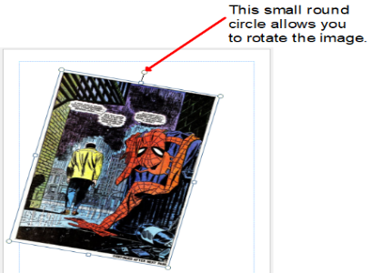  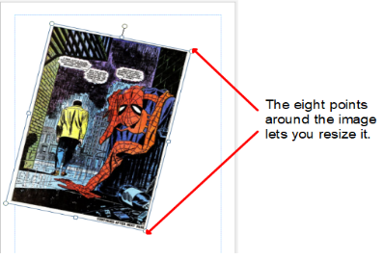  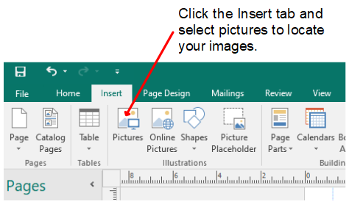 |  |  |  | 