The Woodlands Community Primary School |  | Year 5/6 | PE Autumn 1 2021 |  | Gymnastics
Key Vocabulary | Important Facts |  |  | Knowledge and Skills
Body movement – to move in controlled and rhythmical way, forming a shape.  Combination – one or more movements joined together.  Symmetrical shapes – creating shape which appears to be the same on both sides.  Routine – a combination of skills performed on one apparatus. | In gymnastics competitions, judges look for:  - different use of floor space  - changes in the direction and level of movement  - theatrics, dance elements, command of music  - height and distance of jumping and tumbling manoeuvres.  The floor routine lasts no more than 90 seconds and must cover the entire floor area. |  |  | Knowledge  - I know how joints and sockets allow the body to be in different positions.  - I know how to adapt a combination.  - I know how to use my body to create a symmetrical shape by myself or with a partner.  Skills  - I can select a suitable routine to perform to different audiences, bearing in mind who the audience is.  - I can transfer sequence onto suitably arranged apparatus & floor  - I can perform 6-8 part floor sequences as individual, pair & small group.
Equipment | How does this link with previous learning? |  |  | Shapes
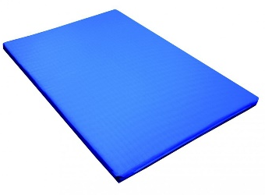  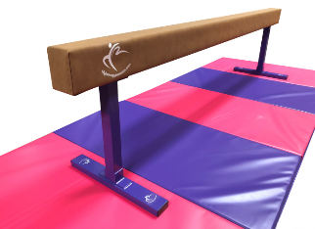  mat  Balance beam | Practise and refine movements  Link a series of movements together  Evaluate own and others’ performances  Perform recognisable movements |  |  | 