Summer 2 2020
Maths – Week 1
Number (Year 3)
Success Criteria | S-A (tick if achieved)
I can count from 0 in multiples of 4, 8,
I can recognise the place value of each digit in a three-digit number (hundreds, tens, ones)
I can compare and order numbers up to 1000
I can read and write numbers up to 1000 in numerals and in words

Note: Before beginning any learning or activity below, look over your ‘knowledge organiser’ for addition and subtraction for your year group.
It has all the knowledge, methods and learning you have done in class to help you carry out the activities below.
Use your ‘knowledge organisers’ as you carry out the activities. They are there for you to use and help you in the activities.
Your ‘knowledge organiser’ is at the end of this document.

Day 1: I can count from 0 in multiples of 4, 8,
Practise counting up and down in both 6s and 7s. Practise this by reading the 4s and 8s below but also without looking at them.
Practise counting backwards.
Get someone to ask you questions like, ‘What number comes after 16?’ ‘What number comes before 64?’

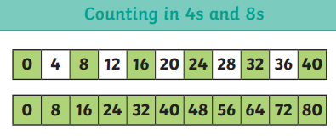

Activity 1: If you have access to ‘Hit the button’, click the link below and practise recall of your multiplication facts for your 4s and 8s
https://www.topmarks.co.uk/maths-games/hit-the-button

Activity 2: Complete the sequences below. They are counting on or counting back in 4s or 8s.
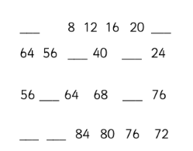

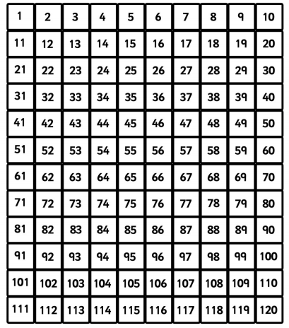
Activity 3: circle all the 8s on the grid below. Begin at 8.

Day 2: I can recognise the place value of each digit in a four-digit number (thousands, hundreds, tens, and ones)
Here’s a place value chart we have used in class which helps you recognise the value of a digit.
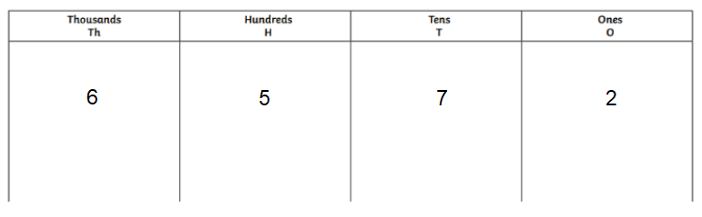
This would help us to recognise the value of a digit and it can also help you read the number.
So above the number is (in words) six thousand, five hundred and seventy-two (6572)

Activity 1:
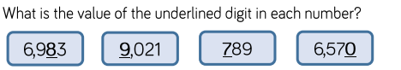

Activity 2:
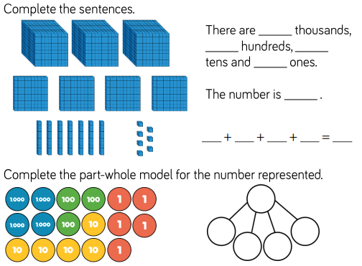

Activity 3: The picture of the number doesn’t match the digits. Find out and explain what’s wrong with each comparison

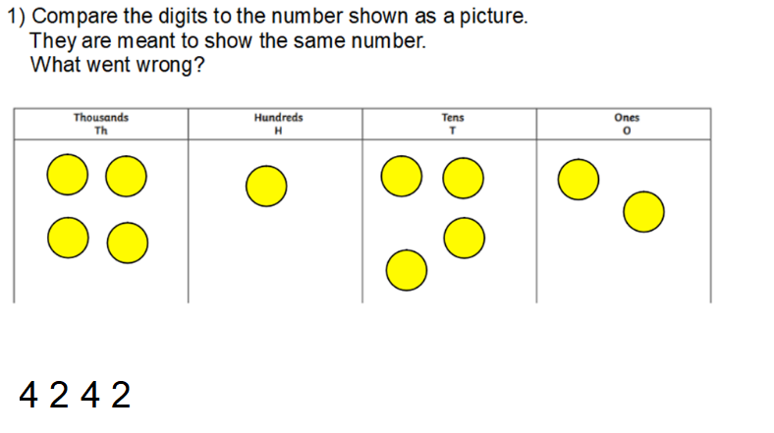

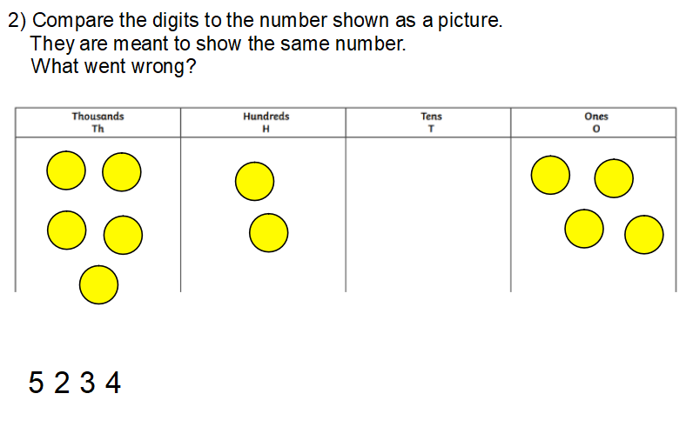

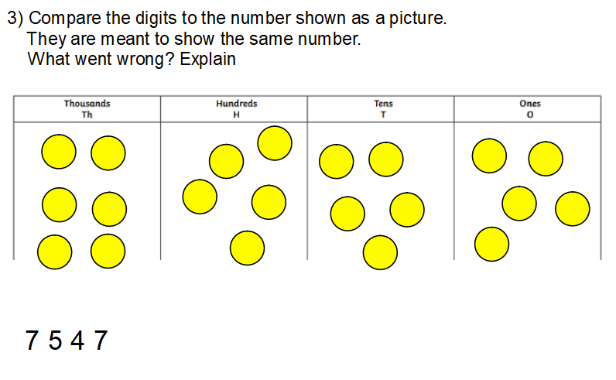

Activity 4:
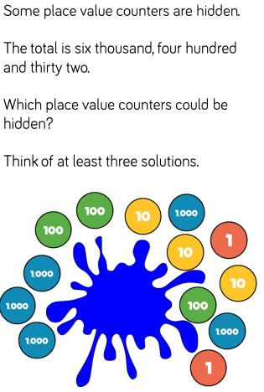
Record your answers in this area.

Day 3: I can compare and order numbers up to 1000
For today’s learning you’ll need yesterday’s learning. You’ll need to use your knowledge of place value to compare and order numbers.
When comparing, always start with the largest digit.
Which is larger? 2439 or 4392?

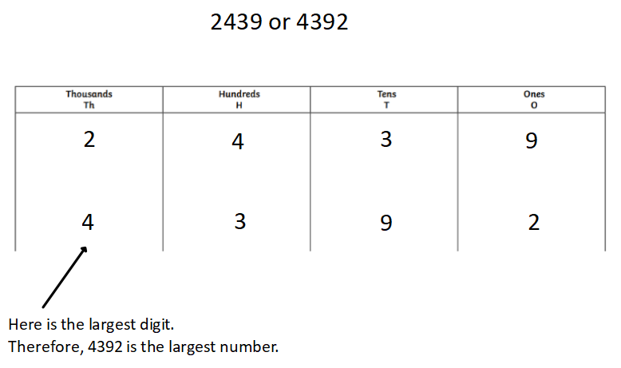

When we write the sentence to compare we use < > and =
< means less than
> means greater than
= means the same as
So we would write our answer above as:
2439 < 4392 2439 is smaller than 4392

Activity 1: Using the place value chart to help compare, use the symbols < > = to complete the statements below.
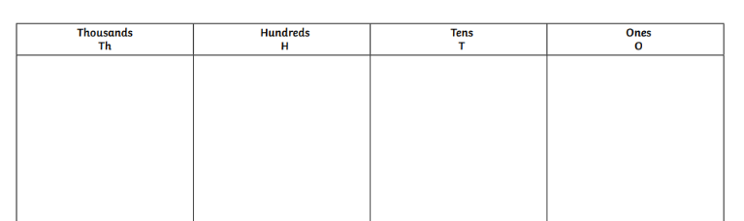

- 4738 ___ 3829

- 9432 ___ 2120

- 7438 ___ 7761

- 2238 ___ 2843

- 4001 ___ 399

When you order numbers, it is exactly the same method as above. Look at the largest digit to order the numbers. If the digits are the same, go to the next largest column/digit.
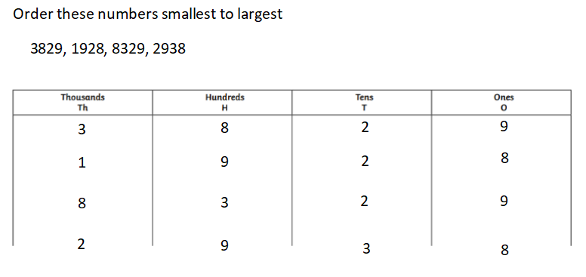

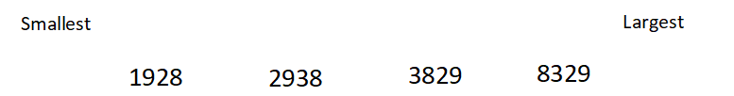

Activity 2: Using the place value chart to help compare, use the symbols < > = to complete the statements below.

Order each set of numbers smallest to largest
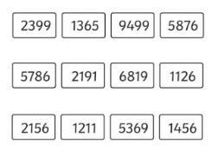

Activity 3:
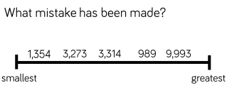

Day 4: I can read and write numbers up to 100 in numerals and in words.
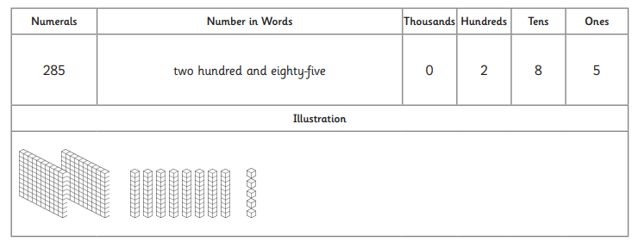
Example:
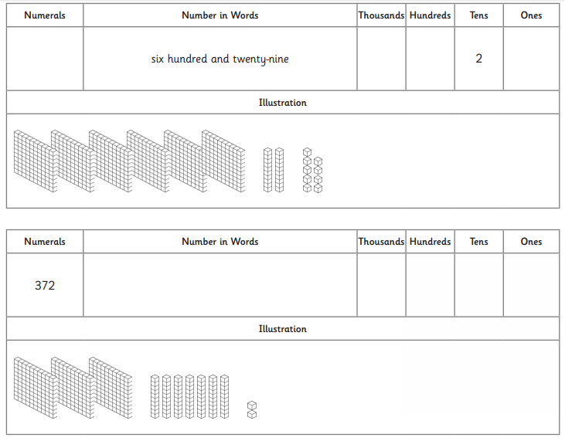

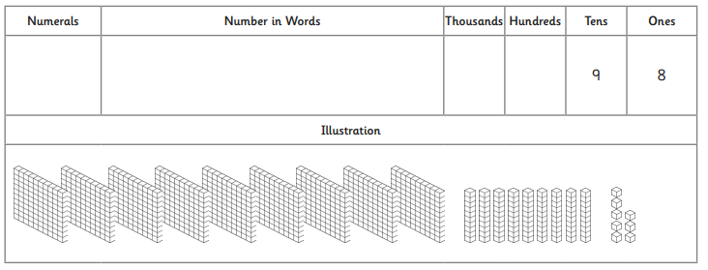

Day 5: Revise your knowledge grids below.

