The Woodlands Community Primary School | Year 1/2 |  | Topic –Geography | Paws, Claws and Whiskers
Key Vocabulary |  | Key Knowledge and Skills
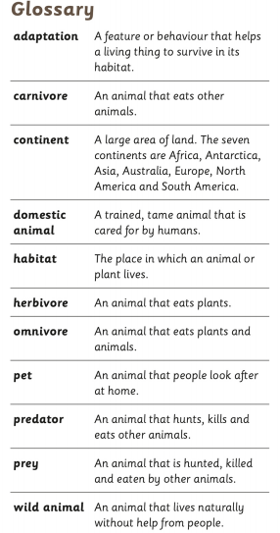 |  | Knowledge  - I can name and locate countries.  - I can name and locate continents.  - I can locate the equator, the North and South pole.  Skills  - I can ask and respond to simple questions.  - I can use picture maps, globes and atlases to locate places.  - I can make comparisons between different places.
 |  | Key knowledge
 |  | 