Home Learning Booklet
Summer 1
Year 4
This booklet belongs to

Woodlands Primary School
Homework Grid Summer 1
 | Expected |  | Exceeding Expected |  |  |  | Greater Depth
 | These need to be carried out every week |  | Maths |  | English |  | Select 2 projects from the list below to do over the half term
Week 1 | Reading at LEAST 3 times  Complete Spelling Sheet  Rule: prefix inter  Complete times table sheets |  | Money |  | Education City – Pitch Perfect  Punctuation direct speech.
Week 2 | Reading at LEAST 3 times  Complete Spelling Sheet  Rule: prefix - anti  Complete times table sheets |  | Education City – It’s Aisle Good  One and two step problems involving money. |  | Spelling, Punctuation and Grammar |  | There are 50 states in America. Find out as many names as you can and see if you can remember them.  Imagine you were President of the USA. What would you do? Make a list of 10 laws that you would put in place.  Native Americans sometimes used smoke signals to communicate over long distances. Come up with a secret code to send messages. For example, it could involve hand signals or flashing lights.  There have been many U.S. presidents over the last 100 years. How many can you find out?  Find the lyrics to the American National Anthem and learn the words.
Week 3 | Reading at LEAST 3 times  Complete Spelling Sheet  Rule: Prefix - auto  Complete times table sheets |  | Symmetry – reflect the shapes |  | Education City – Lance a Lot  A or an?
Week 4 | Reading at LEAST 3 times  Complete Spelling Sheet  Rule: Prefix - ex  changes  Complete times table sheets |  | Education City – Time Bandit  12 – 24 hour clock |  | Apostrophes
Week 5 | Reading at LEAST 3 times  Complete Spelling Sheet  Rule: Prefix - non  Complete times table sheets |  | Two step word problems |  | Education City – Amazing words  Advanced prepositions
 | Homework will be collected on Wednesday and returned on Friday.
Expected - Week 1 Spelling practise: Look, say, cover, write, check
Look | Say | Cover | Write | Check | Write | Check | Write | Check
example |  |  | exampel |  | example |  | example
interact
interfere
international
internet
interrupt
intervene
intermediate
Mr
Mrs
parents
Now write the words in a sentence.
1. ____________________________________________________________________________________________________________________________________________________
2. ___________________________________________________________________________________________________________________________________________________
3. ___________________________________________________________________________________________________________________________________________________
4. ___________________________________________________________________________________________________________________________________________________
5. ___________________________________________________________________________________________________________________________________________________
6. ___________________________________________________________________________________________________________________________________________________
Expected - Week 1
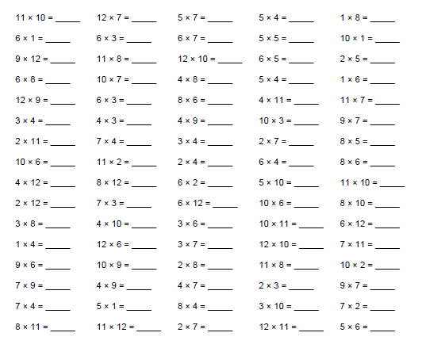

Exceeding expected- Week 1
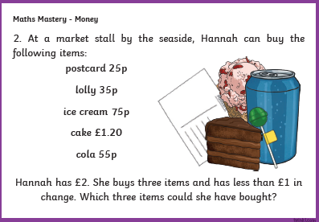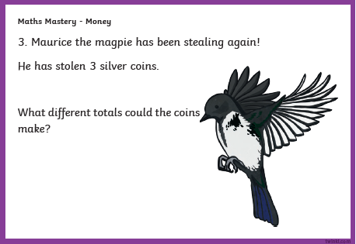
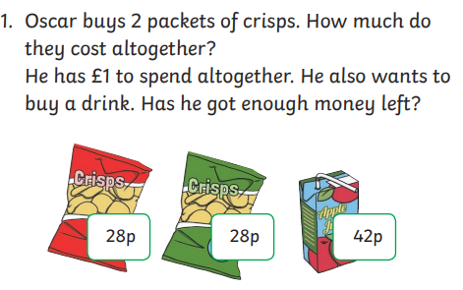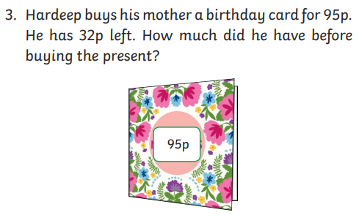

Expected – Week 2 Spelling practise: Look, say, cover, write, check
Look | Say | Cover | Write | Check | Write | Check | Write | Check
example |  |  | exampel |  | example |  | example
antisocial
anticlockwise
antiseptic
antifreeze
antibiotic
antidote
antivenom
Christmas
use
any
Now write the words in a sentence.
1. ____________________________________________________________________________________________________________________________________________________
2. ___________________________________________________________________________________________________________________________________________________
3. ___________________________________________________________________________________________________________________________________________________
4. ___________________________________________________________________________________________________________________________________________________
5. ___________________________________________________________________________________________________________________________________________________
6. ___________________________________________________________________________________________________________________________________________________
Expected
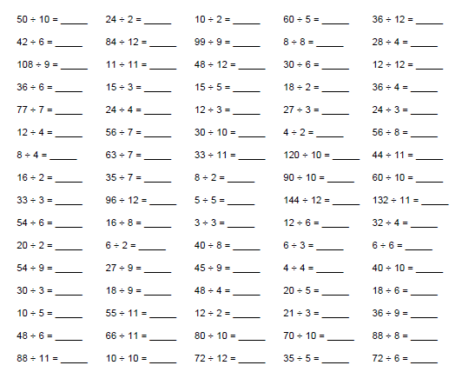
Week 2

Exceeding expected- Week 2
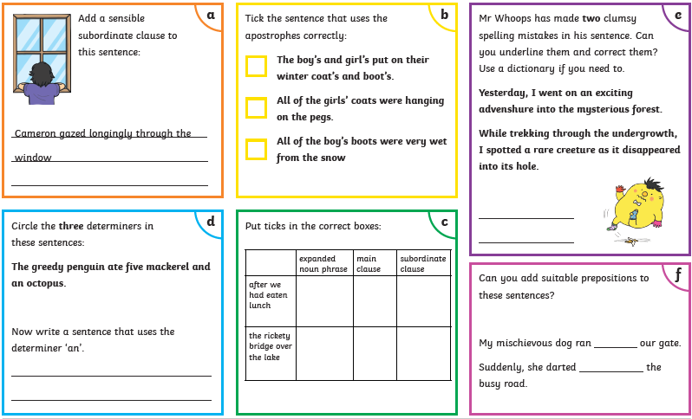

Expected - Week 3 Spelling practise: Look, say, cover, write, check
Look | Say | Cover | Write | Check | Write | Check | Write | Check
example |  |  | exampel |  | example |  | example
autograph
automatic
autobiography
autofocus
autocorrect
automobile
autocue
January
February
March
Now write the words in a sentence.
1. ____________________________________________________________________________________________________________________________________________________
2. ___________________________________________________________________________________________________________________________________________________
3. ___________________________________________________________________________________________________________________________________________________
4. ___________________________________________________________________________________________________________________________________________________
5. ___________________________________________________________________________________________________________________________________________________
6. ___________________________________________________________________________________________________________________________________________________
Expected
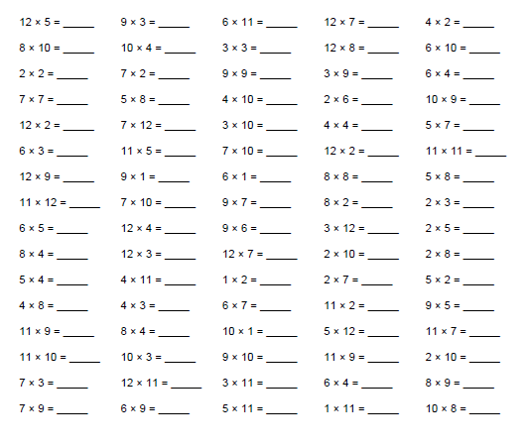
Week 3

Exceeding expected – week 3
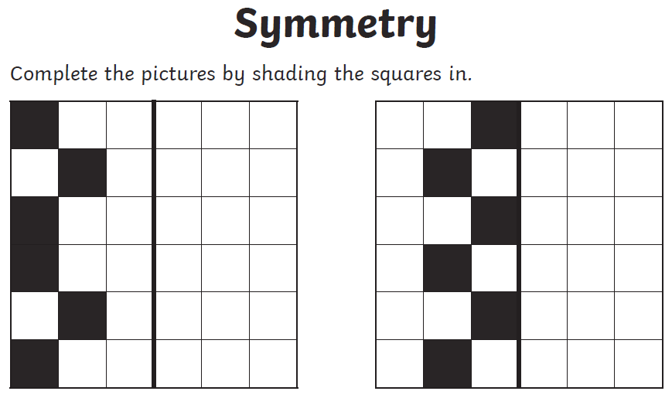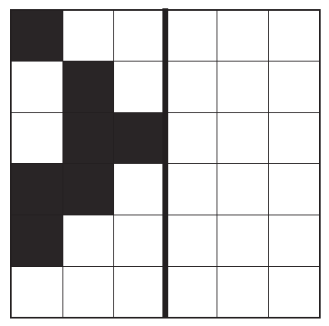
Challenge
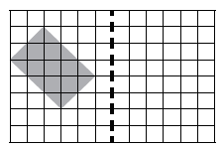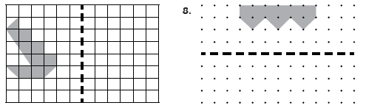

Expected Week 4 Spelling practise: Look, say, cover, write, check
Look | Say | Cover | Write | Check | Write | Check | Write | Check
example |  |  | exampel |  | example |  | example
exit
extend
explode
exchange
exclaim
external
exterior
April
May
June
Now write the words in a sentence.
1. ____________________________________________________________________________________________________________________________________________________
2. ___________________________________________________________________________________________________________________________________________________
3. ___________________________________________________________________________________________________________________________________________________
4. ___________________________________________________________________________________________________________________________________________________
5. ___________________________________________________________________________________________________________________________________________________

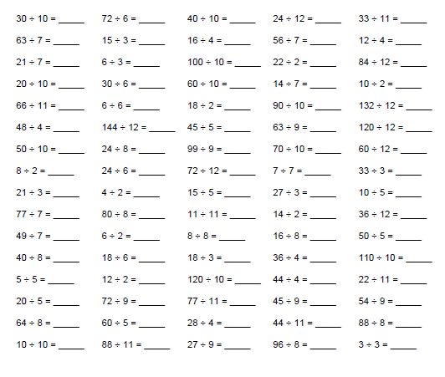
Expected
Week 4

Exceeding expected – week 4
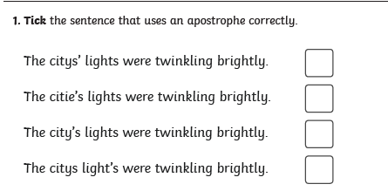 | 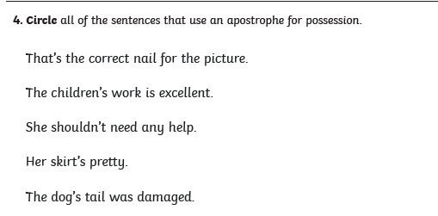
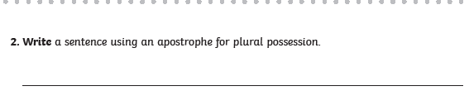  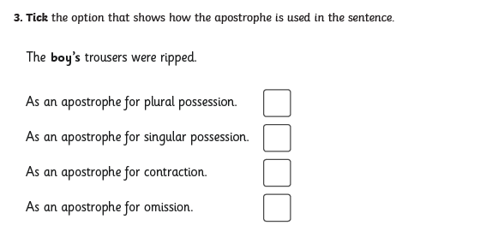 | 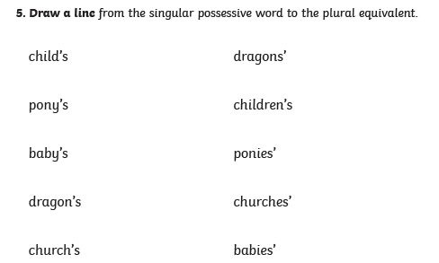

Expected - Week 5 Spelling practise: Look, say, cover, write, check
Look | Say | Cover | Write | Check | Write | Check | Write | Check
example |  |  | exampel |  | example |  | example
nonsense
non-stop
non-fiction
non-profit
non-starter
non-stick
July
August
September
October
Now write the words in a sentence.
1. ____________________________________________________________________________________________________________________________________________________
2. ___________________________________________________________________________________________________________________________________________________
3. ___________________________________________________________________________________________________________________________________________________
4. ___________________________________________________________________________________________________________________________________________________
5. ___________________________________________________________________________________________________________________________________________________
6. ___________________________________________________________________________________________________________________________________________________
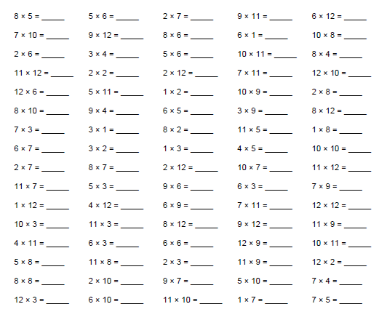
Expected
Week 5

Exceeding expected – week 5
Solve 2 step problems

1) Grapes cost £1.50 per kg and carrots cost £1.00 per kg. How much would it costs for 3kg of grapes and half a kilogram of carrots?

2) Jenny decides to share her sweets between herself and her 3 friends. She has 212 green sweets, 310 blue sweets and 502 yellow sweets. How many sweets will Jenny and her friends get each?

3) Large chocolate bars come with 32 pieces. Medium chocolate bars come with 24 pieces. Barry buys 8 large bars of chocolate and 6 medium bars. How many pieces of chocolate will he have altogether?

4) A flower shop sells roses for £1.79, carnations for £1.25 and buttercups for £1.30. Holly decides to buy 3 roses and a buttercup. How much does she spend?

5) Pencils come in packs of 12 and each pack costs £1.19. Mr Green needs to buy a pencil for each of the 48 children in his class. How much will he spend on pencils?

Work these out on a separate sheet of paper – if you need some please ask your teacher

