Home Learning Booklet
Summer 1
Year 6
This booklet belongs to

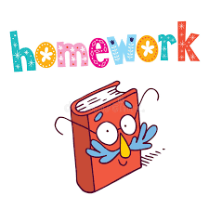

Woodlands Primary School
Homework Grid Summer 1

 | Expected |  | Exceeding Expected |  |  |  | Greater Depth
 | These need to be carried out every week |  | Maths |  | English |  | Select 2 projects from the list below to do over the half term
Week 1 | Reading at LEAST 3 times  Complete Spelling Sheet  Rule:  Complete times table sheets |  | Angles  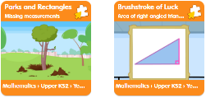
Week 2 | Reading at LEAST 3 times  Complete Spelling Sheet  Rule:  Complete times table sheets |  |  |  | Reading skills – word meaning  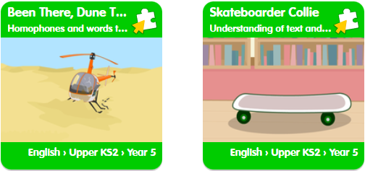 |  | THE BATTLE OF BOSWORTH  - Draw a map of the Battle area and label where the armies were placed.  - Research and make a model of the crown of Richard III.  - Write a letter as Richard III asking Lord Stanley to support him at the battle.  Research the battle clothing and weapons of a Tudor soldier and present in your chosen way.
Week 3 | Reading at LEAST 3 times  Complete Spelling Sheet  Rule:  Complete times table sheets |  | Problem Solving - Time  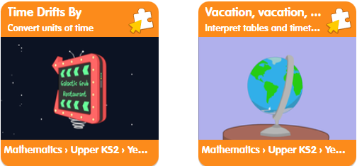
Week 4 | Reading at LEAST 3 times  Complete Spelling Sheet  Rule:  Complete times table sheets |  |  |  | Perfect tense/Subject verb agreement  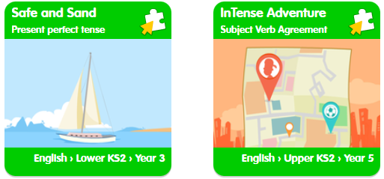
Week 5 | Reading at LEAST 3 times  Complete Spelling Sheet  Rule:  Complete times table sheets |  | Adding, subtracting and multiplying fractions  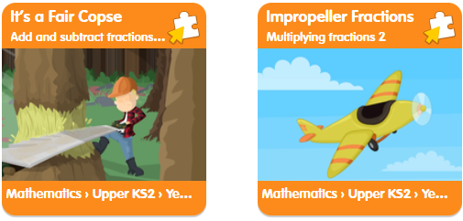
 | Homework will be given out every Friday. Homework will be collected every Wednesday.

Expected Week 1 Due 27/04 Spelling practise: Look, say, cover, write, check
Look | Say | Cover | Write | Check | Write | Check | Write | Check
example |  |  | example |  | example |  | example
programme
telegram
hologram
diagram
grammar
grammatical
parallelogram
monogram
programmer
Now apply all 8 of those words in a sentence.
1. ____________________________________________________________________________________________________________________________________________________
2. ___________________________________________________________________________________________________________________________________________________
3. ___________________________________________________________________________________________________________________________________________________
4. ___________________________________________________________________________________________________________________________________________________
5. ___________________________________________________________________________________________________________________________________________________
6. ___________________________________________________________________________________________________________________________________________________
7. ___________________________________________________________________________________________________________________________________________________
8. ___________________________________________________________________________________________________________________________________________________

Expected - Week 1
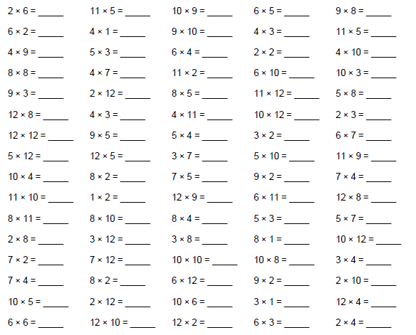
Exceeding expected- Week 1
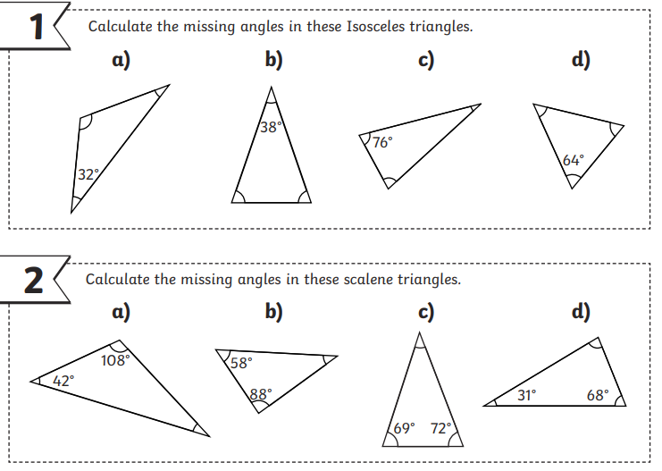

Expected - Week 2 Due 04/05 Spelling practise: Look, say, cover, write, check
Look | Say | Cover | Write | Check | Write | Check | Write | Check
example |  |  | example |  | example |  | example
challenge
damage
broadcast
benefit
charge
function
influence
interest
object
protest
Now apply 8 of the words in a sentence.
1. ____________________________________________________________________________________________________________________________________________________
2. ___________________________________________________________________________________________________________________________________________________
3. ___________________________________________________________________________________________________________________________________________________
4. ___________________________________________________________________________________________________________________________________________________
5. ___________________________________________________________________________________________________________________________________________________
6. ___________________________________________________________________________________________________________________________________________________
7. ___________________________________________________________________________________________________________________________________________________
8. ___________________________________________________________________________________________________________________________________________________
Expected - Week 2
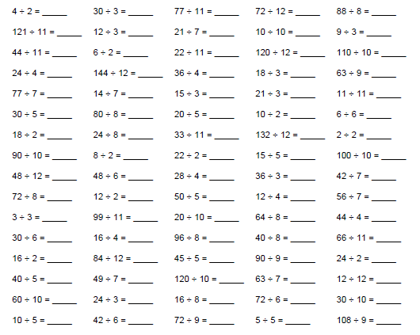
Exceeding expected- Week 2

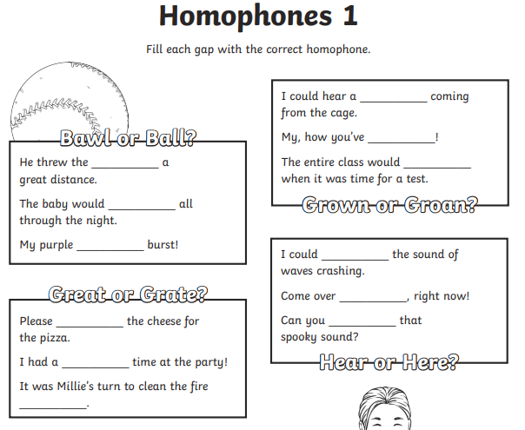
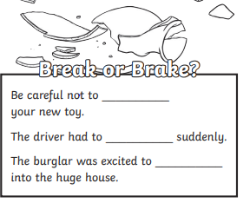

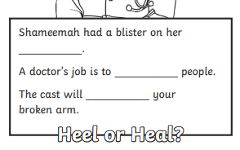

Expected - Week 3 Due 11/05 Spelling practise: Look, say, cover, write, check
Look | Say | Cover | Write | Check | Write | Check | Write | Check
example |  |  | example |  | example |  | example
produce
present
reason
silence
support
transport
surprise
scratch
freeze
balance

Now apply 7 of those words in a sentence.
1. ____________________________________________________________________________________________________________________________________________________
2. ___________________________________________________________________________________________________________________________________________________
3. ___________________________________________________________________________________________________________________________________________________
4. ___________________________________________________________________________________________________________________________________________________
5. ___________________________________________________________________________________________________________________________________________________
6. ___________________________________________________________________________________________________________________________________________________
7. ___________________________________________________________________________________________________________________________________________________

Expected - Week 3
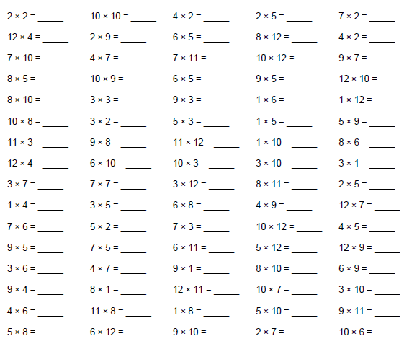

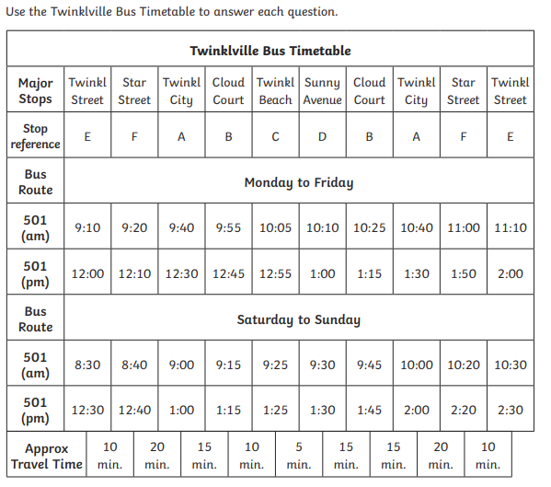
Exceeding expected – week 3
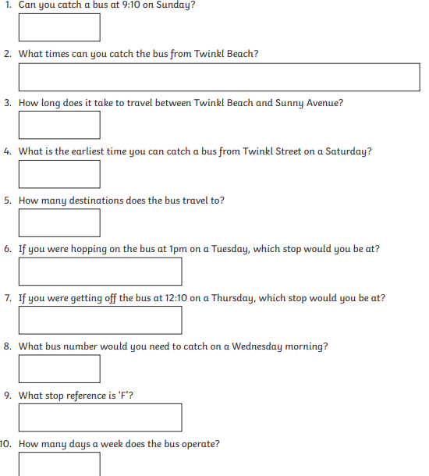

Expected - Week 4 Due 18/05 Spelling practise: Look, say, cover, write, check
Look | Say | Cover | Write | Check | Write | Check | Write | Check
example |  |  | example |  | example |  | example
shoulder
smoulder
mould
poultry
soul
shallow
window
blown
know
thrown
Now apply 6 of the words in a sentence.
1. ____________________________________________________________________________________________________________________________________________________
2. ___________________________________________________________________________________________________________________________________________________
3. ___________________________________________________________________________________________________________________________________________________
4. ___________________________________________________________________________________________________________________________________________________
5. ___________________________________________________________________________________________________________________________________________________
6. ___________________________________________________________________________________________________________________________________________________

Expected - Week 4
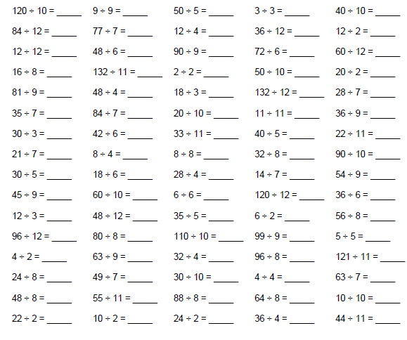
Exceeding expected – week 4

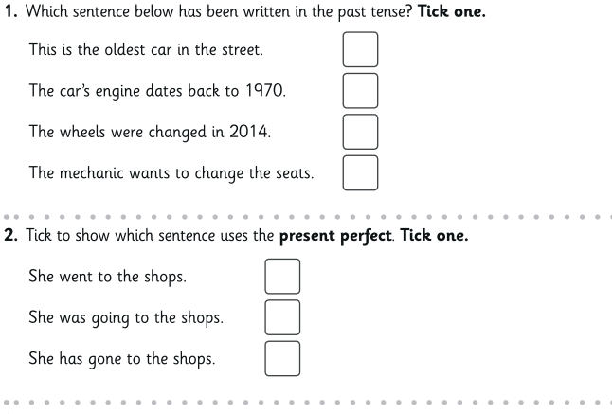

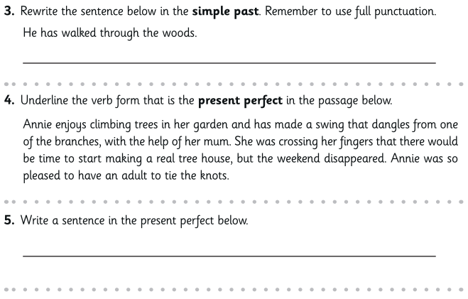

Expected - Week 5 Due 25/05 Spelling practise: Look, say, cover, write, check

Look | Say | Cover | Write | Check | Write | Check | Write | Check
example |  |  | example |  | example |  | example
possible
horrible
terrible
visible
incredible
sensible
forcible
legible
responsible
reversible
Now write the words in a sentence.
1. ____________________________________________________________________________________________________________________________________________________
2. ___________________________________________________________________________________________________________________________________________________
3. ___________________________________________________________________________________________________________________________________________________
4. ___________________________________________________________________________________________________________________________________________________
5. ___________________________________________________________________________________________________________________________________________________
6. ___________________________________________________________________________________________________________________________________________________
7. ___________________________________________________________________________________________________________________________________________________
8. ___________________________________________________________________________________________________________________________________________________
Expected - Week 5
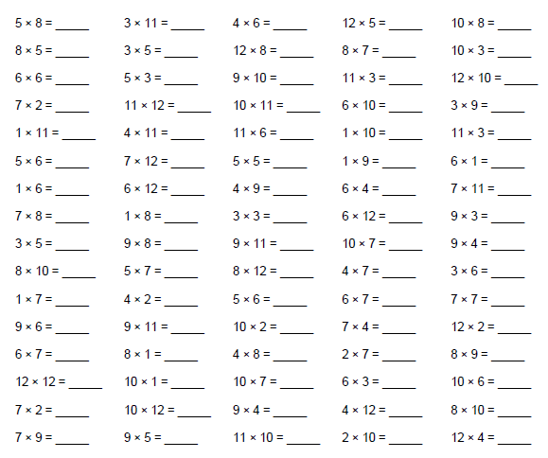

Exceeding expected – week 5
