

**Willow Maths**

**Y4 Home Learning**

**Summer Term**

**Summer 1 Week 5: 18.5.20**

Geometry – Position and Direction (Coordinates)

**Summer 2 Week 1: 1.6.20**

Statistics – interpreting and constructing a range of graphs

Use this knowledge organiser to help you with the coordinates activities:

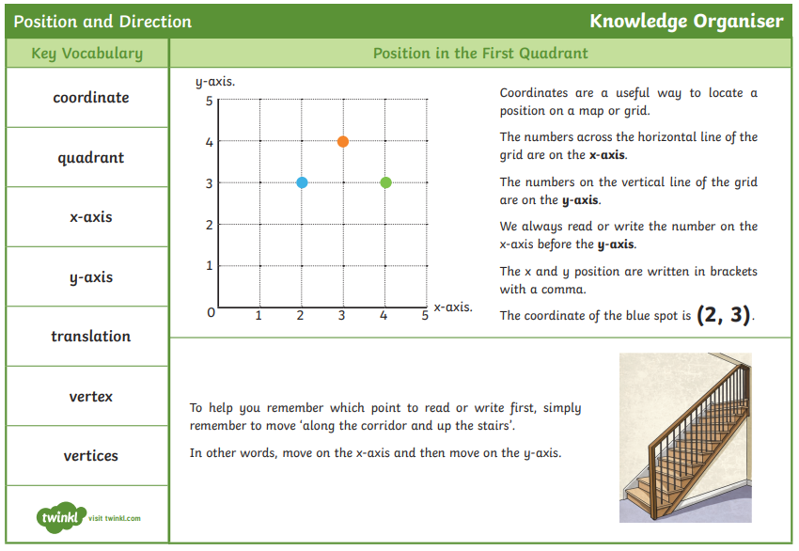

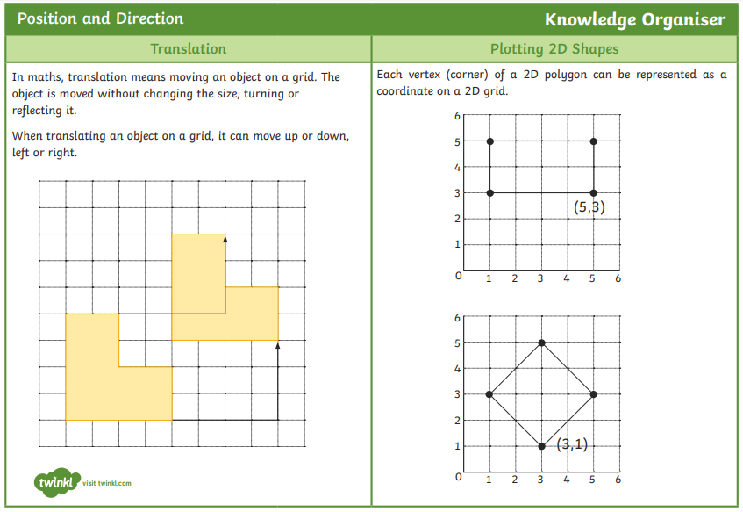

Can I describe positions on a 2D grid as coordinates in the first quadrant?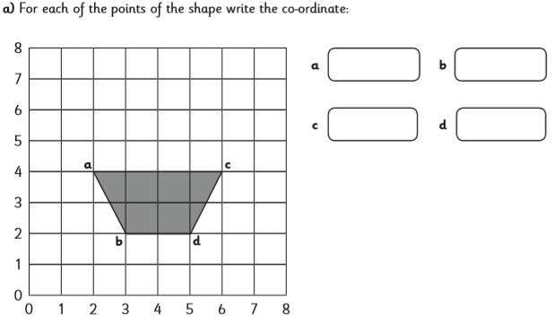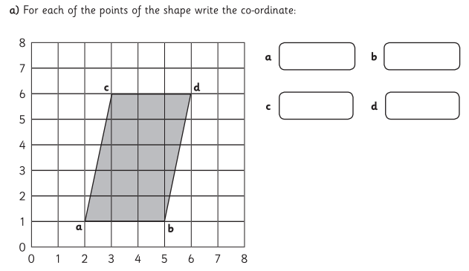

________________________________________________________________________________________________________________________________________________________________________________________________________________________________________________________________________________

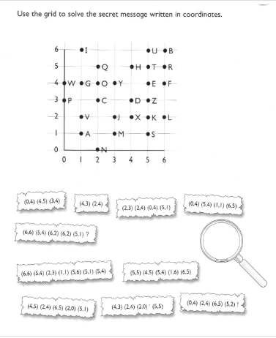

Can I describe movements between positions as translations left/right and up/down?

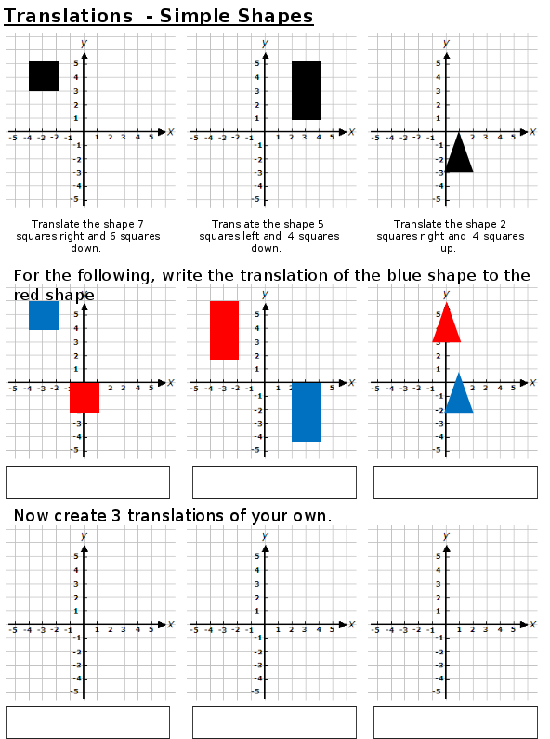

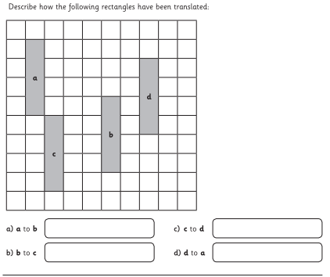

Can I describe movements between positions as translations left/right and up/down?

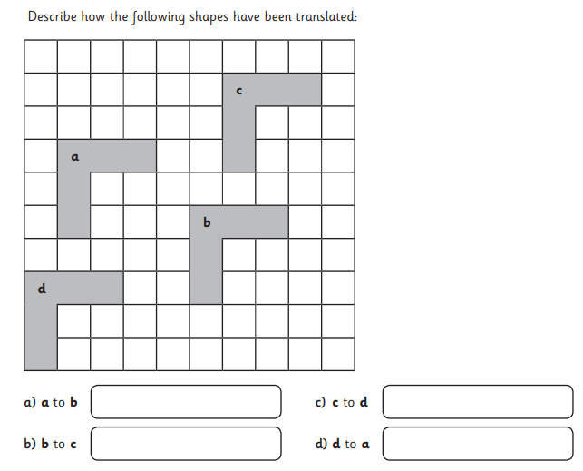

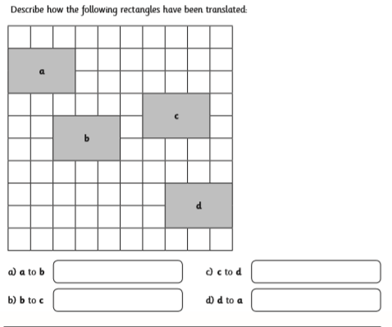

Can I plot points and draw sides to complete polygons?

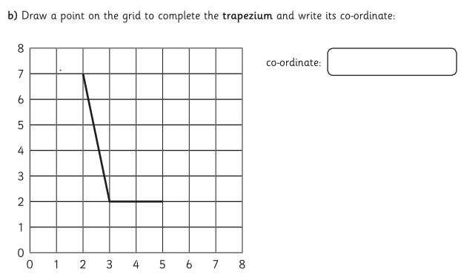

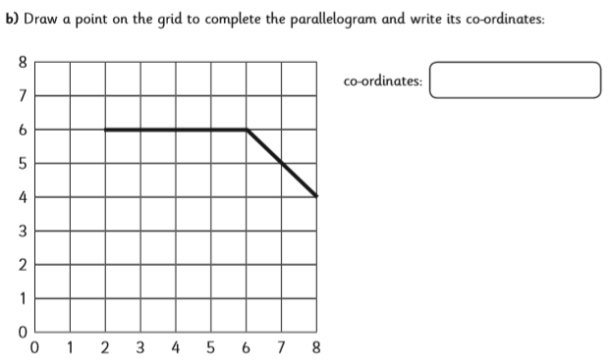

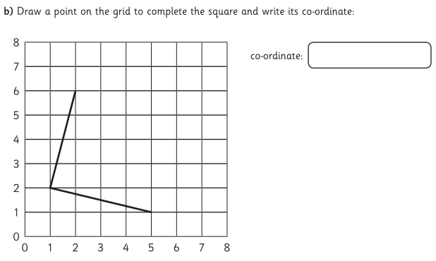

Can I plot points and draw sides to complete polygons?

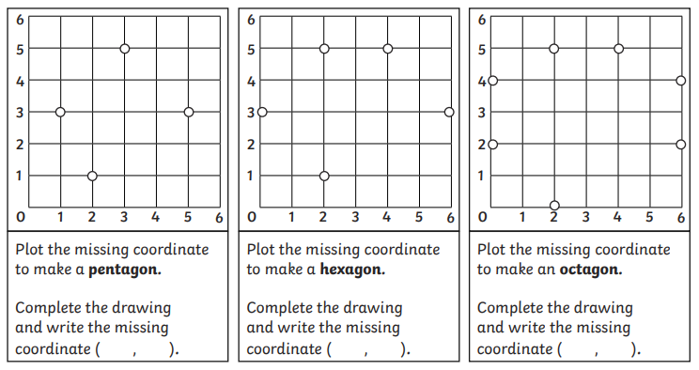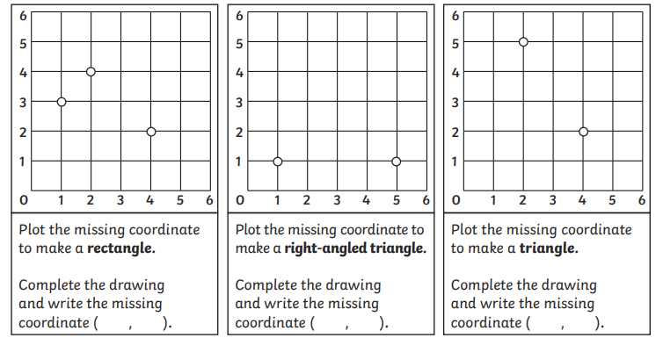

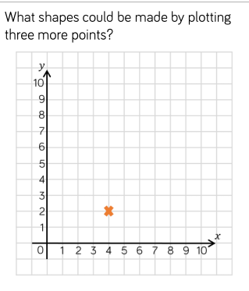

___________________________________________________________________________________________________________________________________________________________________________________________________________________________________________________________________________________________________________________________

Use this knowledge organiser to help you with the statistics activities:

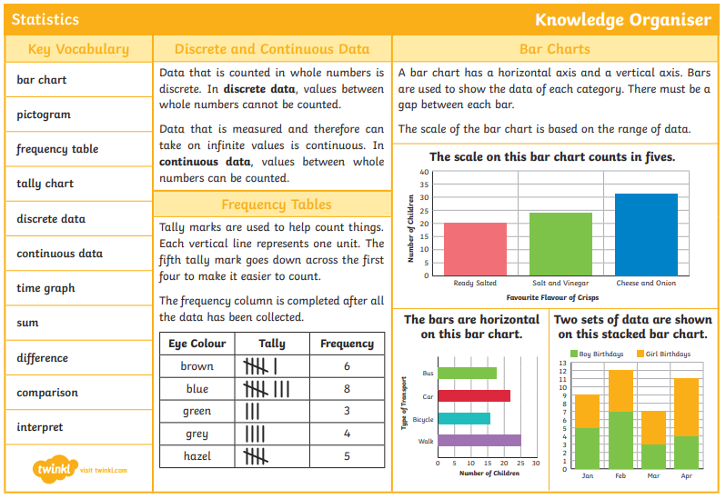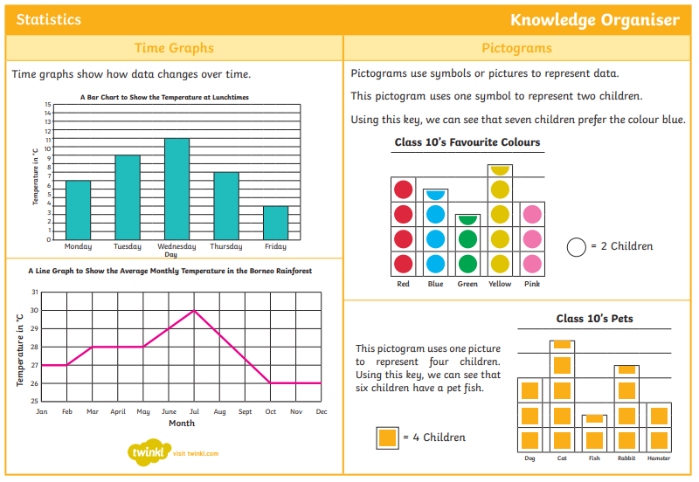

Can I interpret discrete and continuous data?

Tally Charts and Bar Charts:

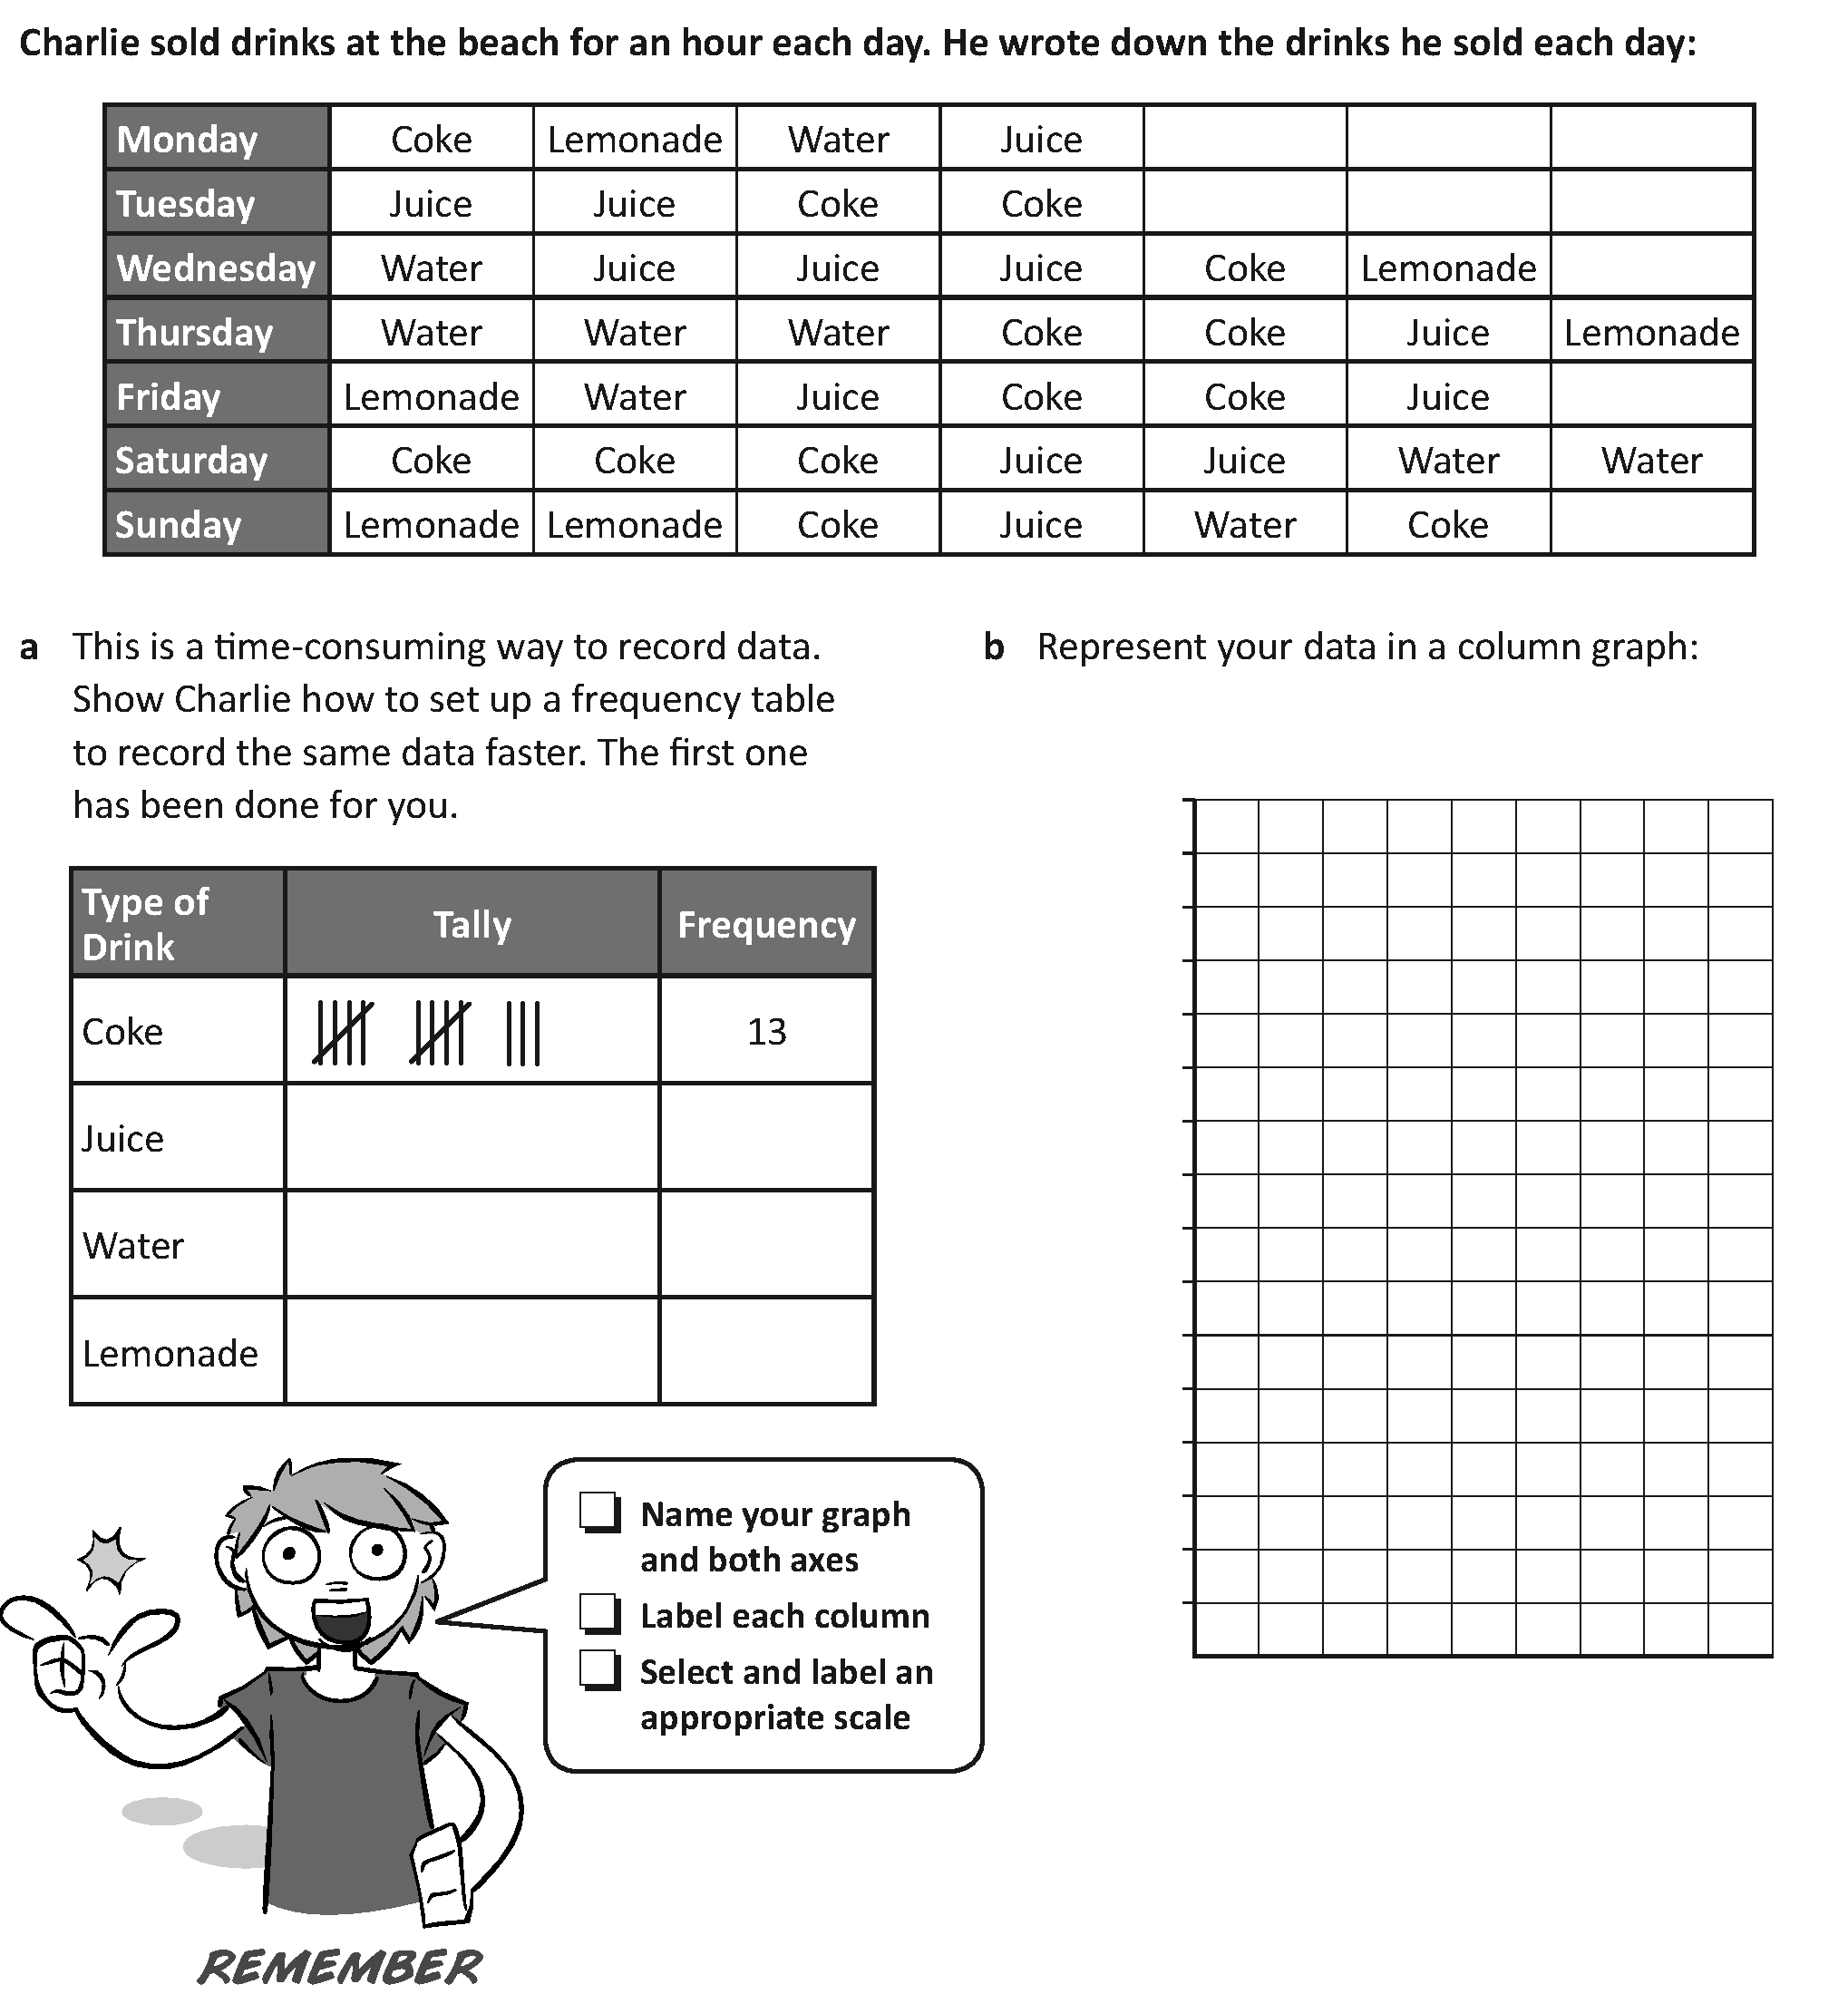

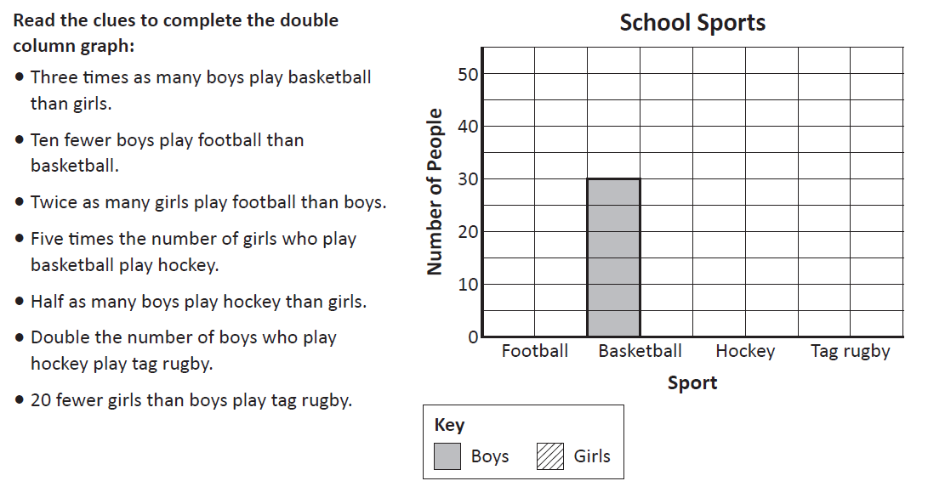

Can I interpret discrete and continuous data?

Line Graphs:

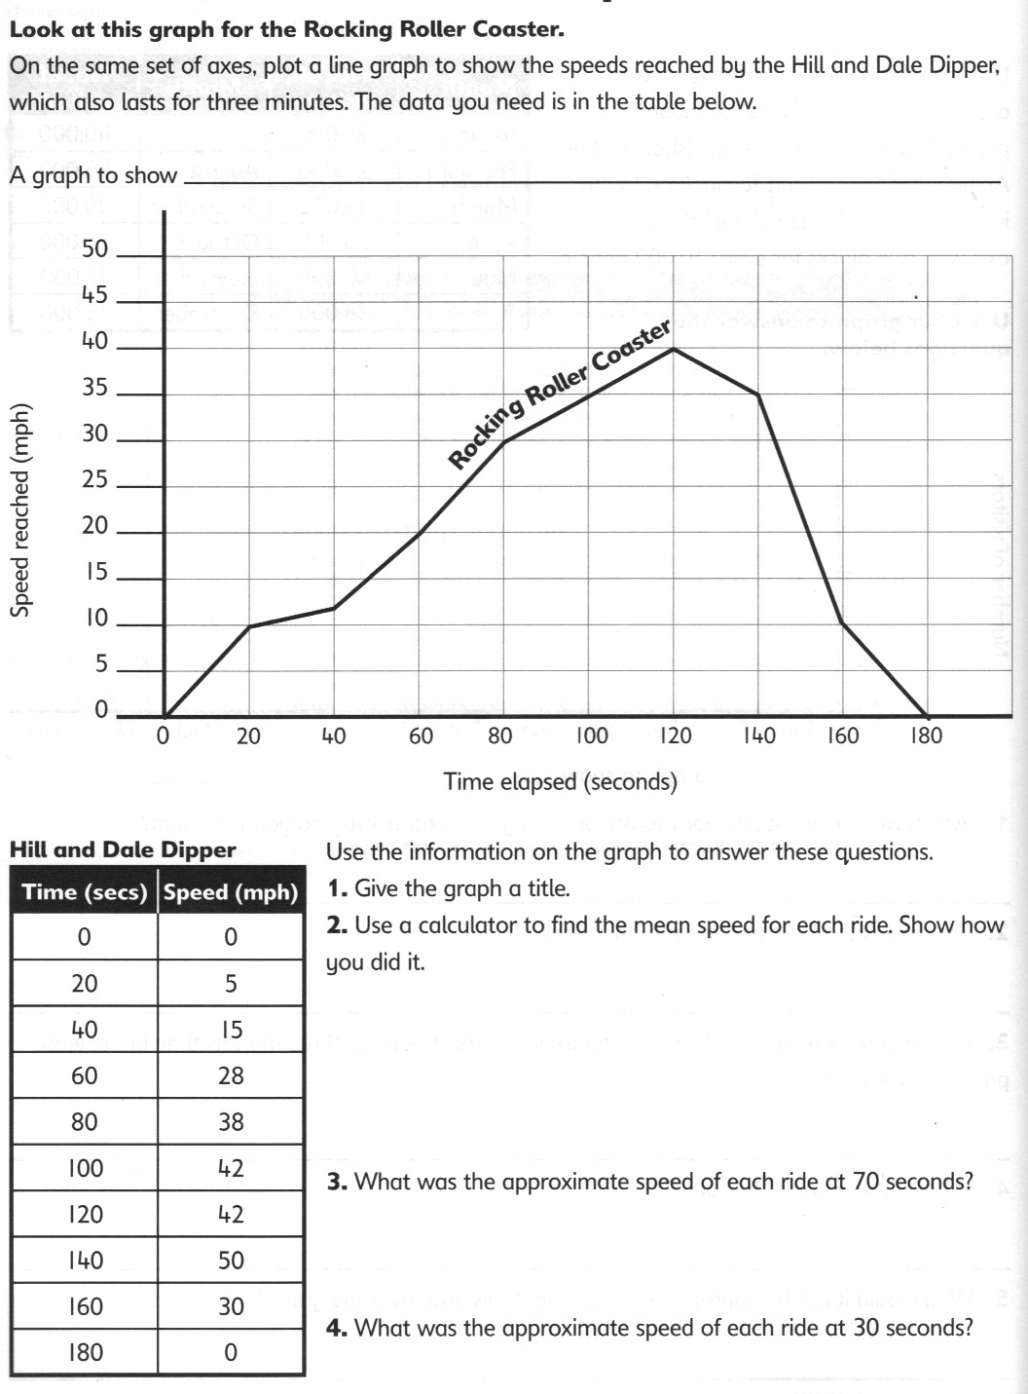

Can I interpret discrete and continuous data?

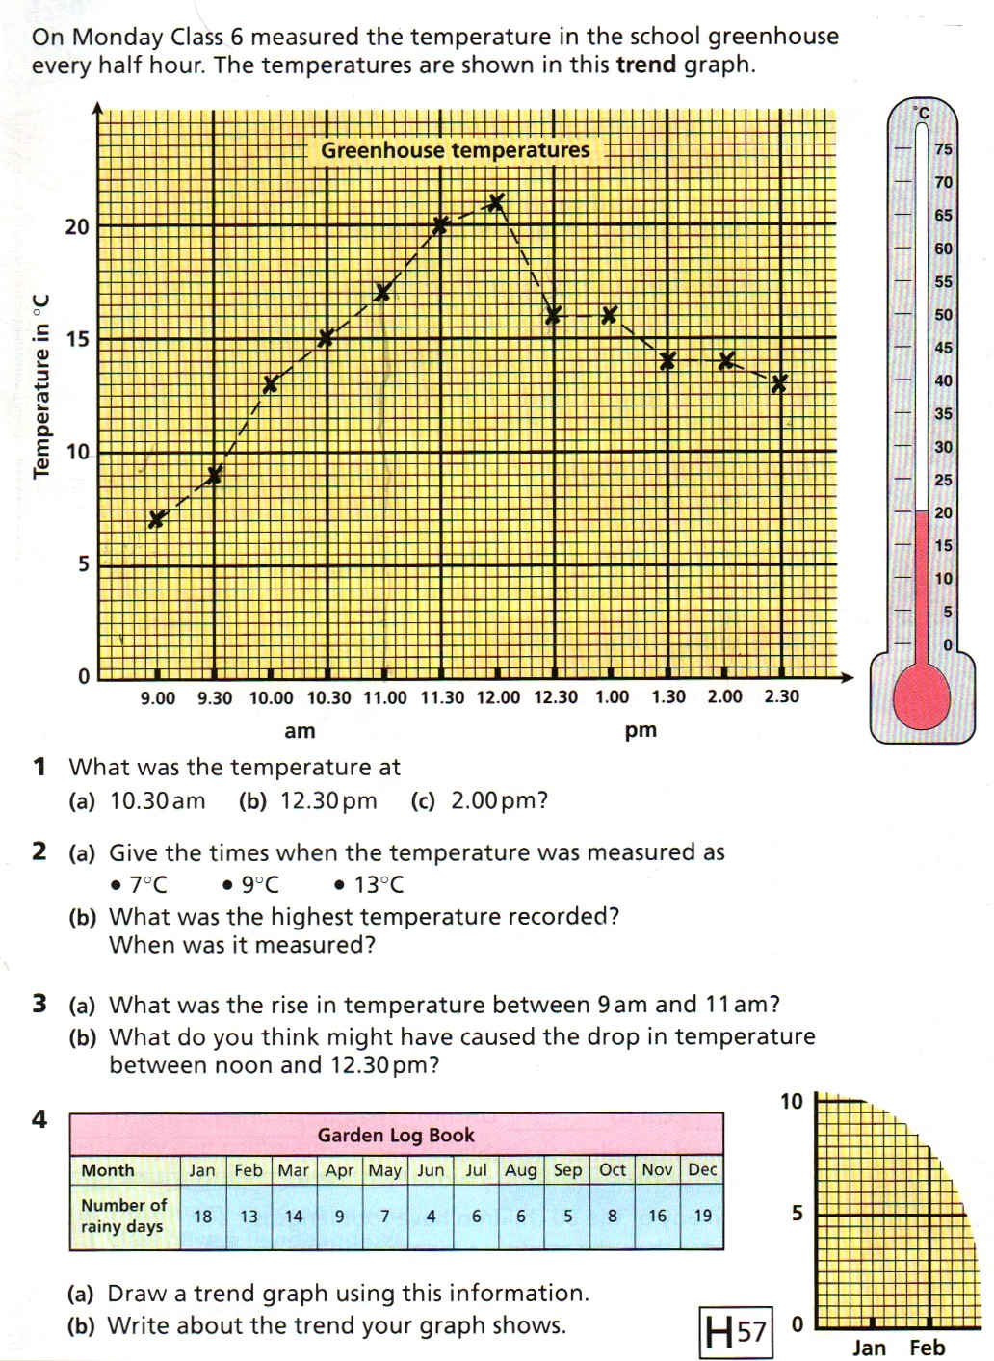

Can I solve problems using information presented in different graphs?

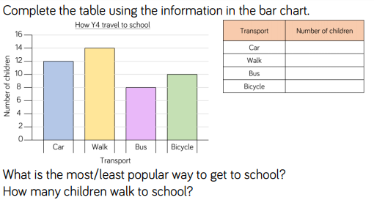

____________________________________________________________________________________________________________________________________________________________________________________________________________________________________________________________________________________________________________

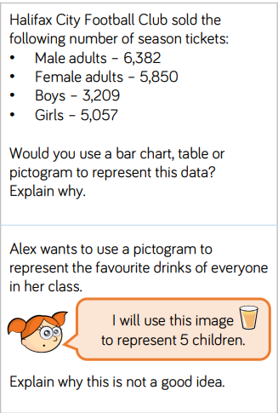

____________________________________________________________________________________________________________________________________________________________________________________________________________________________________________________________________________________________________________

Can I solve problems using information presented in different graphs?





