The Woodlands Community Primary School |  | Year 1/2 | Topic – Outdoor PE |  | Football
Key Words | Key Knowledge and Skills
Control – keeping the ball close and safe.  Dribbling – moving the ball in and out of objects.  Passing – moving a ball from one person to another.  Striking – an accurate driven shot kicked with the inside of the foot.  Defender – somebody who keeps control of the ball. | Knowledge  I know that being active is good for our health  I can describe what I am doing  I know and can describe what my body feel like during football  I know and can recognise good quality performance |  |  | Skills  I can be confident and safe in my own space  I can use skills and actions to play in the game  I can choose and use skills effectively for football  I can watch and describe what others are doing  I can repeat and link a combination of skills  I can choose, use and vary my tactics within a team
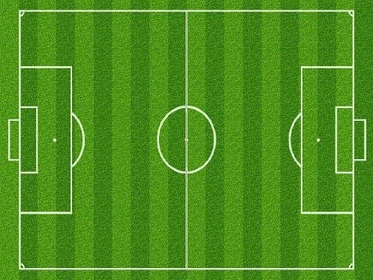
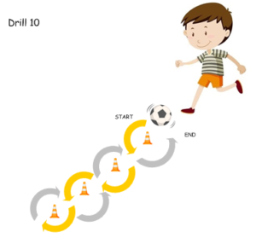
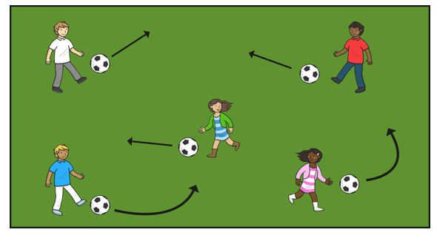
Passing Dribbling Football Pitch

