The Woodlands Community Primary School | Year 1/2 | Art
Key Vocabulary | Key Skills
Blending Mixing  Shading Tone  Shape Brushstrokes  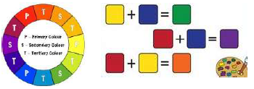 | 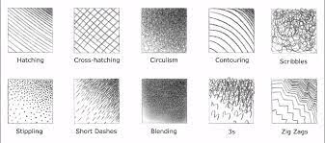
 | Timeline
