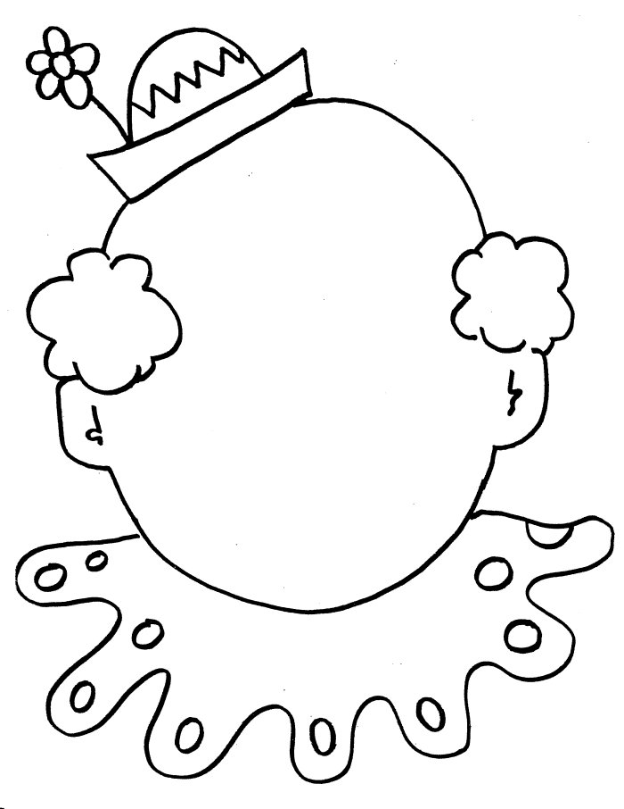
________________________________________________________________________________________________________________________________________________________________________________________________________________________________________________________________________________________________________________________
________________________________________________________________________________________________________________________________________________________________________________________________________________________________________________________________________________________________________________________
Can I write a joke? Can I write a joke?

