The Woodlands Community Primary School |  | Year 1/2 | Topic – Indoor PE |  | Gymnastics
Key Words | Key Knowledge and Skills
Balance – Remain upright and steady  Straight – Extending in one direction  Curved – Having the form of a curve  Landing – movement where you land back on the ground  Control – remaining in control and safe  Sequence – a set of linked movements | Knowledge  I know how to carry and place equipment safely  I know that my body feels different when I am exercising and standing still  I know what my body feels like during activities. |  |  | Skills  I can perform gymnastic actions  I can move safely and change direction  I can copy or create a sequence with a beginning middle and end  I can perform a range of movements with different parts of my body  I can link a combination of actions, shapes and balances  I can improve my gymnastic movements by watching, listening and investigating.
Gymnastic movements
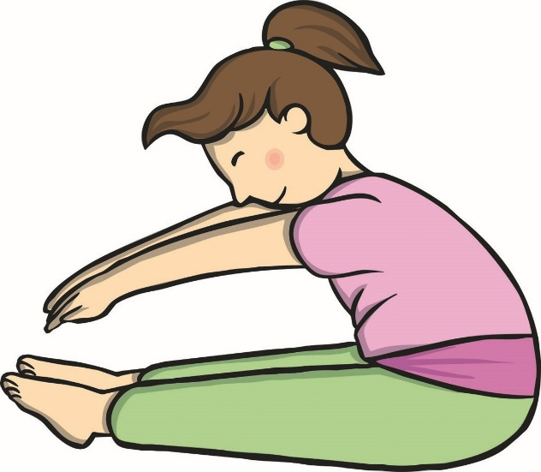
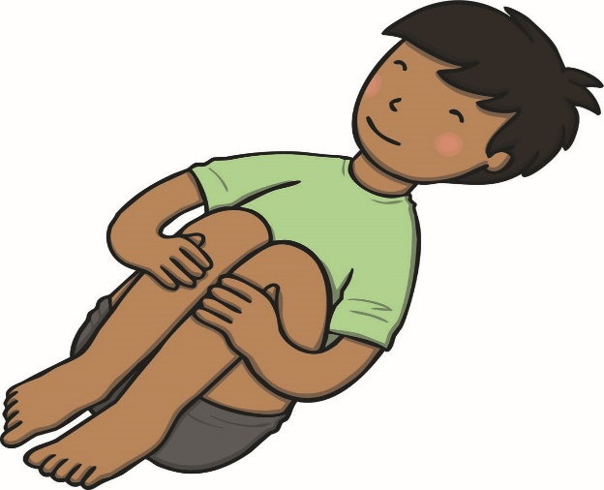
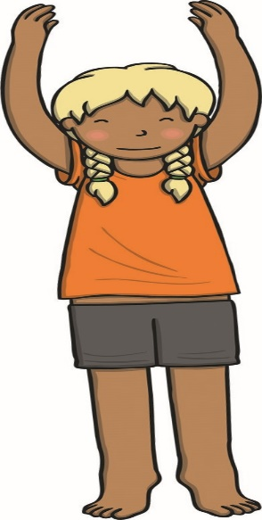
Straight Curved Curved Landing

