The Woodlands Community Primary School |  | Year 5/6 | PE Autumn 1 2021 |  | Tennis
Key Vocabulary | Important Facts |  |  | Knowledge and Skills
Backhand - a stroke played with the back of the hand facing in the direction of the stroke, with the arm across the body.  Forehand - a stroke played with the palm of the hand facing in the direction of the stroke.  Opponent – the person competing against another.  Return - hitting the ball back in the direction of your opponent (attempting to score a point).  Serve - The first shot played in a point/rally. | Scoring  The score starts at 0 – 0 which is known as ‘love all.’  The score then increases as follows:  - First point: 15  - Second point: 30  - Third point: 40  - Fourth point: game  - 40 – 40 is called deuce.  Match  A match is divided into sets.  A set is won when a player reaches 6 games.  A match is won when a player has won 2 sets – apart from in Grand Slam tournaments, when male players must win 3 sets. |  |  | Knowledge  - I know how to position my body when receiving the ball.  - I know how to position my body when hitting the ball with the forehand.  - I know how to position my body when hitting the ball with the backhand.  - I know how to control how much power is exerted on the ball.  Skills  - I can turn and run to the ball getting into the forehand or backhand position.  - I can show a range of grips when using backhand.  - I can use the correct swing technique and control.  - I can serve the ball accurately.
Equipment | How does this link with previous learning? |  |  | Key Strokes
racket  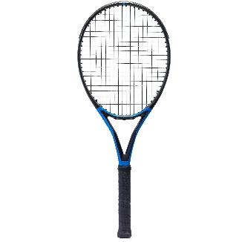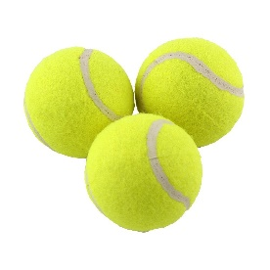  balls  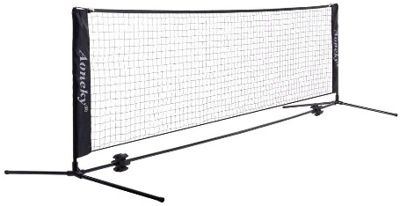  net | Bouncing and catching balls.  Playing attacking and defensive shots  Evaluating my performance  Hand – eye co-ordination |  |  | 