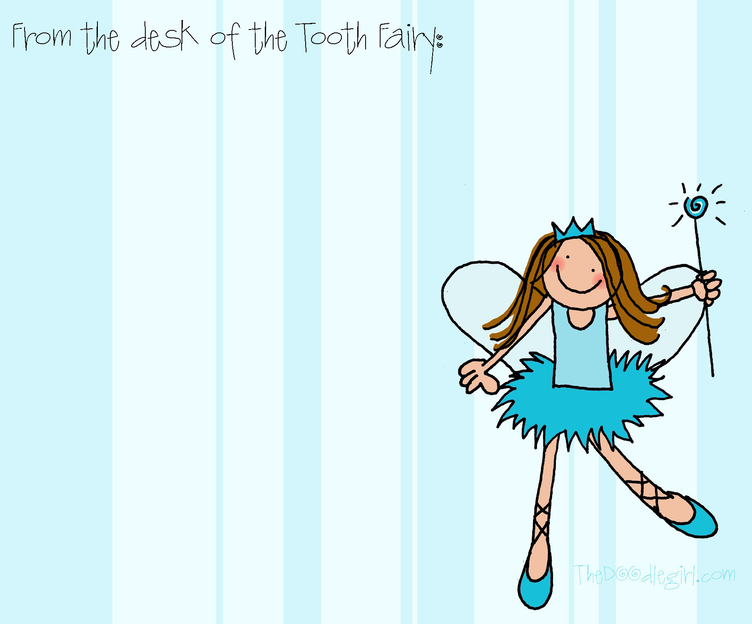

Dear Fairy…

________________________________________________________________________________________________________________________________________________