The Woodlands Community Primary School |  | Year 1/2 | Topic – PE Indoor - Gymnastics |  |  | Bright Lights, Big City
Key Vocabulary | Key Knowledge and Skills
roll  balance  tense  curl  stretch | Knowledge  To know how to link shapes together.  To know how to safely move on a mat. |  |  |  | Skills  To make body tense, relaxed, curled and  stretched, showing some tension.  To roll and balance.
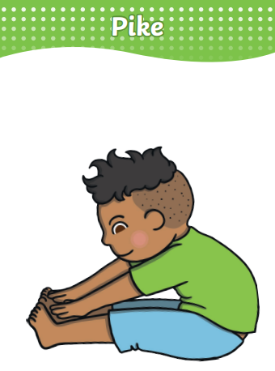 |  |  |  | 