The Woodlands Community Primary School | Year 1/2 |  | Topic – History |  | Moon Zoom
Key Vocabulary |  | Key Knowledge and Skills
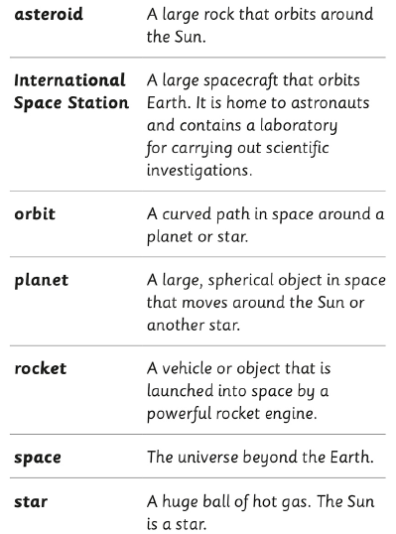 |  | 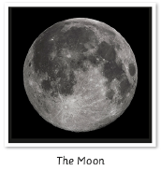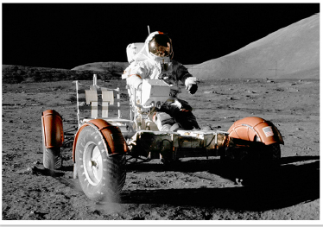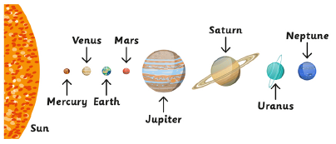 |  | Knowledge  - I know that history is the study of past events.  - I know events happen in time order.  - I know some significant figures from history and their impact on us today.  - I recognise the difference between past and present in my own and others’ lives.  - I recognise why people did things, why events happened and what happened as a result.  Skills  - I can find answers to simple questions about the past from different sources of information.  - I can use a source to answer questions about the past on the basis of simple observations.  - I can communicate my knowledge through discussion, labelling images, role play, using ICT, and writing in short paragraphs.
 |  | Key knowledge
