Home Learning Booklet
Summer 1
Year 3
This booklet belongs to

Woodlands Primary School
Homework Grid Summer 1

 | Expected |  | Exceeding Expected |  |  |  | Greater Depth
 | These need to be carried out every week |  | Maths |  | English |  | Select 2 projects from the list below to do over the half term
Week 1 | Reading at LEAST 3 times  Complete Spelling Sheet  Rule: prefix inter  Complete times table sheets |  | Money |  | Education City – Pitch Perfect  Punctuation direct speech
Week 2 | Reading at LEAST 3 times  Complete Spelling Sheet  Rule: prefix - anti  Complete times table sheets |  | Education City - Starship Enter Price – Money  Giving change |  | Spelling, Punctuation and Grammar |  | There are 50 states in America. Find out as many names as you can and see if you can remember them.  Imagine you were President of the USA. What would you do? Make a list of 10 laws that you would put in place.  Native Americans sometimes used smoke signals to communicate over long distances. Come up with a secret code to send messages. For example, it could involve hand signals or flashing lights.  There have been many U.S. presidents over the last 100 years. How many can you find out?  Find the lyrics to the American National Anthem and learn the words.
Week 3 | Reading at LEAST 3 times  Complete Spelling Sheet  Rule: Prefix - auto  Complete times table sheets |  | Addition and subtraction  Working out column addition and subtraction calculations |  | Education City – Lance a Lot  A or an?
Week 4 | Reading at LEAST 3 times  Complete Spelling Sheet  Rule: Prefix - ex  Complete times table sheets |  | Education City – In safe hands  Tell and write time |  | Apostrophes for contraction.  Focusing on what letters the apostrophe replaces in the word.
Week 5 | Reading at LEAST 3 times  Complete Spelling Sheet  Rule: Prefix - non  Complete times table sheets |  | Statistics |  | Education City – Amazing words  Advanced prepositions
 | Homework will be given out every Friday. Homework will be collected every Wednesday.

Expected Week 1 Spelling practise: Look, say, cover, write, check
Look | Say | Cover | Write | Check | Write | Check | Write | Check
example |  |  | exampel |  | example |  | example
interact
interfere
international
internet
interrupt
interact
would
who
whole
any
Now write the words in a sentence.
1. ____________________________________________________________________________________________________________________________________________________
2. ___________________________________________________________________________________________________________________________________________________
3. ___________________________________________________________________________________________________________________________________________________
4. ___________________________________________________________________________________________________________________________________________________
5. ___________________________________________________________________________________________________________________________________________________
6. ___________________________________________________________________________________________________________________________________________________

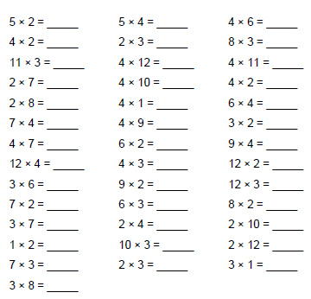
Expected - Week 1
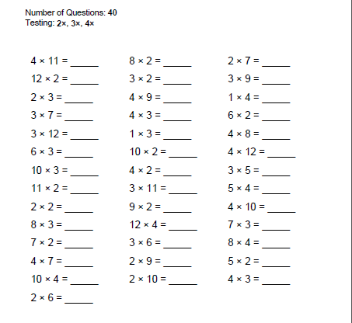

Exceeding expected- Week 1
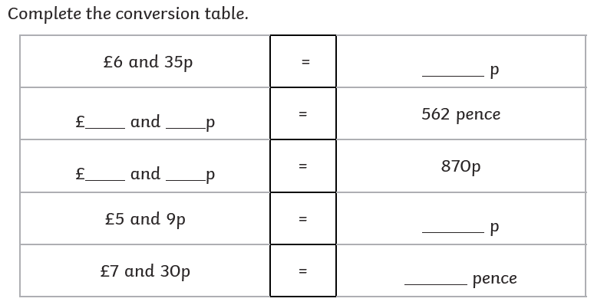
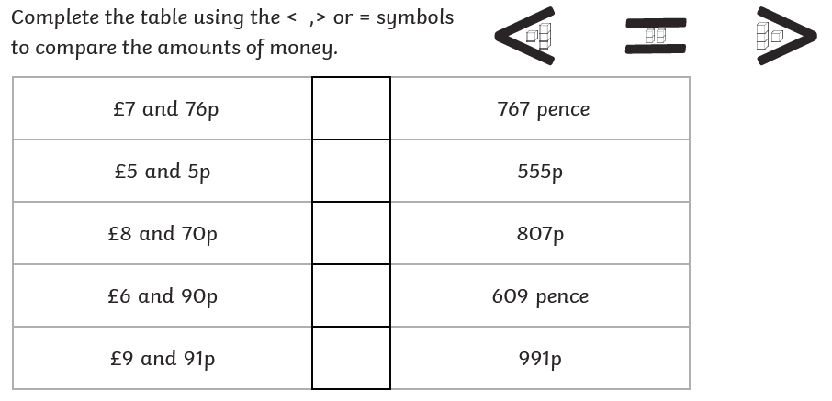
Expected Week 2 Spelling practise: Look, say, cover, write, check
Look | Say | Cover | Write | Check | Write | Check | Write | Check
example |  |  | exampel |  | example |  | example
antisocial
anticlockwise
antiseptic
antifreeze
antibiotic
many
clothes
busy
people
water
Now write the words in a sentence.
1. ____________________________________________________________________________________________________________________________________________________
2. ___________________________________________________________________________________________________________________________________________________
3. ___________________________________________________________________________________________________________________________________________________
4. ___________________________________________________________________________________________________________________________________________________
5. ___________________________________________________________________________________________________________________________________________________
6. ___________________________________________________________________________________________________________________________________________________
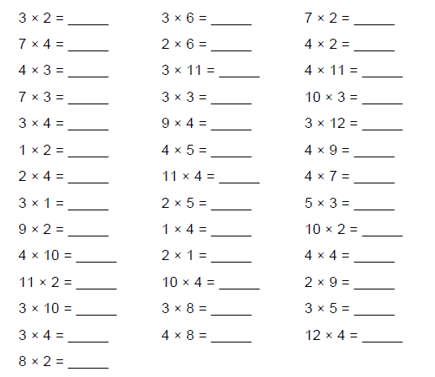
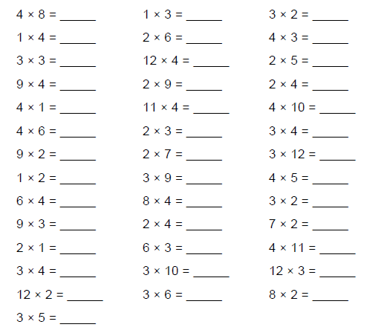
Expected Week 2

Exceeding expected- Week 2
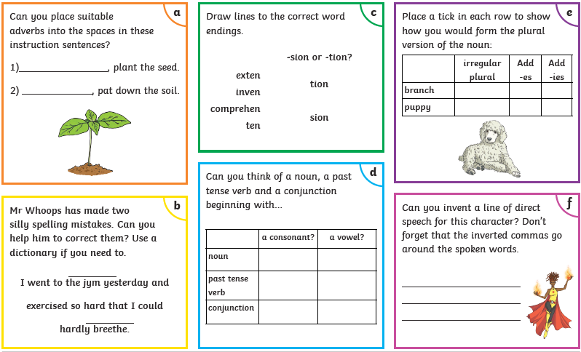

Expected - Week 3 Spelling practise: Look, say, cover, write, check
Look | Say | Cover | Write | Check | Write | Check | Write | Check
example |  |  | exampel |  | example |  | example
autograph
automatic
autobiography
autofocus
autocorrect
again
half
money
Mr
Mrs
Now write the words in a sentence.
1. ____________________________________________________________________________________________________________________________________________________
2. ___________________________________________________________________________________________________________________________________________________
3. ___________________________________________________________________________________________________________________________________________________
4. ___________________________________________________________________________________________________________________________________________________
5. ___________________________________________________________________________________________________________________________________________________
6. ___________________________________________________________________________________________________________________________________________________
7. ___________________________________________________________________________________________________________________________________________________
8. ___________________________________________________________________________________________________________________________________________________
9. ___________________________________________________________________________________________________________________________________________________
Expected
Week 3
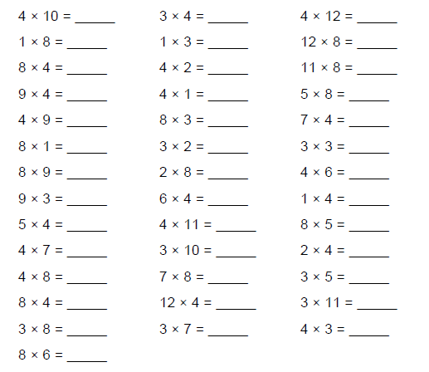
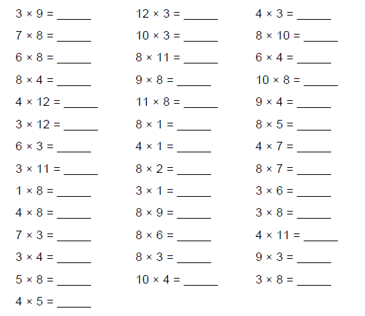

Exceeding expected – week 3
Work out the addition and subtraction calculations. Remember start at the ones column.
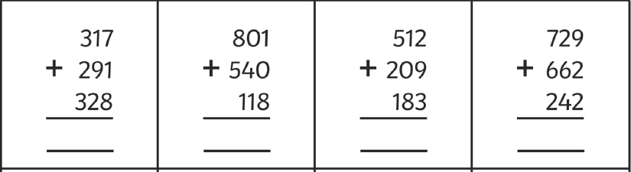
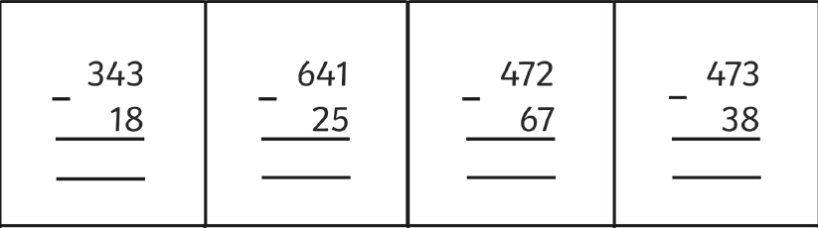

Expected Week 4 Spelling practise: Look, say, cover, write, check
Look | Say | Cover | Write | Check | Write | Check | Write | Check
example |  |  | exampel |  | example |  | example
exit
extend
explode
exchange
exclaim
Christmas
January
February
March
April
Now write the words in a sentence.
1. ____________________________________________________________________________________________________________________________________________________
2. ___________________________________________________________________________________________________________________________________________________
3. ___________________________________________________________________________________________________________________________________________________
4. ___________________________________________________________________________________________________________________________________________________
5. ___________________________________________________________________________________________________________________________________________________
6. ___________________________________________________________________________________________________________________________________________________
7. ___________________________________________________________________________________________________________________________________________________
Expected
Week 4
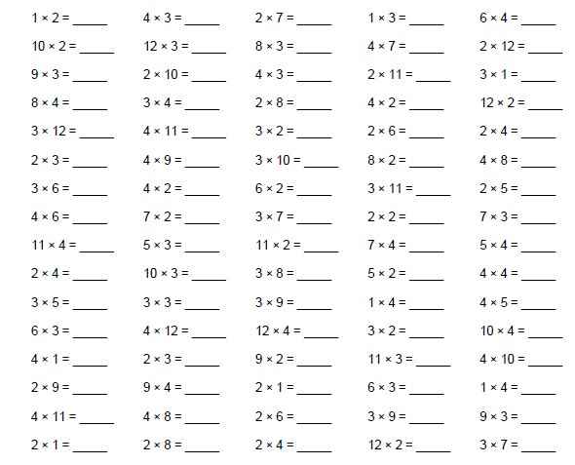

Exceeding expected – week 4
Work out the contractions

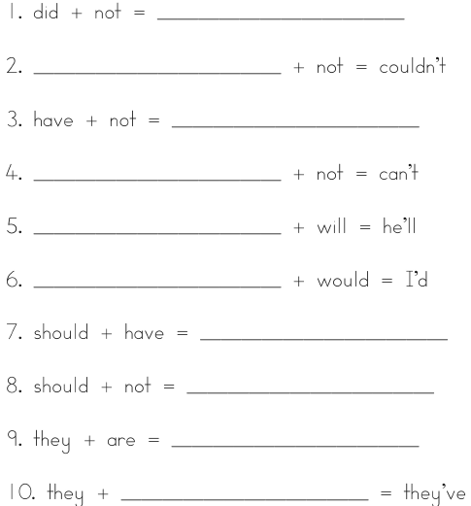
Expected - Week 5 Spelling practise: Look, say, cover, write, check
Look | Say | Cover | Write | Check | Write | Check | Write | Check
example |  |  | exampel |  | example |  | example
nonsense
non-stop
non-fiction
non-profit
non-starter
May
June
July
August
September
Now write the words in a sentence.
1. ____________________________________________________________________________________________________________________________________________________
2. ___________________________________________________________________________________________________________________________________________________
3. ___________________________________________________________________________________________________________________________________________________
4. ___________________________________________________________________________________________________________________________________________________
5. ___________________________________________________________________________________________________________________________________________________
6. ___________________________________________________________________________________________________________________________________________________
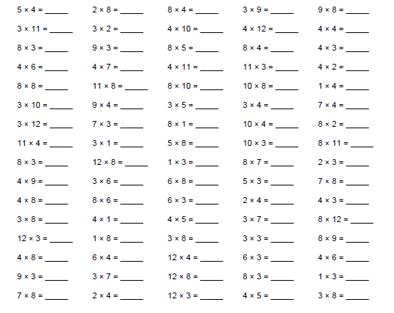
Expected
Week 5

Exceeding expected – week 5
