The Woodlands Community Primary School |  | Year 1/2 | Computing
Key Vocabulary | Key Knowledge and Skills
Internet – a provider of key  information across networks  Bee bot – programmable robot  Navigation – following a route  Debug – identifying and removing  errors  Programme – a set of algorithms or processes  Algorithms – instructions that are  split into small steps so that a  computer can solve a problem | 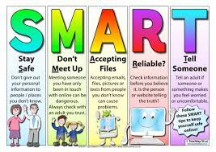 |  |  | Knowledge  - I know about the uses of the internet  - I know and understand how to keep safe on the internet  - Yr 2 - I know what algorithms are  Skills  - I can program e.g. through a bee bot to navigate complex routes  - Yr 2 – I can debug instructions when the bee bot does not reach the intended destination  - Yr 2 - I can create a simple programme  - Yr 2 – I can predict the outcome of a programme.
 | Key knowledge
Bee bot Programming

