The Woodlands Community Primary School |  | Year 1/2 | Topic – Science |  | Everyday Materials
Key Vocabulary | Key Knowledge and Skills
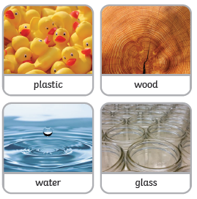  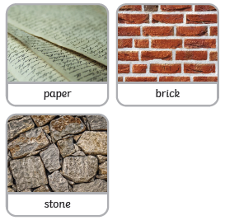  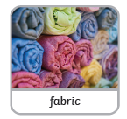 | 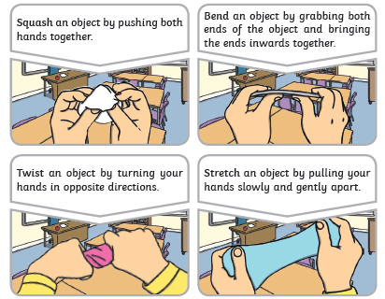 |  |  | Knowledge  - I can identify and name a variety of everyday materials.  - I can describe the simple physical properties of a variety of materials.  - I can compare and group together a variety of materials.  - I can identify and compare the suitability of everyday materials.  - I can find out how the shapes of solid objects made from some materials can be changed.  Skills  - I can ask simple questions.  - I can perform simple tests.  - I can identify and classify.  - I can use my observations and ideas to suggest answers to questions.  - I can gather and record data to help me answer questions.
 | Key knowledge
