The Woodlands Community Primary School |  | Year 5/6 | Music  Autumn 1 2021 |  | Happy by Pharrell Williams
Key Vocabulary | Facts about the song |  |  | Key Knowledge and Skills
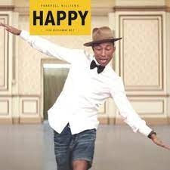  Compose, cover, dimensions of music, dynamics, ensemble, groove, hook, improvise, indicators, melody, Motown, pitch, producer, pulse, rhythm, riff, solo, Soul, structure, tempo, texture, timbre. | Theme: Being Happy!  ● Happy is a song written, produced and  performed by Pharrell Williams.  ● Happy is a Pop song that has a Soul music  sound and groove from the 1960s; very  much like a Motown song.  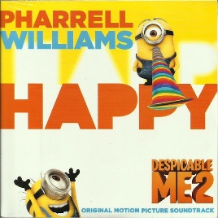 |  |  | Knowledge  - I know the names and appearance of instruments used in Happy.  - I know what Motown and soul music are.  - I know when Motown music was most popular.  - I know key vocabulary to describe the parts of a piece of music.  Skills  - I can appreciate and understand a wide range of live and recorded music  - I can listen with attention to detail  - I can identify sounds and instruments used  - I can improvise and compose music  - I can play and perform as a solo and ensemble
1 – Listen & Appraise | 2 – Musical Activities |  |  | 3 – Perform & Share
- What style indicators can you hear?  - Describe the structure?  - What instruments/voices can you hear?  - Describe the musical dimensions? | 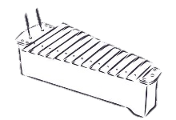  Using glocks and/or recorders  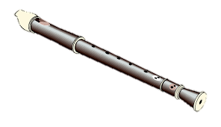  Warm-up Games play and copy back using  up to 3 notes – A, G + B.  Bronze: A | Silver: A + G | Gold: A, G + B  challenge.  Which challenge did you get to?  Singing in 2 parts.  Play instrumental parts with the song  by ear and/or from notation using the  easy or medium part. You will be using up  to 3 notes – A, G + B.  Which part did you play?  Improvise using up to 3 notes – A, G + B.  Bronze: A | Silver: A + G | Gold: A, G + B challenge.  Which challenge did you get to?  Compose a simple melody using simple rhythms  choosing from the notes A, G + B or C, E, G, A + B. |  |  | Perform your composition, perhaps adding some choreography!  Record the performance and talk about it afterwards.  The performance will include one or more of the following:  Improvisations • Instrumental performances • Compositions  